Professional Picture 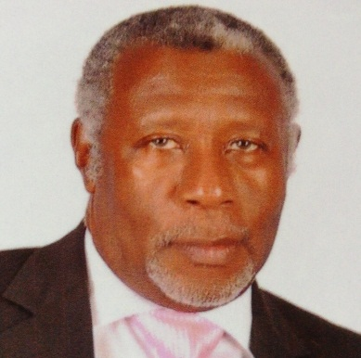

Past Council Chair, Lindel U. Smith served as Council Chair for Multiple District 60 in 2002-2003 immediately following his position of District Governor of District 60B in 2001-2002. He joined the association in 1984 and is a Member of the Mandeville Lions Club. Throughout his career as a Lion, PCC Lindel has had numerous accomplishments, including Lion of the year (1985), Region Chairperson (1995) and many District Governors’, Council Chairpersons” and International Presidents’ awards.
Lion Lindel Smith is an Attorney-at-Law by profession. He holds a Bachelor of Laws (Hons) Legal Education Certificate.

