**Lionism enters Suriname – The persons behind this**

Forty (40) years after the birth of Lionism in 1917 in the USA, Lionism came to Suriname in 1957 with the formation of the Paramaribo Lions Club in 1957. The person responsible for bringing Lionism to Suriname was Dr. Alfredo Wix, a dentist who worked in London, Vienna, Budapest, Quito, Chili, eventually chose to settle in Suriname. The initiative to form the Lions Club came from him with the support of Mr. Evert Treurniet and Adolf Brunings. Mr. Treurniet visited a friend in Aruba, who was the Lions Club President, this created some interest in the organization. Mr. Brunings lived in Aruba and was a member of the Lions club in Aruba, but repatriated in 1955 to Suriname. He was convinced that Suriname had to obtain connection with Lionism. These three men joined forces to bring Lionism to Suriname. They were then joined by Dr. R. Chin Ten Fung, whose office was the meeting place to undertake actions on this collective goal. It was **Dr. Wix Alfredo,** who with his experience in foreign countries,initiated the correspondence with Lions International.

On February 12, 1957 the first meeting started in the auditorium of the Cultural Centre Suriname with 26 prospectivemembers and the club was named “Lions Club Paramaribo” to change later in “Lions Club Paramaribo Central” when the extension started with more Lions clubs in Paramaribo. Lions International was delayed in their reaction to the Surinamese application for membership because none of the International Board members had ever heard of Suriname. Eventually after a visit from a Brazilian lion to Suriname from May 6-9, 1957 as an observer, Lions international agreed to support the charter presentation to Lions Paramaribo.

The club originally formed a part of District E (Venezuela, Curaçao and Aruba) and therefore the next visitor was the Governor of this District, Lion Leoni. The Paramaribo Lions club was chartered on July 27, 1957. It was expected that the current District Governor Dr. Santos Erminy Arismendi from Venezuela would travel to Suriname for this Charter night occasion, however his trip was cancelled and the American Consul, J. Mac Knight was requested to do the Charter presentation with Dr. A. Wix as Club President. On this special occasion on July 26, 1957 the Governor of Suriname, Mr. J. van Tilburg was present with other notables and their spouses. Suriname was un-districted and therefore was part of District E in Region 1 (Venezuela, Aruba, Curaçao).

Lions International was so impressed of the performance of the Lions club in Suriname that started without a sponsoring lions club and decided to pay a visit to the Club in December 16, 1957. International President Edward G. Barry with his wife and DG District E, Dr. Santos Erminy-Arismendi visited Suriname.

The second club to be chartered was the Paranam club in Suriname in August 1960 (name changed to Para in 1963)

**Charter of Paramaribo Lions Club with Charter Members:**

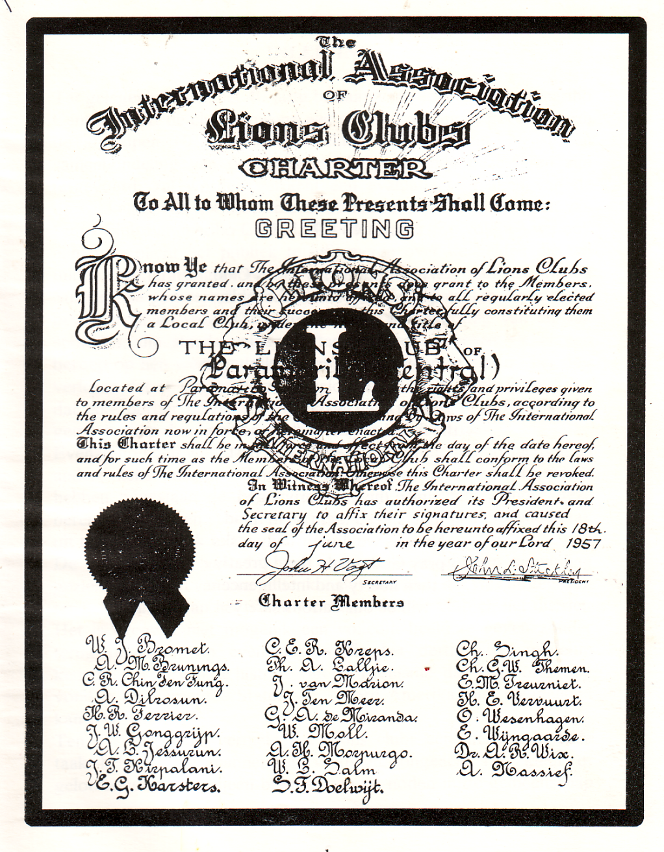

**1960 Start of Extension to other countries**

Lionism went to Guyana in 1960, with the formation of the Georgetown Lions Club on August 23rd, 1960. In 1961, Barbados became a member country of the association with the formation of the Lions Club of Barbados (name changed to Lions Club of Bridgetown in 1974 with the formation of the Lions Club of Barbados North.

**Provisional District**:

With Lionism established in three countries (Suriname, Guyana and Barbados) and with the minimum requirement of six clubs met, this enabled the formation of a Provisional District “P”. the clubs which formed this Provisional District are:

1. 08 May 1957 L.C.Paramaribo 1960 change L.C.Paramaribo Central
2. 15 Aug 1960 L.C. Paranam 1963 change L.C. Para
3. 23 Aug 1960 L.C. Georgetown
4. 31 Aug 1960 L.C. Paramaribo North
5. 04 Sep 1960 L.C. Nieuw Nickerie
6. 23 Oct 1961 New Amsterdam
7. 28 Dec 1961 L.C. Barbados now Bridgetown Central

The first appointed ***Provisional*** District Governor of Provisional District P was Jan van Marion home club L.C. Paramaribo Central the former L.C. Paramaribo.



PDG Jan van Marion

Quite independently, through a Venezuelan Lions Club, the Trinidad North (now Port of Spain Central) Lions Club was chartered in May 1962.

In 1963, Trinidad and Tobago having learnt of the Lions Clubs in Guyana, Barbados and Suriname joined District “P” and the growth of Lionism continued apace with the formation of several Clubs in Guyana, Suriname and Trinidad & Tobago.

In the 1960s a number of clubs were formed in the Caribbean, the Barbados Lions formed clubs in St. Vincent and the Grenadines (1964), St. Lucia (1967), Dominica (1968) and Antigua and Barbuda (1968)

In 1965 the Port of Spain Central Lions sponsored the Grenada (now St. George’s) Lions Club.

The first elected District Governor of Provisional District P, fiscal year 1967-1968 was Dr. Harry Carrington - home club Lions Club of Port of Spain (POS) Central. The first ***contested*** election for District Governor was at the 1971 Jamaica Convention.

**Full District – District 60**

With the growth of all these clubs, in 1969, the Provisional District P became a full district – District 60, the first District Governor was John Fernandes Jr. of Guyana.

The first club was established in Jamaica, the Kingston Lions Club in 1964 and chartered 22 February 1965. Jamaica however remained un-districted.

The Lions Clubs on the US Virgin Islands was formed through the Lions in Puerto Rico and became part of District 51 in 1966

At the Convention in 1969 the Lions of Martinique and Jamaica received invitations to attend. Jamaica sent a delegation of nine Lions to the District Convention in 1969. Shortly thereafter, Jamaica which was un-districted like Martinique decided to join District 60.

Jamaica became part of the District in 1970 and hosted a memorable Convention in 1971 in Kingston.

The Georgetown Lions Club through Past International Director Louis Chung was responsible for Clubs in Nevis 1972 and the Turks & Caicos Islands (this club lasted only two years).

By 1975 there were 12 clubs in Jamaica.

The District was divided into six regions as follows:

Region 1 Suriname

Region 2 Guyana

Region 3 Trinidad & Tobago and Grenada

Region 4 Barbados and the Windward Islands

Region 5 The Leeward Islands & the Virgin Islands

Region 6 Jamaica and Grand Cayman

**Attempts to split into two Districts:**

Because of the progress of growth of Lionism in the region, in 1975, it was suggested by the then District Governor Lion Bernard Cridland that the District be split because it had become quite a task for a Governor to visit each Club which by then also included the British Virgin Islands.

Governors and Cabinet Officers at the Union Club in Trinidad the following made the following proposal for three Sub-District to Lions International.

60A Suriname, Guyana and *(Cayenne)*

60B Trinidad & Tobago, Grenada, Barbados, St.Vincent, St.Lucia, Dominica, Antigua, Nevis, Tortola, virgin Gorda, *(St. Maarten, St.Croix, St.Thomas and St.John, Martinique & Guadeloupe)*

60C Jamaica, Grand Cayman *(Belize, Bahamas, Haiti, Aruba and Curaçao)*

Those territories in brackets were not then part of District 60 as St. Maarten and the US Virgin Islands left District 51 some years later. This perhaps too ambitious proposal was turned down by Lions International as each Sub-District is required to have at least 35 Clubs and1,250 members and of course most of the other territories had not expressed a desire to join District 60.

**Multiple District 60**

With more than 70 Lions clubs, in 1980 the district finally became a Multiple District. In order to facilitate this, Grenada’s two Clubs, St. Georges and St. Andrews which were part of Region 3, became part of Region 1 of Sub-District 60B. This was necessary as the then proposed 60B did not have the required 35 Clubs to be able to form a separate District.

At that time the fear was expressed by many Lions that with the split, the District might drift apart and that it would lose its “Uniqueness”. Others however saw that become a Multiple District was purely an administrative matter and that with joint meetings and Convention the Lions of the Caribbean would be able to preserve their quite unique District.

The first Chairperson of the Council of Governors was Immediate Past District Governor (1979/1980) Dr. Joseph Robinson of Antigua and Barbuda; the members of Council were DG60A Gopichan Ramsaran of Trinidad & Tobago (Vice Council Chairperson) and DG60B Cecil Sproul of Jamaica - member. They presided over the First Multiple District Convention was held on 28 June 1980 in Kingston-Jamaica.

Since then the Multiple District has held its annual Conventions in the month of May, and its Mid Year Conference in the month of November. In November 1989 Council Chairman Harold Ramdhani of Suriname held the 1st Mid Year Conference in Port of Spain – Trinidad & Tobago. It should be noted that the first draft of the Multiple District Constitution was piloted by Past District Governor Edmund Hart and Past International Director Terry Inniss.

**Gentleman’s Agreement/Rotation of Leadership:**

At the Convention in 1976 in Montego Bay (Jamaica) the amendment to the District Constitution was passed in an attempt to enshrine “The Gentleman’s Agreement” for the rotation system. This however was not approved by Lions International as it sought to impose other qualifications outside of that in the International Constitution for a Lion to become a District Governor. At that time the District was divided into six regions as follows:

Region 1 Suriname

Region 2 Guyana

Region 3 Trinidad & Tobago and Grenada

Region 4 Barbados and the Windward Islands

Region 5 The Leeward Islands & the Virgin Islands

Region 6 Jamaica and Grand Cayman

The gentleman’s Agreement not part of the Multiple District Constitution continues to be observed by both Sub-Districts. In Sub-district 60B the “Montego Bay” resolution is practiced as proposed where delegates vote for the Vice Governors at the Region meeting of the Region whose turn it is to put forward such candidate. Final vote is taken at the District Convention. In Sub-district 60A delegates vote for the Vice Governors at their Convention rather than at the Region meeting with the exception of Suriname.

The current configuration of the Multiple District is:

**District 60A:**

Region 1 Suriname

Region 2 Guyana

Regions 3 and 4 Trinidad and Tobago

**District 60B:**

Region 1 Jamaica

Region 2 Anguilla, Antigua and Barbuda, British Virgin Islands (Tortola and Virgin Gorda), Dominica, St. Kitts and Nevis, St. Maarten, the Dutch Islands of Saba and St. Eustatius, United States Virgin Islands (St. Thomas and St. Croix) and ***Montserrat which no is no longer functional)***

Region 3 Barbados, Grenada, St. Lucia and St. Vincent and the Grenadines including Union Island

Region 4 Jamaica and Cayman Islands (Grand Cayman and Cayman Brac)

Further the Chair of the Council of Governors is rotated between the two sub-districts. The two Governors vote for the Council Chair. The Council Chair is the Immediate Past District Governor of one of the sub-districts whose turn it is to take the chair. There was only one occasion where the Immediate Past District Governor did not take the Chair. Past District Governor 60A Iwan Toussaint declined the position for 1995-1996, therefore in order for District 60A to maintain its position of Chair of the Council of Governor that year, the most recent serving Governor in 60A prior to PDG Iwan was voted to the position – PCC Stephen Backer. Based on the rotation system PCC Backer would not have been voted to the Council Chair position.

**Multiple District 60 moves from Constitutional Area 3 to Constitutional Area 1**

MD 60 had been part of Constitutional Area 3…**South America, Central America, Mexico and Islands of the Caribbean Sea. The “Islands of the Caribbean Sea” included all of MD 60 as well as other islands,** including **Haiti, Guadeloupe, Aruba and Martinique.**

During that time, MD60 Lions attended several of the CA III forums (FOLAC). In fact, one forum was held in Trinidad and Tobago in 1984, where simultaneous translation from English to Spanish and vice versus was done for the first time. In 1973 the first candidate from this District to be endorsed to represent CA III as an International Director was Past International Director Louis Chung. In 1996, Terence Boswell Inniss was elected International Director, representing CA 111. As time went by, the Lions of MD 60 became less inclined to attend FOLAC as they felt that the language barrier was becoming unsurmountable.

Past International Director Nicolin Moore in 2011 felt strongly about the Multiple District’s limited ability to adequately participate and contribute to the organization being part of Constitutional Area III. Based on her enquiry into what was required, and discussions with others in the Multiple District, in November 2012, at the Mid-Year Conference in Kingston, Jamaica, there was a presentation aimed at sensitising Lions to some of the problems with being a small English-speaking part of a constitutional area that spoke mainly Spanish and Portuguese. The presentation also cited the potential benefits of being part of a constitutional area where English was the official language.

At the end of that fiscal year, at the MD 60 convention in June 2013, delegates voted overwhelmingly in favour of a resolution to request LCI for a move to CA 1. One requirement was a list of reasons for the request; another was consultation with the International Directors from CA III. A detailed case statement was prepared by Past Council Chair Lion Malcolm Kirwan and submitted to LCI and the consultation with the sitting ID’s resulted in a request for a meeting. This took place in January 2015, and the MD 60 team was able to lay out its concerns, and indicated to the CA III team that the lions were not prepared to reconsider their position. Under the leadership of Past Council Chairs Izette Mc Calla and Maxine Cummings, the necessary paperwork was executed.

At the meeting of the LCI Executive and Board of Directors in June 2015, in Honolulu, the request was granted and MD 60 officially became part of CA 1 as of July 2015. Even though this change was effected, the names of the constitutional areas have not been modified.

The Board Policy Manual of LCI lists the countries of CA 1 as follows:

**United States of America, Its Affiliates, Bermuda & The Bahamas**

* Anguilla
* Antigua and Barbuda
* Bahamas, Commonwealth of The
* Barbados
* Bermuda
* British Virgin Islands
* Cayman Islands
* Dominica, Commonwealth of
* Grenada
* Guyana, Co-operative Republic
* Jamaica
* Montserrat
* Puerto Rico, Commonwealth of
* Saint Christopher-Nevis
* Saint Lucia
* Saint Vincent and the Grenadines
* Sint Maarten (Netherlands, Antilles)
* Suriname, Republic of
* Trinidad & Tobago, Republic of
* United States of America
* United States Virgin Islands

**WOMEN OF THE MULTPLE DISTRICT:**

The Lioness programme started in Multiple District 60 in October 1975 with the Lioness Club of Barbados North. The first Lioness Club in 60A was the Lioness Club of Felice sponsored by Paramaribo Central, Paramaribo North and Para Lions Club in **1977**.

The Lioness movement in District 60A was organized into a District in 1988 with the first Lioness District President being Lioness Anna Marie (Maike) Storm van Leeuwen-Eliazer. She was then followed by Lioness Alison Sloane-Seale in 1989.

In 1990, the first all-female Lions Club in the Multiple District was chartered in Trinidad and Tobago, this was the Port of Spain Upper Belmont Lions Club, with Charter President Kathleen Pacheco.

In an effort to fully incorporate women’s contribution into the Association, Lions international moved away from programmes for Lioness and encouraged Lionesses to become full members with full privileges as their male counterparts. To reflect this by 1992, most of the Lioness clubs in Trinidad and Tobago converted to Lions Clubs. In District 60B, Lioness clubs also converted to Lions Club; the St. Thomas Lioness club converted to the St. Thomas East End Lions Club in April of 1992

Out of the group of Lionesses in the Multiple District thus far seven (7) became District Governors (Anna Marie Storm v Leeuwen-Eliazer, Alison Sloane-Seale, Beverly Reddock, Dr. Maria Byron, Shirley Quetel-Hendricks, June Mc Catty, and Nicolin Moore and four (4) became Council Chairs (Sloane-Seale, Reddock, Hendricks, Moore and one as an International Director (Nicolin Moore).

To date (2019/2020) there have been a total of 13 Female District Governors and five (5) female Council Chairs and One female International Director.

**MD UNIFORM:**

The first District Uniform as well as the first District Trading pin was adopted in 1973 for the International Convention in Miami. It is at that Convention that the District for the first time marched as one and not as individual territories. The uniform was a purple waist coat and all-white clothing including shoes for the Lions, wives and children. A steelband was taken up for the parade.

The current Multiple District Uniform was established in 1993, under the Leadership of Past Council Chair Colette John. The colours selected were maroon top and grey bottom. The maroon colour was chosen to mirror the colour of the West Indies Cricket Team. The Multiple District has used this uniform since then.

**OUR INTERNATIONAL ACHIEVERS:**

Over time, the MD has had several of its Members have made their mark at the international level. The High Achievers:

***Our International Directors:***

Louis Chung – Lion Louis served as International Director from 1976 to 1978. He was a Member of the Georgetown Lions Club. Lion Louis Chung also ran for the office of International 3rd Vice President, but was not successful.

The Multiple District’s Second International Director was Lion Terence Boswell Inniss who served from 1996-1998. Lion Nicolin Moore, the first female International Director from the region served from 2016 to 2018. She was also the first Director to serve under Constitutional Area One (1).

These three Past International Directors all received the Ambassador of Goodwill Award, which is the highest award of the International Association of Lions Club.

***Lions Achieving International Awards:***

Lion Shefanie Vin, a very young Lion who came through the Leo Movement received an International President’s Award from International President Gudrun Yngvadottir for her work in Membership Development on the international stage in 2019.

***Our Top Performing Governors***:

In 2015 Lion Maxine Cummings received the top prize for constitutional area One (1) the Pride of Excellence Award from the International President during the International Convention in Honolulu, Hawaii.

***Lions with International Positions:***

Several Lions have functioned on the International Stage. Past Council Chair Malcolm Kirwan of the Charlotte Amalie Lions Club was among the first group of Lions world-wide to be designated as a Lions Certified Instructor. He has served as a member of the faculty for the Emerging Lions Leadership Institute (ELLI) and Advanced Lions Leadership Institute (ALLI) on several occasions. Lion Malcolm was also the Global Leadership Team (GLT) – Global Membership Team (GMT) Special Area Advisor MD60, District 63, Haiti and Belize from 2013-2017, and Vice Area Leader-1E LCIF Campaign 100 (2018-2021)

Past District Governor Dr. Maria Byron of the Arima Santa Rosa Lions Club is also a Lions Certified Instructor and served as Faculty for the ALLI in Winnipeg 2018 and Faculty Development Institute (FDI), Reno 2019.

Lion Dr. Carlisle Goddard of the Bridgetown Lions Club served as part of the Lions Club International Task Force for Diabetes 2017-2018.

**TWINNING:**

District 63

The relationship between District 63 and District 60 started in 1969 when District 60 invited Martinique to attend its Convention in Trinidad and Tobago. Martinique/District 63 again participated in the District Convention in 1976.

Since 1969 District 63 and Multiple District 60 has had cordial relationships, they have visited each other’s meetings.

At the July 1993 Lions International Convention in Minneapolis, District Governors Stephen Backer (60A) and Rudolphe Robinel (63) expressed a desire to twin the two districts. This finally took place in 1995 at the Multiple District Convention in Kingston, Jamaica. The agreement was signed by the two (2) initiators Backer and Robinel and the two current District Governors Iwan Toussaint (60A) and Guy Chalono (63).

Most notably every year at the Lions International Convention Multiple District 60 hosts a joint Cocktail reception with District 63.

Twinning Agreement District 63 and District 60A

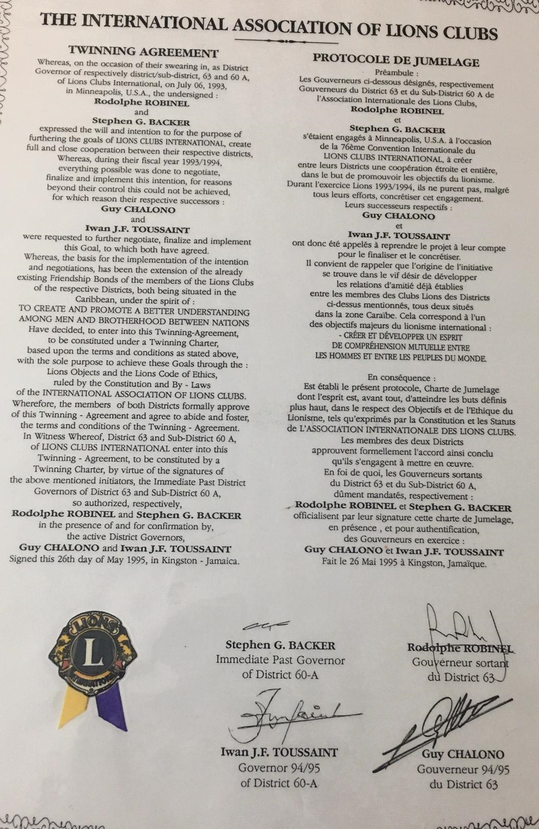

**Club Twinning:**

Some clubs in 60A have twinned with clubs in District 63. From Suriname: Paramaribo North is twinned with Ille de Cayenne, Commewyne with Mont Jolie, Paramaribo Central with Guyane Doyen, Paramaribo South is twinned with Matoury Fort Trio and Paramaribo Felice is twinned with Remire Diamant D’armire. All these clubs are from French Guiana. In Trinidad and Tobago, the Port of Spain Upper Belmont Lions Club is twinned with the Guyane Amazonie Lions Club also of French Guiana/Cayenne. These clubs over time exchange visits and gifts and most notably do joint projects for example restroom facilities between Suriname and French Guiana.

The Lions Club of Dominica is twinned with Lions Club of Guadeloupe Doyen.

**LEOS -**

The Leo Movement started in Barbados with the charter of the Leo Club of Bridgetown on 24th July 1971. In Jamaica, the first Leo Club as the Montego Bay Leos Club was certified June 23, 1972. The first Leo Club in District 60A was Suriname in 1972 with the certification of the Leo Club Nieuw Nickerie. This was closely followed by Leo Club Leo Gado Tjo – Nov 29, 1972

Leo Clubs were established in all territories of the Multiple District with the exception of Anguilla and ***Montserrat***

Many Leos in the Multiple District have become Lions and several have ascended to leadership positions in the district, serving as Zone and Region Chairpersons. Of note are those former Leos, who would have reached to the level of District Governor - Tony Buncamper (2012/2013), Nadine Bushell (2016/2017) and Anwar Hollingsworth (2019/2020), with Nadine Bushell serving as Council Chair (2017/2018).

Multiple District 60 Leos have also had the opportunity to make their presence felt on the International stage. In 2017, the Leos of Suriname entered the International Leo Day Video Contest, and had one of the top ten (10) videos – Leos of Suriname – Vegetable Garden. LINK TO VIDEO

***CLUB CHARTER HISTORY- to be checked-verified***

| **Nr.** | **Charter Date** | **Club Name** | **Country** | **Re-voked** |
| --- | --- | --- | --- | --- |
| 1 | 8 May 1957 | Paramaribo, (1960 Paramaribo Central) | Suriname |  |
| 2 | 15 Aug 1960 | Paranam, (1963 Para) | Suriname |  |
| 3 | 23 Aug 1960 | Georgetown | Guyana |  |
| 4 | 31 Aug 1960 | Paramaribo North | Suriname |  |
| 5 | 2 Dec 1960 | Nieuw Nickerie | Suriname |  |
| 6 | 28 Sep 1961 | Bridgetown | Barbados |  |
| 7 | 1 Jul 1962 | Port of Spain Central | Trinidad and Tobago |  |
| 8 | 5 Apr 1963 | Corriverton | Guyana |  |
| 9 | 28 Jun 1964 | San Fernando | Trinidad and Tobago |  |
| 10 | 18 Jul 1964 | Tobago | Trinidad and Tobago |  |
| 11 | 2 Nov 1964 | St. Vincent | St. Vincent and the Grenadines |  |
| 12 | 22 Feb 1965 | Kingston | Jamaica |  |
| 13 | 3 Apr 1965 | St. Georges | Grenada |  |
| 14 | 4 Mar 1966 | Trinidad Central | Trinidad and Tobago |  |
| 15 | 13Aug 1966 | Marowijne | Suriname | †1992 |
| 16 | 1 Nov 1966 | St. Croix | St. Croix |  |
| 17 | 23Feb 1967 | Charlotte Amalie | US Virgin Islands |  |
| 18 | 23Feb 1967 | St. Thomas | US Virgin Islands |  |
| 19 | 24 May1967 | Arima | Trinidad and Tobago |  |
| 20 | 24 Jun 1967 | Castries | St. Lucia |  |
| 21 | 5 Feb 1968 | Central Demerara | Guyana |  |
| 22 | 15 March 1968 | Dominica | Dominica |  |
| 23 | 17 Jul 1968 | Upper Demerara | Guyana |  |
| 24 | 20 Jul 1968 | St. Patrick East | Trinidad and Tobago |  |
| 25 | 11 Sep 1968 | Montego Bay | Jamaica |  |
| 26 | 14 Oct 1968 | Antigua | Antigua |  |
| 27 | 15 Apr 1969 | North St. Catharine | Jamaica |  |
| 28 | 25 Mar 1970 | Paramaribo South | Suriname |  |
| 29 | 15 Jun 1970 | West Demerara | Guyana |  |
| 30 | 27 Oct 1970 | Clarendon | Jamaica |  |
| 31 | 12 Dec 1970 | St. Maarten | St. Maarten |  |
|  | 14 August 1971 | Bridgetown | Barbados |  |
| 32 | 25 Aug 1971 | St. Andrew | Grenada |  |
| 33 | 23 Oct 1971 | New Amsterdam | Guyana |  |
|  | 17 Apr 1972 | St. Augustine | Trinidad and Tobago |  |
| 34 | 27 Apr 1972 | Tortola | British Virgin Islands |  |
| 35 | 6 Oct 1972 | Grand Cayman | Cayman Isle |  |
| 36 | 13 Jan 1973 or 1971 | East Demerara | Guyana |  |
| 37 | 23 Mar 1973 | St. John | US Virgin Islands |  |
| 38 | 15 May 1973 | Central Corentyne | Guyana |  |
| 39 | 19 May 1973 | Savannah La Mar | Jamaica |  |
| 40 | 8 Jun 1973 | Diego Martin West | Trinidad and Tobago |  |
| 41 | 12 Dec 1973 | Ruimveldt | Guyana |  |
| 42 |  |  |  |  |
| 43 | 21 Jan 1974 | Bel Air | Guyana |  |
| 44 | 22 Jan 1974 | Kwakwani | Guyana |  |
| 45 | 9 May 1974 | Vieux Fort | St. Lucia |  |
| 46 | 11 Mar 1974 | Barbados North | Barbados |  |
| 47 | 15 Jul 1974 | Old Harbour | Jamaica |  |
| 48 | 23 Aug 1974 | West Berbice | Guyana |  |
|  | 14 Jan 1975 | Spanish Town | Jamaica |  |
| 49 | 31 Jan 1975 | Porus | Jamaica |  |
| 50 | 10 Apr 1975 | Paramaribo West | Suriname |  |
| 51 | 17 March 1975 | Virgin Gorda | British Virgin Islands |  |
| 52 | 27 May 1975 | St. Andrew | Jamaica |  |
| 53 | 22 May 1975 | St. Thomas Jamaica | Jamaica |  |
| 54 | 8 Aug 1975 | Mandeville | Jamaica |  |
| 55 | 5 Nov 1975 | Barbados South | Barbados |  |
| 56 | 1 Jan 1976 | Waco | Suriname | †1994 |
| 57 |  |  |  |  |
| 58 | 8 Jun 1976 | Port of Spain North | Trinidad and Tobago |  |
| 59 | 2 Dec 1976 | Point Fortin or 1 Jan 1990 | Trinidad and Tobago | † .... |
| 60 | 7 Jan 1977 | Corentyne East | Guyana | † .... |
| 61 | 1 Feb 1977 | South Georgetown | Guyana |  |
| 62 | 18 Feb 1977 | Commewijne | Suriname |  |
| 63 | 23 May 1977 | Port of Spain East | Trinidad and Tobago | † .... |
| 64 | 6 Jun 1977 | Saba | Saba |  |
| 65 | 15 Jun 1977 | Point-a-Pierre | Trinidad and Tobago |  |
| 66 | 24 Oct 1977 | North St. Ann | Jamaica |  |
| 67 | 9 May 1978 | Portmore | Jamaica |  |
| 68 | 18 May 1978 | South Central St. Catharine | Jamaica |  |
| 69 | 22 Jun 1978 | East Canje | Guyana |  |
| 70 | 26 Jun 1978 | St. Croix Mid Island | US Virgin Islands |  |
| 71 | 10 Sep 1978 | St. Vincent South | St. Vincent |  |
| 72 | 13 Dec 1978 | St. Eustatius | St. Eustatius |  |
| 73 | 28 Feb 1979 | Nevis | St. Kitts and Nevis |  |
| 74 | 19 May 1979 | Barbados Central | Barbados |  |
| 75 | 25 Jul 1979 | Mayaro | Trinidad and Tobago |  |
| 76 | 4 Dec 1979 | St. Kitts | St. Kitts and Nevis |  |
| 77 |  |  |  |  |
| 78 | 30 Jan 1981 | Sea Front | Trinidad and Tobago |  |
| 79 | 10 Jun 1981 | Portland | Jamaica |  |
| 80 | 10 Jul 1981 | San Juan Barataria | Trinidad and Tobago |  |
|  | 25 Aug 1981 | St. Andrew | Grenada |  |
| 81 | 1 Dec 1981 | Anguilla | Anguilla |  |
|  | 26 Mar 1982 | St. Andrew Central | Jamaica |  |
| 82 | 10 Jun 1982 | Tortola II | British Virgin Islands |  |
| 83 | 27 Apr 1983 | Sangre Grande | Trinidad and Tobago |  |
| 84 | 31 May 1983 | St. Thomas East | US Virgin Islands |  |
| 85 | 16 Jan 1984 | Piton see 5 Febr 1995 | St. Lucia | † .... |
| 87 | 16 Jan 1984 | Piton see 5 Febr 1995 | St. Lucia | † .... |
| 86 |  |  |  |  |
| 87 | 18 Jul 1985 | Montserrat | Montserrat | 2018 |
| 88 | 9 Aug 1985 | St. Mary | Jamaica |  |
|  | 2 Nov 1985 | St. Vincent Lions Club | St. Vincent and the Grenadines |  |
| 89 | 10 Sep 1985 | Cayman Brac | Cayman Islands |  |
| 90 | 17 Mar 1986 | Paramaribo Wanica (Parwani) | Suriname |  |
| 91 | 12 Jul 1986 | Princes Town | Trinidad and Tobago | † .... |
| 92 | 24 Sep 1986 | Santa Cruz | Trinidad and Tobago |  |
| 93 | 1 Jan 1988 | Nickerie Golden Grain | Suriname | †2008 |
| 94 | 1 Feb 1988 | East Coast Demerara Upper | Guyana |  |
| 95 | 1 Feb 1988 | Demerara Lioness | Guyana |  |
| 96 | 4 Feb 1988 | Barbados East | Barbados |  |
| 97 | 27 Dec 1988 | Saramacca | Suriname | †2009 |
| 98 | 20 Jun 1989 | Chaguanas | Trinidad and Tobago |  |
| 99 | 1 Jan 1990 | Diego Martin North/West or 1 Jul 1992 | Trinidad and Tobago |  |
| 100 | 1 Jan 1990 | La Romaine Gulf View see 112 | Trinidad and Tobago |  |
| 101 | 1 Jan 1990 | Moruga | Trinidad and Tobago |  |
| 103 | 1 Jan 1990 | St. Patrick West | Trinidad and Tobago |  |
| 104 | 5 Feb 1990 | Corentyne South | Guyana |  |
| 105 | 1 May 1990 | Port of Spain Upper Belmont | Trinidad and Tobago |  |
| 106 | 5 May 1990 | Paramaribo Excel | Suriname | †1995 |
| 107 | 29 May 1990 | Valsayn | Trinidad and Tobago |  |
| 108 | 15 Jun 1990 | Couva | Trinidad and Tobago |  |
| 115 | 06 Jul 1990 | Falmouth Trelawny | Jamaica |  |
| 116 | 14 Nov 1990 | Trincity | Trinidad and Tobago |  |
| 117 | 16 Feb 1991 | Downtown Kingston | Jamaica |  |
| 118 | 27 Apr 1991 | St. Vincent North | St. Vincent and the Grenadines |  |
| 119 | 22 Jun 1991 | St. Elizabeth South | Jamaica |  |
| 121 | 23 Oct 1991 | Essequibo Coast | Guyana |  |
| 122 | 24 Nov 1991 | San Fernando Petit Morne | Trinidad and Tobago |  |
| 123 | 3 Dec 1991 | Gros Islet | St. Lucia |  |
|  | 23 Dec 1991 | Scotland District | Barbados |  |
| 125 | 22 Jan 1992 | Kwatta | Suriname |  |
| 83 | 7 Mar 1992 | St. Andrew Central | Jamaica |  |
| 126 | 27 Mar 1992 | New Kingston | Jamaica |  |
| 127 | 28 Mar 1992 | Castries Central | St. Lucia |  |
| 128 | 20 Jul 1992 | St. Vincent West | St. Vincent and Grenadines | † .... ? |
| 129 | 27 Apr 1992 | St. Thomas Eastend | US Virgin Islands |  |
| 131 | 27 Apr 1992 | Tortola II | British Virgin Islands |  |
| 132 | 1 May 1992 | Tunapuna | Trinidad and Tobago |  |
| 133 | 5 Jun 1992 | St. Croix Mid-Islands | US Virgin Islands |  |
| 134 | 15 Jun 1992 | Valley Sound | British Virgin Islands |  |
| 135 | 23 Jun 1992 | St. Michaels | Barbados |  |
| 136 | 1Jul 1992 | Port of Spain Success Laventille | Trinidad and Tobago |  |
| 137 | 23 Jul 1992 | St. James | Jamaica |  |
| 141 | 2 Aug 1992 | San Juan Petit Juan | Trinidad and Tobago |  |
| 142 | 4 Aug 1992 | San Fernando Les Efforts | Trinidad and Tobago |  |
| 143 | 6 Aug 1992 | Arima Santa Rosa | Trinidad and Tobago |  |
| 144 | 15 Aug 1992 | Paramaribo Ready | Suriname |  |
| 145 | 30 Sep 1992 | Paramaribo Felice | Suriname |  |
| 146 | 25 Nov 1992 | Christ Church West | Barbados |  |
| 136 | 27 Nov 1992 | St. Catherine Central | Jamaica |  |
| 147 | 16 Apr 1993 | Tropical Gardens | Cayman Islands |  |
| 148 | 14 Dec 1993 | Georgetown D’Urban Park | Guyana |  |
| 149 | 8 Jun 1994 | Mona | Jamaica |  |
| 150 | 22 Jul 1994 | Frederiksted Twin City | US Virgin Islands |  |
| 151 | 14 Dec 1994 | Scarborough Upper | Trinidad and Tobago |  |
| 152 | 13 Mar 1995 | Micoud | St. Lucia |  |
|  | 11 Dec 1995 | St. Catherine’s Central | Jamaica |  |
|  | 5 Feb 1996 | (Soufriere) Piton | St. Lucia | † .... |
| 153 | 1 May 1996 | Portsmouth Dominica | Dominica |  |
| 154 | 25 Mar 1997 | St. Catherine Bridgeport | Jamaica |  |
| 155 | 16 Jun 1997 | Bartica | Trinidad and Tobago |  |
| 156 | 12Nov 1997 | Kwakwani Upper Rio Berbice | Guyana |  |
|  | 14 Dec 1998 | Lucea | Jamaica |  |
| 157 | 24 Oct 2002 | Georgetown Stabroek | Guyana |  |
| 158 | 21 May 2007 | Port of Spain 1st Officers Club | Trinidad and Tobago | † 2018 |
| 159 | 24 Apr 2009 | Chaguanas Central Plain | Trinidad and Tobago |  |
| 160 | 7 Feb 2011 | Diamond Grove | Guyana |  |
| 161 | 27 May 2014 | Eldorado East | Trinidad and Tobago |  |
| 162 | 20 Apr 2017 | Paramaribo East | Suriname |  |
| 163 | 27 Jun 2017 | D’Abadie | Trinidad and Tobago |  |
| 164 | 23 Jun 2018 | Paramaribo Focus | Suriname |  |
| 165 | 13 Mar 2018 | Princes Town Central | Trinidad and Tobago |  |
| 166 | 30 Apr 2018 | Wanica | Suriname |  |
|  |  |  |  |  |
|  |  |  |  |  |

XXXX Union Island