Professional Picture
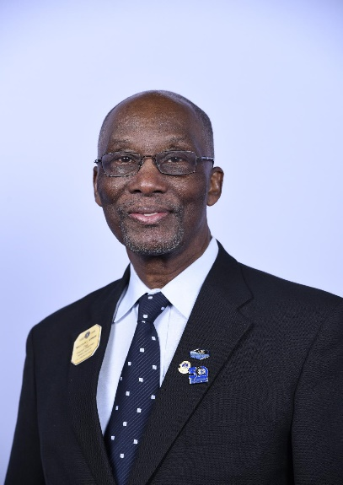
MALCOLM KIRWAN PMJF
Council Chair - 1998-1999
District Governor - 1997-1998
GLT-GMT Special Area Advisor MD60, D63, Haiti and Belize. (2013-2017)
Vice Area Leader-1E LCIF Campaign 100 (2018-2021)
Past Council Chair Malcolm Kirwan joined the Association in 1974. His Home Club is Charlotte Amalie St. Thomas Lions Club. Lion Malcolm a very accomplished Lion, has received numerous awards at the Club, District and Multiple District Level. He has received various International President Certificates and the following International President’s Medals
  - Presidential Medal, President J. Frank Moore III, May 2002
  - Presidential Leadership Medal, President Barry J. Palmer 2014
  - Presidential Medal, President Joe Preston 2015
  - Presidential Medal President Dr. Jitsuhiro Yamada, 2016
  - Presidential Medal President Bob Corlew, 2017

Throughout his career as a Lion, PCC Malcolm has made significant contributions. He organized and developed the first two Regional Institutes for Multiple District 60 in Guyana 2001 (with 59 participants) and St. Lucia 2002 (with 55 participants). He has presented leadership papers at the Latin American and Caribbean Forum of Lions in Chile and Santo Domingo. Lion Malcolm also served as District Trainer for District 60B, (1993-1997) and published a series of seventeen (17) articles on various leadership topics under the banner of a Quarterly Bulletin entitled “The District Trainer”. PCC Malcolm was a member of the LCI Leadership Exchange Team facilitating a mini-session on “Goal Setting” at the Lions Clubs International Convention. (2006 – 2018).

Also in the area of Leadership, Lion Malcolm wrote over Thirty (30) articles and papers on various leadership topics, was invited to be a featured presenter and speaker at the Annual Convention of District 63 on more than six (6) occasions, facilitated numerous seminars and workshops for District Governor’s Elect, Vice-District Governors, District Officers and Lions members.

PCC Malcolm was also among the first group of Lions world-wide to be designated as a Lions Certified Instructor by Lions Clubs International and has served as a member of the faculty for the Emerging Lions Leadership Institute (ELLI) and Advanced Lions Leadership Institute (ALLI).

When the Multiple District made the decision to pursue its move from Constitutional Area Three (3) to One (1) Lion Malcom wrote the “Case Statement” for presentation to LCI that led to the eventual transfer of MD60.

Although now retired, Lion Malcom has more than 35 years of service as a higher education executive, management professor and business consultant having served as:
- Executive Director of the UVI Research and Technology Park (2004-2005)
- University Vice-President for Administration and Finance (1979-2004)
- Associate Professor of Management (1971-2005)
- Business and training consultant (1988-2016)
PCC Malcolm has an MBA, Management and Finance, University of the Connecticut, Storrs, Connecticut (1971), a B.Sc., Accounting, University of the Connecticut, Storrs, Connecticut (1970), AA, Accounting, University of the Virgin Islands, St. Thomas, Virgin Islands, (1965) and certificates in College Management from Carnegie-Mellon University (1980), Entrepreneurship Education from Babson College (1999), Grievance Mediation from Nova University (June, 1999), Grievance Mediation from the Federal Mediation and Conciliation Services and Public Employees Relations Board (1999). He is also a certified Civil and Family Court Mediator by the Territorial Court of the United States Virgin Islands.

Lion PCC Malcolm has also been awarded the William “Bill” La Motta Community Service Award by St. Thomas-St John Chamber of Commerce in May 2002 in recognition of contributions to excellence in public service.

