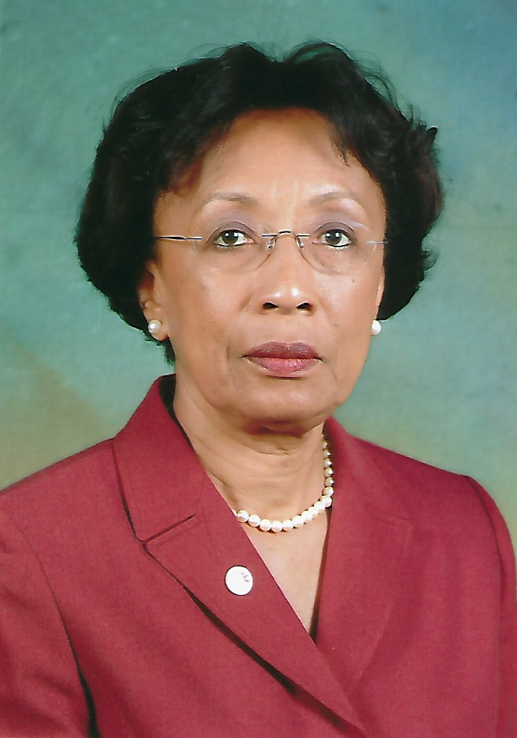
MARIA BYRON PMJF
District Governor - 2007-2008
Past District Governor Dr. Maria Byron joined the Association as a Lioness in 1980. She became a Lion in 1995 at her current Home Club, Arima, Santa Rosa. At her club Lion PDG Maria served as Club President, Secretary, Treasurer and several other Board Positions. She was instrumental in initiating many advancements in her club including strategic planning, club succession planning, drafting and publication of club constitution, innovative service projects, one of which was featured in the digital and print versions of Lion Magazine May 2018.
At the District Level she was the Zone Chair in 1999, Region Chair in 2000 and the Leadership Chair from 2001 – 2006. She has also co- facilitated Regional Leadership Institutes.
Given her passion for learning, education and training Lion Maria successfully completed several Lions Club International Leadership Programmes including the Senior Leadership Institute, Faculty Development Institute and Lions Certified Lions Instructor Programme (LCIP).
PDG Dr. Byron served as Faculty at international training events, the Advanced Lions Leadership Institute (ALLI) in Winnipeg 2018 and the Faculty Development Institute (FDI) in Reno 2019.
PDG Maria is an Educator by profession. She served as Senior Lecturer School of Education, University of the West Indies (UWI), Deputy Dean Programming, Faculty of Arts and Humanities, UWI. She was also a Consultant Coordinator, Continuing Professional Development Unit, School of Education, UWI and Chair of the National Curriculum Council of Trinidad and Tobago, as well as an External Evaluator of the Accreditation Council of Trinidad and Tobago.
Lion Dr. Maria Byron has a PHD Mathematics Education, Ohio State University 1995, as well as
M.A. UWI; BA UWI and Diploma in Education from UWI.
In the realm of community service, in addition to the Lions Association, Lion Maria currently serves as a Member of the Cluny School Board of Management, Chair, Malabar Roman Catholic Parish Pastoral Council and as Director, Catholic Religious Education Development Institute (CREDI).

