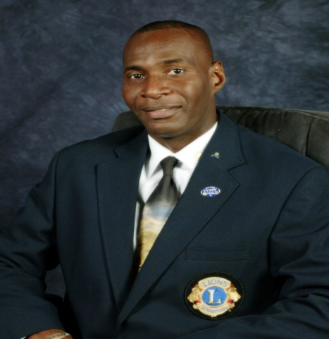

Name: Marvin O. Grant MJF
District Governor: 2015-2016

Past District Governor Marvin joined the Association in July 2002. His home Club is the Lions Club of Tortola, British Virgin Islands. He was club President in 2005/2005 and 2005/2006. He received numerous awards for his contribution to his club including Lion of the year on three occasions.

At the District level, Lion Marvin served as Zone Chair in 2009-2010, Region Chair in 2010-2011, in addition to serving as HIV/Aids Chair in 2011-2012 and LCIF Associate District Chair in 2012-2013. He was responsible for the coordination of the First Cabinet Meeting for District 60B in 2011-2012. Lion Marvin has received many awards for his contribution from District Governors and Council Chairs and some International Presidents Certificates, and also successfully completed the Multiple District 60 2012-2013 Leadership Institute.

PDG Marvin is a Medical Technologist and has an Associate Degree in Medical Technology with a distinction in Microbiology. He undertook his training at the University of Guyana, where he obtained a Diploma in Medical Technology (Hematology).

His partner in service in Michelle Jackson-Grant and his hobbies are dancing, listening to music; Karaoke; sports; travelling; photography.

