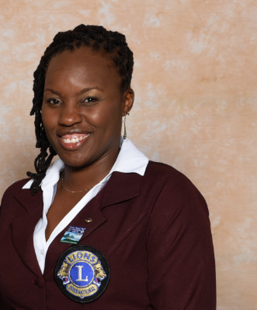

Nadine Bushell PMJF
Council Chairperson – 2017 -2018
District Governor 60A – 2016-2017

Lion Nadine Bushell, member of the Santa Cruz Lions Club, Second Century Ambassador, started her involvement with the Lions Movement as the Charter President of the Upper Belmont Leo Club in 1996. She became a Lion in 2001, when she joined, the Port of Spain, Upper Belmont Lions Club. Lion Nadine has held several Board Positions including Club President in 2004/2005.

At the District and Multiple District levels Lion Nadine has served as Leo Associate, Zone Chair, Region Chair, Cabinet and Council Secretary/Treasurer. She is a graduate of the MD60 Regional Leadership Institute as well as the Advanced Lions Leadership Institute.
She is also the recipient of three (3) Lions International President Appreciation awards.

At the District Level as District Governor she gave the Leos a forum to contribute substantively to the meeting and to also showcase the work of young persons who participated in the International Association’s Peace Poster contest through a calendar showcasing their artistic pieces.

At the Multiple District level Lion Nadine as Council Chair introduced a service project as part of the District Meeting programme which would involve all the members of the Multiple District and serve as an opportunity for Lion Members to contribute meaningfully to the host country. She also worked with the leadership team to update the Multiple District’s policy documents and commence work on the Multiple District Strategic Plan in line with the International LCI Forward.

Lion Nadine also in her leadership positions focused heavily on utilizing modern technology and social media to improve the efficiency of doing business and bringing the District and Multiple District closer to all Lions and the general public.

PCC Nadine is currently the President of the Lions District 60A Foundation.

Lion Nadine has a MSC in Development, Project Planning, and BSc in Sociology and Management and has worked in the field of development, project planning and management and resource mobilisation in the Public Service in Trinidad and Tobago, international and regional agencies. She was also a Trinidad and Tobago National Scholarship recipient.

Outside of Lionism as she has served as the secretary for the Catholic Commission for Social Justice, and through this organization has written a weekly column for the Catholic Newspaper and moderates a monthly “Ask Why” Catholic television programme. She is also currently a Member of the Procurement Board of Trinidad and Tobago, representing civil society through the Lions Association.

