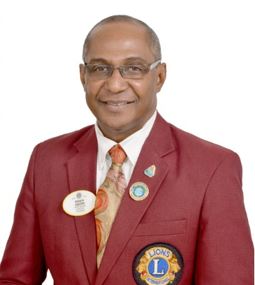
RUDOLPH E. AUGUSTIN
PAST DISTRICT GOVERNOR DISTRICT 60A FY 2018 - 2019
COUNCIL CHAIRPERSON DISTRICT 60 FY 2019 - 2020

Lion Rudolph Augustin from Suriname, was elected to serve as District Governor of District 60A Fiscal Year 2018 – 2019 at the Multiple Convention held in Antigua & Barbuda, on May 10, 2018
At the Multiple Convention held in the republic of Guyana, on may 8 – 12 Lion Rudolph was elected as Council Chairperson 2019 – 2020 of Multiple District 60.

Lion Rudolph has been a member of the Paramaribo North Lions Club since June 2001 and has held a number of positions within his Club, of which the highest as President.
In the Fiscal Year 2008-2009, he held the position of Zone Chairperson 1B and in the FY 2011-2012 the position of Region Chairperson.
In recent years he held various cabinet and multi-cabinet Chairperson positions.
Lion Rudolph received his Bachelor's and master degree from Lions University at the USA-Canada forum

In recognition for his service, he received two District Governor Awards, a Centennial Excellence Award, Lion of the Year Club Award, Board member of the year award and he also received several times the 100% Attendance Award, since he has joined the Association.
Lion Rudolph is also a Melvin Jones Fellow.

In addition to Lionism, he was and is still socially active in various positions;
- Vice President of the Foundation "de Mantel" a day care for senior citizens
- President of the Lions Food Aid Foundation in Suriname
- He was also a board member of the Caribbean Volleyball Federation
- Past President of the National Board of the Junior Chamber International (JCI) in Suriname. From this organization he received the highest award, namely Senator.

Lion Rudolph is a Consultant in Human Resource Management and holds a Bachelor’s degree in Economics and a Master Degree in Human Resource Management with specialization in Strategic Human Resource Management.
He is married to Sandra and has two children, Shivaïd and laïsha

