Professional Picture:

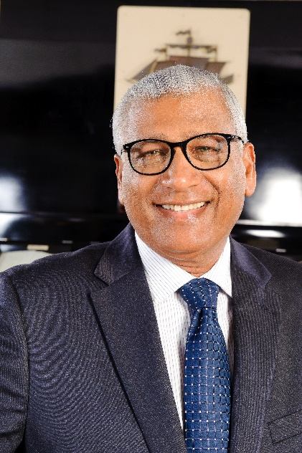

Shabir Hussein, A.A. PMJF
Council Chairperson – 2003 - 2004
District Governor – 2002 - 2003

Past Council Chair Shabir Hussein joined the Association in 1982 and is a member of the Lions Club of West Demerara.

Lion Shabir is an Engineer by profession and is currently the Engineering Director, Banks DIH Limited, Guyana. He has extensive training based on his professional affiliations including Fellow of the Institute of Road Transport Engineers (FIRTE) and Fellow of the Society of Operations Engineers (FSOE). He has a Diploma in Business Administration from the University of Western Ontario, Canada and a Diploma in Environmental Management and sustainable development from the Swedish Environmental School in Karlstad and Stockholm, Sweden

- Agricultural Engineering from City and Guilds of London Institute
- Automotive Engineering Parts I, II and III from City and Guilds of London Institute
- Engineering and Management training at Bookers Sugar Estates and Guysuco
- Diesel Engineering Diploma from Cummins Diesel School in Tampa Florida
- Civil Engineering through Banks DIH Limited
- Diesel Engineering through Hyundai in South Korea

Lion Shabir prides himself in having Perfect attendance for 36 years. He has received the Lion of the Year on several occasions. His key accomplishments include delivering leadership talks to new and existing members of the Association and organizing the following Clubs:
  - Lions Club of Essequibo Coast
  - Lions Club of Bartica
  - Lions Club of Diamond/Grove
He was also involved in the rebuilding of the Lions Club of East Canje, Georgetown and Corriverton.

Lion Shabir is also the Honorary Consul for Sweden in Guyana, the President of the Muslim Youth League of Guyana (MYL) and received the National Award – Golden Arrow of Achievement (A.A.)

