PAST COUNCIL CHAIRPERSON SHERWIN D. GREENIDGE
COUNCIL CHAIRPERSON, MULTIPLE DISTRICT 60 (2018-2019)
District Governor 60B 2017-2018 PMJF

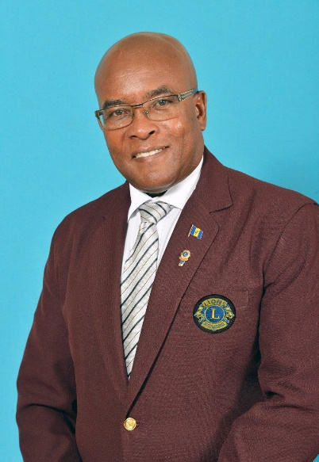
Past Council Chairperson (Progressive Melvin Jones Fellow) served as District Governor, District 60B (2017-2018).
A member of the Lions Club of Barbados East since March 1991, he has served in the positions of Leo Advisor, Club Membership Director, Tail-twister, Treasurer, Secretary, Vice President and President in 2002-2003.

Lion Sherwin was appointed Zone Chairperson, Zone 3A (2004-2005); Region Chairperson, Region 3 (2006-2007); District Chairperson, Sight and Diabetes (2007-2008); District Chairperson, LCIF (2008-2009); Convention Secretary (MD60 Convention 2011); Cabinet Secretary/ Treasurer (2011-2012); Council Secretary/ Treasurer (2012-2013); Multiple District, Budget & Finance Chairperson (2015-2016).
He was elected to serve 2nd Vice District Governor (2015-2016); 1st Vice District Governor (2016-2017) and District Governor (2017-2018).

At the Zone level, Lion Sherwin successfully introduced the concept of the Zone Health Fair held annually on World Heath Day, April 7 in Barbados.
At the Multiple District Level, while serving as Council Chairperson, Lion Sherwin initiated the Multiple District Diabetes Project which resulted with seven Standard MultiCare HBA1C Analyser testing machines being donated to the Diabetic Association of Trinidad & Tobago and the subsequent training of over 100 Lions and members of the association in prediabetes screening.

In recognition of his service to the association, Lion Sherwin has received numerous awards, including Lion of the Year, President of the Year, Zone Chairman of the Year, Lions Clubs International Membership Builder Award and four International President’s Certificate of Appreciation. He was awarded a Melvin Jones Fellowship by his club in 2016 and a Progressive Melvin Jones Fellowship by his District in 2018.

Professionally, Lion Sherwin is a Customer Service Consultant and Trainer and continues to be active in numerous professional and community organisations, including the International Customer Service Association, the Credit Union, Toastmasters, and the Anglican Church.

Lion Sherwin is driven by the mantra: “People won't remember what you said or did, they will remember how you made them feel”.

