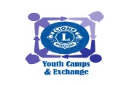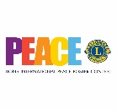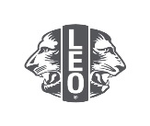
Youth Outreach Committee
To 5M13 Lions Clubs
The 2023 – 2024 Peace Poster pre-order went very well so we are going to be doing it again for the 2024-2025 year. The new kits will be available in February 2024.
The 5M13 Youth Outreach committee would like to encourage more clubs to participate in this very easy project that would give Clubs the opportunity to connect with youth in their communities.
We know that shipping from LCI can be expensive; and we know that many schools do not have the appropriate size of paper required for this competition. This is why the 5M13 Youth Outreach committee has decided to step in and help:
We will be pre-ordering Peace Poster kits and we have been able to source out the appropriate size paper for you. By pre-ordering these kits, we will only pay one shipping fee which is more cost efficient for our Clubs. By sourcing out the paper for our Clubs, we can ensure that schools will be able to participate without incurring addition costs!
In this next year, we want to encourage Clubs to promote the Peace Poster competition in April – June 2024. Here are some reasons why: Firstly; Educators are always so busy getting things ready and classes up and running in September that they feel that this is just “one more thing” they have to do! Secondly, many schools participate in the Royal Canadian Legion poster contest in October and this is causing educators to choose. Thirdly, many Clubs in our District do not meet until October as they are still farming! Therefore, if we promote the Peace Poster from April – June, we hope to ease this added stress! The winning poster can then be sent in to the 5M13 Youth Outreach as soon as possible.
Lion Lorna
5M13 Youth Outreach
lornahislop@gmail.com
204-210-2111

