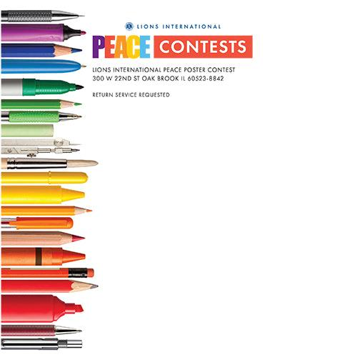3

**Order Your Peace Poster Contest Kit for 2024 – 2025**

**Contact Lion Lorna Hislop**

**204-210-2111 or lornahislop@gmail.com**

To sponsor the Peace Poster Contest, Lions clubs can pre-order a contest kit along with the appropriate size paper from **District 5M13**. The Youth Outreach Committee will order the kits from Lions Club International.

**A kit is needed for each contest sponsored.**

**Peace Poster kits - $20.00 each**

**Peace Poster kits with 50 sheets of appropriate size paper - $30.00 Additional sheets of paper is $0.20/each**

Make cheques payable to:

Lions District 5M13 and sent to Lion Lorna at:

PO Box 111, Minnedosa, MB R0J 1E0.

**ORDER DEADLINE IS February 15, 2024.**

##### **Each kit contains:**

* Official Club Contest Guide and Rules
* Official School or Youth Group Contest Guide and Rules
* Participant Flyer to duplicate and give to participating students to take home
* Sticker to place on back of winning poster
* Certificates for contest winner and school or youth group

