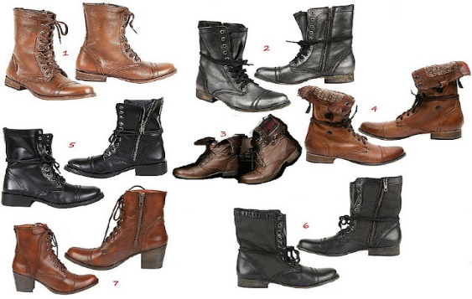

Boot Camp!

Training for Leaders

September 15, 2018

10:00 a.m. – 2:00 p.m.

Multi-district Office

7200 Lake Ellenor Drive

Suite 109

Orlando, Florida 32809

To reserve your position, please call (352-596-8485) or email vivianhenegar64yahoo.com

Rations Provided