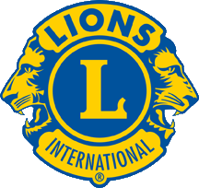

Calling all 2018-2019
Lions Club Officers!!
First Officer Training Session will be held
in Orlando on Monday, April 30, 6:00 PM
615 Herndon Ave., Suite F
(Federacion Internacional de Domino)
Orlando, FL 32803

Second Officer Training Session will be on the West Coast
on Wednesday, May 9 at 6:00 PM at
Mama’s Kuntry Kafe
1787 W. Main
Inverness, FL 34450

Final Officer Training Session will be on the East Coast on
Saturday, June 9 at 10:00 at the
Ponce Inlet Community Center
4670 S. Peninsula Dr.
Ponce Inlet, FL 32118

These training sessions will help you assume your officer positions with confidence in our new Lions Year. The sessions fill up fast - RSVP to Lion Vivian Henegar at vivianhenegar64@yahoo.com or call 352-596-8485 See You At Training!
See You At Training!

