  OSCEOLA LATIN AMERICAN LIONS CLUB  9TH ANNIVERSARY PARTY  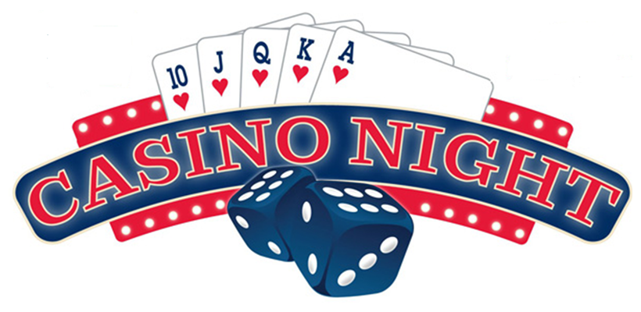  OSCEOLA STEAK & GRILL  E. Osceola Pkwy Kissimmee, FL 34743 | APRIL 21, 2018  7:30 PM  Donation: $15 p/p  Dinner Included  Dress: S – Formal  Raffle  Live Music  para informacion  Tel: 407-701-8568  WE SEVE

