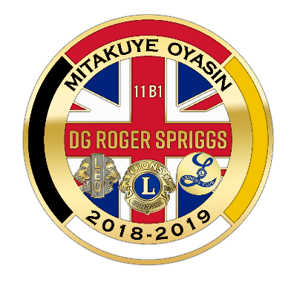
District 11-B1
2019 Convention
April 12-14, 2019
DG Roger Spriggs

December 2018

Dear Club President/Club Secretary of Lions, Lioness, and Leos:

SUBJECT: DISTRICT CONVENTION RAFFLE ITEMS

Over the last several years, the District Convention Committee has requested that clubs help support the convention by either sending $30 for the committee to purchase a raffle item or bringing a raffle item to the convention. Your past contributions have been super and greatly appreciated. We could not have done it without your club’s and individual member's support!

This year, District 11-B1 is again asking that your club help support the District Convention by sending a $30 donation that can be used toward door prizes. We had such a great response last year from most of the clubs!

We are asking clubs to act now and submit their $30 donation for the purchase of these items. The convention committee finds that if they shop for the items around in December, they can find many great deals and can purchase items at lower prices.

We are glad for all those individual Lions who bring an item to the convention to be used as a door prize and urge them to continue to do so. Those items are welcomed and very much appreciated!

We encourage you to support this activity as well as attending the Convention which will be held at Michindoh Conference Center in Hillsdale this coming spring. We do hope that ALL clubs will help the committee with a $30 donation this year and are able to respond as soon as possible so that we can purchase items before the end of December. Your checks should be made payable to:

District 11-B1 and sent to District Treasurer Barry Allen, 19230 Sharon Valley Road, Manchester, MI 48158.

Thank you for your club’s support! We look forward to joining you for a fun-filled weekend on April 12-14, 2019.

Sincerely,

Lion Peg Griggs
District 11-B1 Convention Chairperson

