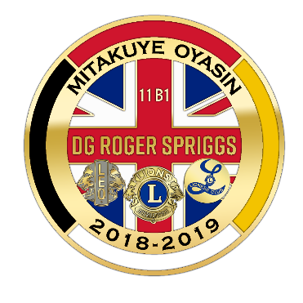
District 11 B-1
2019 Convention
April 12-14, 2019
DG Roger Spriggs

Where: Michindoh Conference Center, 4545 East Bacon Road, Hillsdale, MI 49242

Rooms: All room reservations and payments are to be made through the District on the appropriate registration form and submitted to Lion Harriet Spriggs. Reservations are NOT made with Michindoh Conference Center.

Meals: All meals, including Saturday’s Melvin Jones Breakfast, are open to Lions, Lionesses, Leos and guests. Registration and payment for meals are to be made through the District on the appropriate registration form and submitted to Lion Harriet Spriggs. Prepaid meal registration is required. No meal tickets will be sold at the Convention.

All meals will be buffet style including Saturday night’s banquet.

Below is the tentative schedule of events. Official schedule will be included in your packets
that you will receive when you register at the Convention.

Friday: 3:30 Registration begins
5:45 Dinner
7:00 Memorial Service
7:30 Social time and activities including entertainment, hayride,
50/50’s, and prizes

Saturday: 7:45 Melvin Jones Breakfast
9:00 Opening Ceremony
10:30 LEO’s begin their Saturday activities
10:30 Break-out sessions
11:55 Awards Luncheon and Live Auction
1:30 Break-out sessions
2:30 Business Meeting
3:30-4:00 Election
5:00 Formal Banquet

Sunday: 8:30 Breakfast
Cabinet meeting to follow

