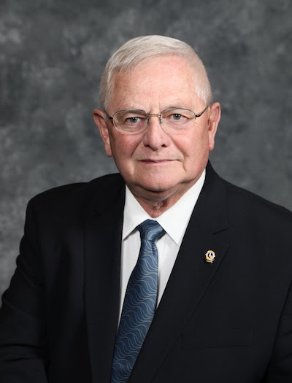

**Lions District 26-M3 Convention**

**Friday, March 26 & Saturday March 27, 2021**

**Boonville, Missouri**

Convention Speaker **International Director Steve Thornton** of Wooster, Ohio, was elected to serve at the 2018 convention in Las Vegas.

He is retired from 35 years in law enforcement, including

Chief of Police for the city of Wooster.

A Lion since 1980, he has been active in every level of

Lions leadership and is a Progressive Melvin Jones Fellow.

His wife, Rebecca Lynn Thornton, is also a Melvin Jones

Fellow. Please join us to give them a warm Lions welcome!

**Registration Form**

**Meeting, luncheon, and banquet facility: Isle of Capri, Boonville, MO.**

**Lodging**: A block of rooms at the **Isle of Capri**, 100 Isle of Capri, Boonville, is set aside for our convention. Our Lions rate of $106.00 for Friday and room block will be held until February 26, 2021. Make reservations directly with Isle of Capri 800-843-4753. Ask for “Lions Block.” Rooms requested after February 26 will be on a space available basis at the prevailing rate.

**Friday Afternoon**- Tour of Warm Springs 25270 Rt 98, Boonville Walking tour to see the Clydesdales. $20.00-time TBA

**Friday Night Hospitality:** The Isle of Capri on their patio for a western theme party, round up your hats ‘n boots ‘n jeans. There may be a jail for those desperados. There are fire pits for smores and more, clubs/members can bring food and drinks.

Our **Silent Auction** will be Saturday and once again will feature items donated by Lions. Clubs are encouraged to bring items to help make the silent auction a success! The silent auction along with raffle tickets helps us keep our cost of our convention affordable. Contact IPDG Susan Paden for silent auction items.

**General Convention Information:** Face Masks and social distancing

* When registering as a club please fill in the name of the club below and attach a list of all attendees.
* You must be registered for the convention to be eligible to vote.
* First time attendee? Lunch is on us! Mark your registration “First-Timer” to receive the discount. *(Lions only, please!)*
* Questions? Contact IPDG Susan Paden 573-473-8241 or PDG Sandy McCann 573-823-7345.

**Name(s) of Lion(s)** __________________________________**Club**___________________________________________

**Phone** ______________________________**Address**______________________________________________________

**City, State Zip**________________________________________**Email**________________________________________

Registration Only (**Must be registered to vote)** _____ @ $10.00 __________

Full Registration (Luncheon, Banquet, registration) _____ @ $48.00 __________

Registration & Luncheon Only _____ @ $18.00 __________

Registration & Banquet Only _____ @ $30.00 __________

Warm Springs walking tour Only _____ @ $20.00 __________

Make checks payable to “**District 26-M3 Convention 2021.**” **Total:** __________

*Mail payment and form to:* ***Lion Dexter Enders, 815 Monroe Street, St. Charles, MO 63301****.*

**Please indicate if needed**: Large Print________, Braille Materials________, Special diet menu______________________