From the Desk of
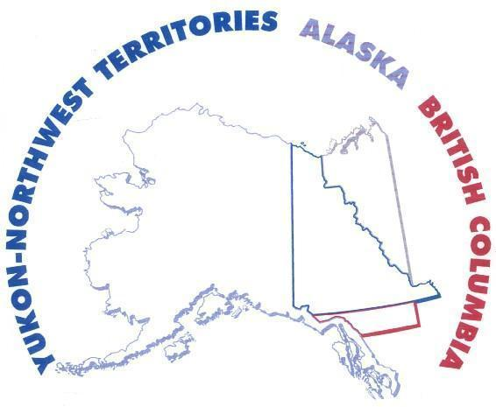
District 49B Governor
Lions Clubs International
PO Box 73495
Fairbanks, Alaska 99701 (USA)
WARNING NOTICE

___________ Lions Club

Dear ___________ Club Officers & Members Date

With deep regret the District 49B Lions brings you notice that your Lions Club has been deemed
Not-In-Good-Standing, as of: ________________, 2015.

Pursuant to the Constitution, Bylaws and Policy Manual every club must sustain an active association with Lions Clubs International and its assigned district. Each club must conform to the following:

- Abide by the Constitution, Bylaws and Policy Manual
- Actively support the Lions Objects (Purpose)
- Conform to the Lions Code of Ethics
- Report membership and activities
- Make timely payment of all financial obligations
- Be active within your assigned Zone, Region, District, Multiple District & Lions Clubs International

Your Lions Club has been found deficient in items: __, ___, __, __ & __ from above. Unless immediate action is taken to remedy your status in these areas, your club will be placed on Suspension, effective (60 days from the date of this notice): MMM DD, 2015.

Suspension is the temporary deferment of the charter, rights, privileges and obligations of a Lions club. Clubs on Suspension shall: (a) Hold meetings to discuss the future of the club and identify the steps needed to regain an active status; and (b) Make payments to clear the existing outstanding balance, or request a payment plan.

Clubs on suspension shall not:
- Conduct service activities;
- Conduct fund raising activities (including gaming permit activities);
- Participate in district and multiple district functions or seminars;
- Participate in any voting procedures outside of the club
- Endorse or nominate a candidate for district, multiple district and international office;
- Submit Monthly Membership Report and report forms;
- Sponsor a Lions club, or organize a Leo or a Lioness club.

Furthermore, on behalf of all the Lions Clubs who enjoy the benefits of a gaming permit, District 49B is obligated to report any Lions Clubs who are no longer in good standing with the parent association, which will place any permit in suspension status as well.

We urge your officers to take action and remedy any deficiency before the suspension date above.

Sincerely,

XXX Y. ZZZZ
District 49B Governor

