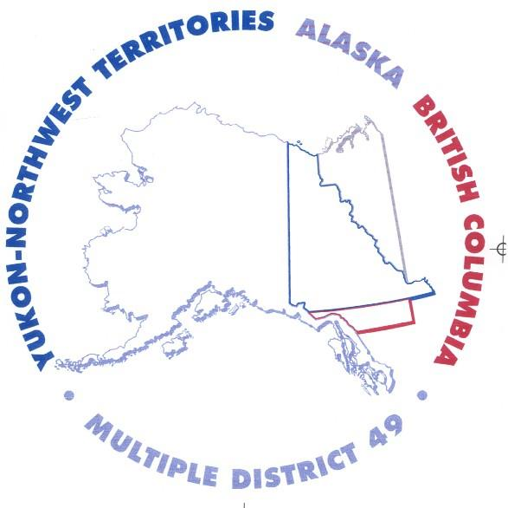
CLUB OFFICER BINDER

TABLE OF CONTENTS

- Organizational Chart & Officer Contact Information
- Constitution & Bylaws
- General Membership Regular Meeting Administration
a. Schedule
b. Meeting Agendas
c. Meeting Minutes
- Board of Director Meeting Administration
a. Schedule
b. Meeting Agendas
c. Meeting Minutes
- Finance
a. Finance Committee Members
b. Current 12-Month Budget
c. Monthly Financial Reports (Income & Expenses; & Balance Sheet)
d. Copy of Annual Tax Report (IRS Form 990/EZ)
e. Annual Audit Committee Report
- Membership
a. Invitation Process
b. Membership Application
c. Dues Structure
d. Membership Roster
e. Membership Induction Ceremony

- Projects
a. Project A
(1) Committee
(2) Committee Reports
b. Project B
(1) Committee
(2) Committee Reports
- Election of Officers
a. Slate of Officer Positions
b. Nomination Committee & Schedule
c. Sample Ballot
d. Election Results
e. Installation of Officer Ceremony
- District Meeting Agendas & Minutes
- Convention Information
a. Multiple District & District
b. International
c. USA/Canada Leadership Forum

