DISTRICT 25-B

Volume 1, Issue 1 December 2015
Monroe $200, Woodburn $300, Hamilton $100, Decatur $200, Stroh $300, South Milford $250, Fort Wayne Coliseum $200, Shoaff Park $500, Ligonier $150, Bluffton $250, Zanesville $100, Heritage $200, New Haven $500, Roanoke $150 and Cromwell-Kimmell $500.
The following Lion’s have also donated to this project: DG Randy Greer, District A $50.00, DG Ken Krauter, District B $50.00, DG Betty Weist, District D $50.00,
DG John Brown, District F $50.00 and Zone D sent $22.00 and Zone E&F $41.00.

With the help of all of the clubs and the State DG’s we can accomplish much!
Thank you very much fellow Lions for all that you do.
And there’s more!
Several things have come up this month. I attended the Council meeting in Shipshewana and we had PDG Bob Block talk to us about the Centennial Celebration planned for the International Convention in Illinois in 2017. It was very informative as he talked about some of the plans which were being discussed and the parade routes in Chicago. He also had forms to order Commemorative pins from the Host Committee (Contact information) PDG Bob Block, 615 – 205th Place, Dyer, Indiana 46311 (219) 671-0287.
Training for new club building and retention programs were also discussed. LCI covered the cost to bring in PDG Ronnie Martin to address a group of interested Lions from across the state. We were able to gather ideas to help us build new clubs and strengthen existing clubs. All clubs need new members and here are a few new ideas. First it helps if you take credit cards for dues payments (this can happen if you incorporate the use of The Square – which is a card reader which can be plugged into a smart phone). Also if two or three clubs get together and set up a table at a college student center and recruit new members; remembering college students are exempt from the initiation dues and need permission slips from the college. If you need help contact me or PDG Kaylene Souers (your Global Membership Coordinator).

From the Desk of Governor Ken Krauter

As of this date, the following has taken place. First, I had to inform the District that a grant was made possible from the Lions Club International Fund and that through, LCIF, we were responsible for $12,500.00 as part of a 50% matching grant. I used the local Lion’s Newsletter as well as the Hoosier Lion’s Newspaper to spread the word about this project. As I visited clubs in the district, I requested their help to fill our need for donations to support this project. To date, we have received over 100% of the funds needed for our matching portion. Also, the USABA organization has obtained their share, which is $37,500.00, and has come from a private donor.
Turnstone; the group where the housing will be built has obtained the land needed for the housing and this land has passed the EPA testing. We are well underway towards the construction phase of this project.
The following Lion’s Clubs’ have made donations toward this project: Huntertown $2500, Land of Lakes $2500, Auburn $1000., Auburn Classic $1000, Fort Wayne Central 1250, Clear Lake $500, Cedar Creek $200, Fort Wayne Chapel Ridge $1000, Bippus $100,
Membership and Activity Reporting
Reported by VDG Al Arnold
Membership and Activity reporting is being stressed by Lions Clubs International. It is very important that you file these reports on time.
Membership reports are due at midnight on the last day of the month. As of this writing, 42 of 57 clubs are current. There are 15 clubs that are two or more months behind. If you are not current, please get caught up. Reporting is very convenient if done online. Also, if you have issues or need assistance, ODG Kathy Morton can help. She is our District Administrator and can be contacted at 260-344-1339 or kmorton65@hotmail.com.
Service Activity Reports (SAR) are also running behind. These need not be filed monthly but it is recommended that they do. As of this writing, only 23 of 57 clubs have filed an SAR this year. The world-wide rate for all Lions clubs is 47%. We need to improve this reporting. All service projects and fund raisers are activities. You can also submit club meetings as activities. If someone in your club donates blood, volunteers at a food bank, or any other volunteer service, these can be submitted as a service activity. When a Lion serves others whether it is a regular club project or just individually, it can be recorded on the SAR.
So please, if your club is behind on these projects, submit them as soon as possible. Make it a club New Year’s resolution.
Introduction of Nominee Roger Cash
Running for 2nd Vice District Governor
Lion Roger Cash has been a Lion for over 12 years. He obtained an Associate’s Degree in Business, a B.A. in Geology with post graduate work in Public Administration and Education. Roger recently moved back to Indiana from Texas and joined the Ossian Lions. He has served as club president, club secretary, club treasurer and membership chair.
He also has served 5 years on the Board of Directors of the West Texas Lions Eye Bank, 2 of which as President. At the district level Roger was Zone Chair as well as 2VDG for MD2T-3 in Texas. He has a Masters in Leadership from Lions International.

Heritage Lions Club News
The Heritage Lions have added four new members plus one to be installed later. The new members are: Dan Harkless, John and Betty Ogren, and Cindy Wolf.
The club will hold its annual couples night Christmas Party on December 8, 2015

Upcoming Events for 2016
January 12th
Regular Meeting, Heritage Lions Club
January 26th
Regular/Board Meeting, Heritage Lions Club
January 30th
Cabinet Meeting at The History Center, 302 Berry St. Fort Wayne.

LEADER DOGS TRIP

Southport Lions Club will be leaving from Indianapolis on April 7, 2016 and returning on April 8, 2016. The trip will include round trip transportation, Quality Inn room in Troy Michigan, Greek town Casino trip, Breakfast at the Inn, Lunch at Leader Dog, and free snacks and drinks on bus plus door prizes. Cost is $175.00, contact Bob Roe @ 317-797-3294 or Alescia Johnson @ 317-250-3556.

Inside This Issue
2 | 1st VDG Al Arnold
2 | Introduction of Roger Cash
2 | Upcoming Events
3 | Membership Minute – by PDG Kaylene Souers

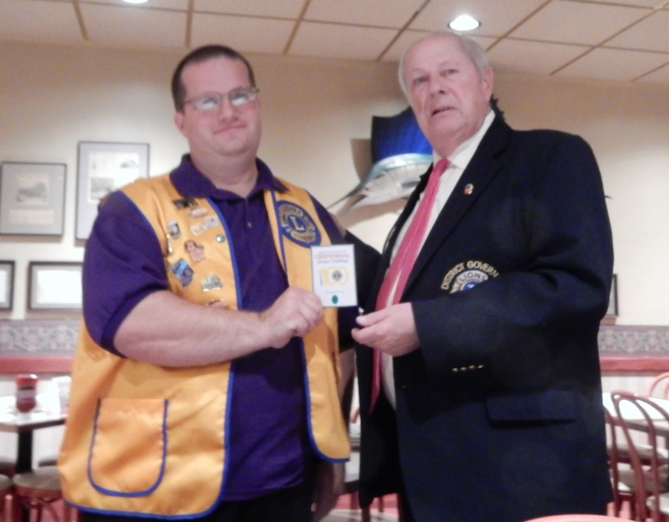

- That October, twenty-three clubs from nine states held an organizational convention in Dallas, Texas. States participating were Illinois, Texas, Oklahoma, California, Minnesota, Colorado, Arkansas, Louisiana and Iowa. No club from Indiana sent a delegation, so W.P. Woods attended on his own.

- During the convention, the delegates took the name of Lions and selected colors to symbolize the ideas on which the club would be based. They listed the Goals and Objectives to which we all aspire. They framed the Code of Ethics we all revere. They started work on the Constitution. And, W.P. Woods of Evansville, Indiana, the one man with delegation, was chosen as the first President with Melvin Jones of Chicago as Secretary.

The Association of Lions Clubs was definitely on its way.

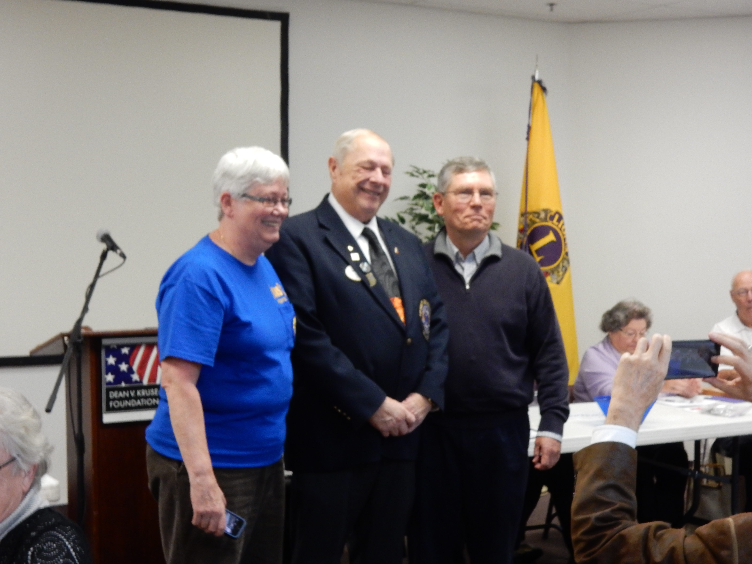
MEMBERSHIP MINUTE
Reported by PDG Kaylene Souers

In 1917, across the country, businessmen were finding something missing in their business clubs. Many concluded that what was missing was purpose.

Let’s take a quick look at what was going on in their world in 1917.

- The U.S. population was 100 million – with 14 million of them foreign born.
- There were 4.8 million motor vehicles in the U.S.—with less than a million in the rest of the world.
- The cost of cars ranged from $325 for a Ford Runabout—to $1250 for a Willys.
- Women got the vote.
- IPFW was established. Fr 25 cents one could attend “a Sparkling Bubble of a musical comedy” titled “Little Miss Innocence.”
- There was no Indianapolis 500 because of the threat of war.
- Woodrow Wilson had just been re-elected because he had kept the U.S. out of the European war. However, the Germans sank American ships.
- Congress declared war, and one million conscripted U.S. soldiers were sent to Europe.
- The Federal Reserve doubled the money supply to finance WWI.
- Soon President Wilson presented the 14-Point Plan, which was accepted in 1918.
Later, President Wilson won the Nobel Peace Prize, but, his idea for the League of Nations was rejected by the U.S. Congress in 1920.
- In Chicago in June 1917, a young insurance agent thought his business club lacked purpose. Others around the country were thinking the same about their business clubs. So, Melvin Jones set out to lead several clubs from various areas to join together into one strong, influential club with added Purpose – to help the community in which they lived AND to serve mankind.

Rome City & Brimfield joining together as one.

The Mission of LCIF

Reported by PDG Gary Ochs

Indiana LCIF Multiple District Coordinator

Every day, Lions Clubs International Foundation (LCIF) works to fulfill our mission: "To support the efforts of Lions clubs and partners in serving communities locally and globally, giving hope and impacting lives through humanitarian service projects and grants."

Since our founding in 1968 we have strived to sustain Lions’ humanitarian service goals throughout the world, awarding over 12,000 grants totaling more than US$900 million, in the four key areas of sight, youth, disaster relief and other humanitarian efforts.

We give sight.
LCIF is providing vision for those in need all over the world by combating eye diseases, creating infrastructure to improve eye care delivery, increasing the number of trained eye care professionals and making vision care more equitable and sustainable.

We support youth.
All young people deserve to have an education, feel cared for and experience healthy development so they can have the chance to achieve their dreams. Through our positive youth development program, Lions Quest, LCIF is helping children learn to work together, make positive decisions and serve their communities. The Foundation also supports youth through constructing schools, youth centers and vocational training centers.

We provide disaster relief.
Lions are often some of the first to arrive at a disaster to provide relief, and Foundation support is right there with them. We help devastated communities survive after disasters and bring hope by assisting in long-term efforts of rebuilding of homes and lives.

We address humanitarian needs.
From working to combat global health issues such as measles and diabetes to empowering those with disabilities to lead more independent and fulfilling lives, LCIF is dedicated to a range of humanitarian service projects. The Foundation continues to develop and expand programs that meet emerging needs worldwide.
Make sure you and your Lions Club supports your foundation LCIF.
Please contact either LCIF Coordinator PID David Fiandt 260-484-4975 or PCC/PDG Robert Morton 260-344-1339 for a club presentation.

December Membership Key

Reported by PDG Kaylene Souers
25B Global Membership Team coordinator

Does your club have a membership goal? I trust that each of you can answer with a resounding YES! Since July 1, 23 clubs have added 43 new members. That’s a great start to this year.

The Christmas season keeps our members busy with fundraisers and service projects. This is the perfect time to invite a friend to join you. What better way to show how we serve than when we deliver gifts and food to a family in need, or sharing laughter ringing bells, selling fruit and Christmas trees.

It is easy to feel like we have tried every membership tool available. Here is one idea for membership --- Lion Paul Row has implemented something for the Monroeville Lions that I think is great. Do your members and guests wear name badges? Some clubs have badges from LCI they wear at every meeting. Others of us come from the camp that we know everyone in our club and there isn’t any reason for badges.

When I installed the officers for the Monroeville Lions I received a badge from Lion Paul. While I recognized many of the Lions, I am the first to admit that I am terrible at remembering names. It was extremely helpful to walk up to someone and call them by name because they were wearing a name badge.

Lion Paul also shared a membership tip that he learned at the Indiana State Lions Convention. First, we have to meet someone. For most of us, that is pretty easy! Second, we need to like them. Finally, we need to remember. In most cases within 30 minutes we will have forgotten each other’s name. I know for me it happens much quicker than that. Think how easy it would be to create a business card that you could give your new friend that has your name and when and where the Lions Club meets. It can also be used to record contact information from your new friend.

If you would like help creating name badges or a business card, Lion Paul has put together a step by step guide.

Please contact him at: picklepastorpaul@yahoo.com

Let’s strive to meet someone new this month and invite them to serve with you!

New Members from July 1 – Nov. 30, 2015

Albion
Nikki Marker sponsored by Randall Myers
Andrews
Teresa May sponsored by Robert Sunday
Arcola
Joseph Geller sponsored by John Geller
Auburn
Wesley Bohl sponsored by Mike Boger
Auburn Classic
Eldon Byler sponsored by Brian Neal
Karen Metcalf sponsored by Burtie Rynearson
Lisa Palumbo sponsored by Kelly Oswalt
Bluffton
Mollie Forbes sponsored by Jerry Zeigler
Teresa Grund sponsored by Jerry Zeigler
Timothy Grund sponsored by Lowell Tillman
Cedar Creek
Ric Runestad sponsored by Richard Hill
Chapel Ridge
Janet Roehm sponsored by Kaylene Souers
Cromwell Kimmell
Jerry Mangus sponsored by Kenneth Bales
Hamilton
Janet Albright sponsored by Frances Gould
Heritage
Dan Harkless sponsored by Thomas Bullerman
Betty Ogren sponsored by Thomas Bullerman
John Ogren sponsored by Thomas Bullerman
Cindy Wolf sponsored by Tom Wolf
Huntertown
Scott Brown sponsored by Philip Ginder
Brad Hoot sponsored by Barbara Wagner
John Ryan sponsored by Robert Ables
Kendallville
Jeffrey Devers sponsored by Robert Krueckeberg
David Young sponsored by Robert Krueckeberg
Larwill
Jeanne Blain sponsored by Hollie McKinney
Monroe
Jenifer Swanson sponsored by Alan Arnold
Jesse Swanson sponsored by Alan Arnold
Monroeville
Susan Hoffman sponsored by Angela Palmer
Jason McBride sponsored by Colleen Grabner

DISTRICT 25-B OFFICERS

District Governor
Ken Krauter
1458 Breckenridge Pass
Fort Wayne, IN. 46845
Cell: 260-229-2732
Res: 260-637-0950
Email: kennethkrauter@comcast.net

1st Vice District Governor
Alan Arnold
595 East SR 124
Monroe, IN. 46772
Cell: 260-216-1101
Res: 260-692-6610
Email: pamalarn@centurylink.net

2nd Vice District Governor
Vacant

Cabinet Secretary
Cheryl Okuly
8647 W 500 N
Andrews, IN. 46702
Cell: 260-388-3637
Email: okulyc@yahoo.com

Cabinet Treasurer
PDG Richard Hill
17611 DeVall Road
Spencerville, IN. 46788
Cell: 260-413-9441
Res: 260-627-2504
Email: rhill34@frontier.com

GLT Coordinator
PID David Fiant
2007 Lawndale Drive
Fort Wayne, IN. 46805
Res: 260-484-4975
Email: hdfiant@comcast.com

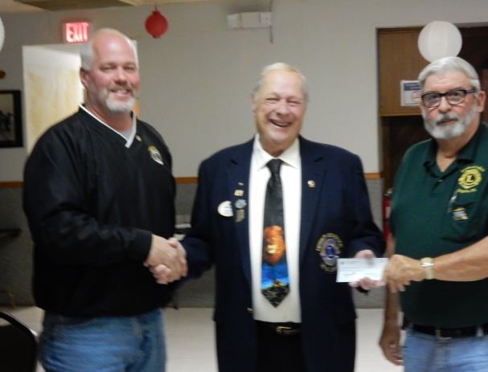

ZONE CHAIRS

Zone A
Vacant

Zone B
Vacant

Zone C
Vacant

Zone D
Kevin McDermit
Cell: 260-625-5878
Email: kvmedermit@comcast.net

Zone E
Janice & Jim Platzer
Res: 260-489-1057
Email: japlatzer@hotmail.com
Zone F
Keith Hanson & Linda Garfield
Cell: 260-356-9604
Keith’s Email: khansonfw@aol.com
Linda’s Email: lindagarson62@aol.com

Zone G
Larry Elliot
Cell: 260-519-2652
Email: larry@elliot-ins.com

Zone H
Rev. Paul Row
Cell: 260-438-4000
Email: picklepastorpaul@yahoo.com

GMT Coordinator
PDG Kaylene Souers
17002 Darling Road
Woodburn, IN. 46797
Cell: 260-438-0797
Email: anchud@aol.com

Notice: Any articles or ideas for our future newsletters please email them to me at kennethkrauter@comcast.net.

Our District is growing and I appreciate all of the hard work you have done and support you have given me. Bite ‘em.

Merry Christmas &
Happy New Year
to one and all!

Sunday | Monday | Tuesday | Wednesday | Thursday | Friday | Saturday
 |  | 1 | 2 | 3 | 4 | 5  Council  Christmas  Party
6 | 7 | 8 | 9 | 10  Union Twp.  Visit | 11 | 12
13 | 14 | 15 | 16 | 17 | 18 | 19
20 | 21 | 22 | 23 | 24 | 25 | 26
27 | 28 | 29 | 30 | 31 | 1 | 2
December 2015

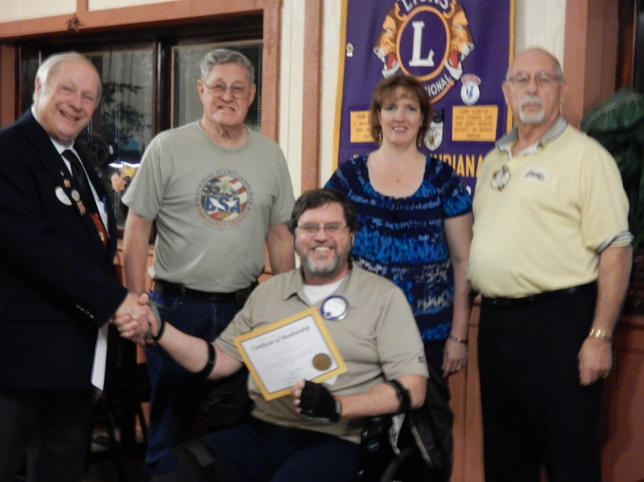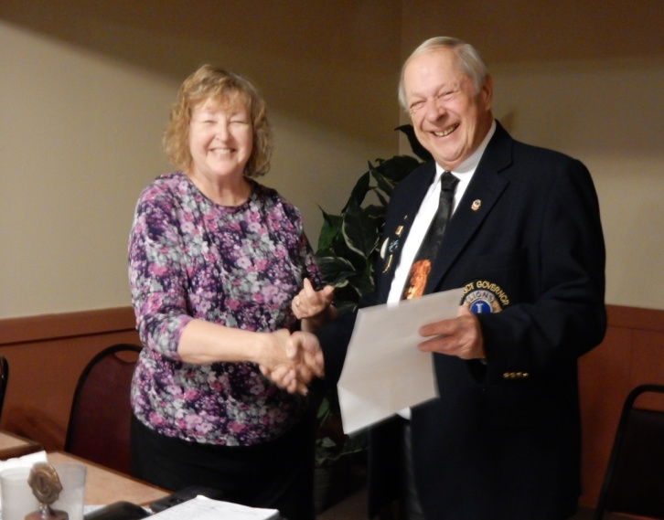
New Members on board!

