W W W . L I O N S 2 5 E . O R G

District 25E Newsletter

DISTRICT GOVERNOR

DG Sheryl Schafer
Lions

of

25
-
E
,
Southwest Indiana Lions

September Events
2 - Labor Day
2 - Picnic and Rod Run - Georgetown
15 - Brian's Trike Race - Indianapolis
19 - 22 - USA/Canada Leadership Forum -
Seattle, WA
27-28 - Chandler Celebration Days
29 - Officer Training - Francisco
29 - Long Range Planning - Francisco

Upcoming Visits
11 - Bedford Noon
17 - Ellettsville
October Events
5 - Fall Flapjack Festival - Bedford
12 - 25-E 2nd Cabinet Meeting - Salem
18-20 - MD-25 PDG Weekend - District A,
Fairview Farms
19 - MD-25 2nd Council Meeting -
Bloomington

On the Horizon
January 10-11, 2020 - Mid-Winter Conference
Indianapolis
March 13-14, 2020 - 25-E Spring Convention
Mitchell
April 24-26, 2020 - State Convention
Bloomington

Send newsletter articles, upcoming events, and photos by September 25 to:

Newsletter Editor Steve Maitlen swmaitlen@gmail.com
812.830.2026
October is Medication Safety Awareness for the Blind Month. What a time to kick off a new service project! There are people in our community who are blind/visually impaired who have problems reading their prescription labels. Because they cannot read their prescription correctly, they take too much, not enough, or the wrong ones. Not reading the prescription labels right causes a lot of deaths to the blind/visually impaired.

Lion Trish and Lindsay Haley are an Advocate Team for En-Vision America. Lion Trish Bissell & Lindsay Haley are located out of Florida. They can tell you all about the cool machines they have to help the blind/visually impaired.

ScripTalk Station is one of those machines. It is a talking prescription station. It works by the pharmacy attaching a small electronic tag on the prescription container. This electronic tag has the same data as the printed label. Then you take it home and place it on ScripTalk Station and it will read the label information out loud for the person to hear. As part of EN-Vision America’s Pharmacy Freedom Program they can supply ScripTalk Stations on loan to patients at no cost.

Galaxy Talking Bar Code Scanner is another machine for audible identification and information assistance for the blind/visually Impaired. It is a handheld scanner that has so many uses. Reading the groceries at the store and once you get them home. You could also use it to organize at home, for inventory, cooking, and many more applications.

Script View is when the prescription labels are printed larger at the pharmacy for the visually impaired. The label can also be translated into 17 different languages. There is no additional cost to you for this service. You can get started planning now: Call Lion Trish or Lindsay Haley
(1-800-890-1180) to order free brochures and a demonstration unit. Let’s see if we can start a new project to help our communities!

Lions Can Do It!

S E P T E M B E R

1ST VICE DISTRICT GOVERNOR
1VDG Kenny Williams

The kids are back in school. Most vacations are over. State and county Fairs are history. Vision screening has started. I'd like to rant a little about participation. We need to get more people participating at all levels of Lions, from the International, State, and District conventions to Cabinet meetings.
District Governor Sheryl Schafer 432 N. Deer Lake Rd.
Bloomfield, IN 47424
Cell: 812.325.7762 sheryl.schafer1@comcast.net
1st Vice District Governor Kenny Williams 4966 N. Chatham Dr.
Bloomington, IN 47404
Cell: 812.320.4258
kenny.williams@edwardjones.com

2nd Vice District Governor Lee Cuba
32 Sherwood Lane
Bedford, IN 47421
Cell: 812.583.2875 nanlee.engineering@gmail.com
Cabinet Secretary PCC Keith Thomas
400 12th Street
Petersburg, IN 47567
Cell: 812.354.4637
kthomas@threeidesign.com

Cabinet Treasurer Richard Kaiser 1510 Red Leaf Dr.
Evansville, IN 47712
Home: 812.204.2518 rjkaiser1510@yahoo.com

Global Membership Chair PDG Jean Bodensteiner Cell: 575.517.7613
lionjeanb@yahoo.com
Global Leadership Chair PCC Keith Thomas
Cell: 812.354.4637
kthomas@threeidesign.com
Global Service Team Chair IPDG Ron Edwards
Home: 812.275.3139 jzwn7h@sbcglobal.net
LCIF Chairperson Sam Hopper
Cell: 812.951.2185
choppershopper@aim.com
I volunteered at the State Fair this year and had a good time with one of the most dedicated Lion volunteers I've met, besides the Tinchers. AJ (Southport Lions) worked the Tunnel 6 gate almost every day of the fair and also took a few shifts at a Lions corn booth. I learned a great deal from her and had a good time getting to know her. I will go back to my club and now the District to encourage more volunteers at next year's State Fair.
Cabinet meeting and conventions: we need to take care of business during these events, so some of it will be dry, but we need to add some fun to make our fellows Lions want to come and join us. I am open for suggestions. They need to be things that appeal to all ages. Therein lies the rub. We won't attract many young people, if we don't do some younger things. And we can't alienate our older members, because right now, they are who we have the most of. I want to appeal to all clubs to send a representative to all District events. Just one person from each club will increase our attendance rate by 25-50%. Hey, if the President can throw out numbers, so can I. I watched Hacksaw Ridge for the umpteenth time the other day. It made me think about membership. "Lord help me get just one more." Ask them. They will join, then get just one more, and repeat.

TANKS FOR SERVING

Cares and Concerns
Our thoughts and prayers are with those Lions and their family members or friends around the world who are sick or in the hospital or at home, and all others whose losses were unknown to us at this time.

Lion Doris Bliss  Lion Sandy Ruane  Lion Henry Spindler  Lion Mary Chisham  Lion Betty Taylor  PDG Phillip Lange  In Memoriam  (As reported in August 2019)  Lolita McCauley Leonard Jay Newman New Members  (As reported in August 2019)  Bedford  Ellettsville  Ellettsville  Lanesville  Lanesville  Odon  Odon  Petersburg | Lion Cindy Dehart  Lion Jaline Spurgeon  Lion Harry Martin  Lion Alma Graf  Lion Brenda Hayes Lion Gib Hayes  Elizabeth  Jasper  Troi D. Stith  Ross M. Whittaker  Savanah M. Whittaker  Elaine Y. Haines  Amy M. Schoen  Carl Mike Trueblood  Rick J. Wittmer  Al R. Johnson

Club Anniversaries
Bloomington Inc. September 29, 1928 Paoli/Meridian September 27, 1954

Lion Dave Milby
Lion Bob Evans
Lion Kermit Flinn
Lion Bill Stoops
Lion Richard Dean
15.93 years of service
68.76 years of service
Sponsor: Judy Clifton
Sponsor: 1VDG Kenny Williams
Sponsor: 1VDG Kenny Williams Sponsor: Matthew Hamblem
Sponsor: Richard Kochert
Sponsor: Dave Smith
Sponsor: Charles Neiswanger
Sponsor: Connie Thomas
92 years 65 years
Lion John Davis
Lion Joan Bode
Lion Ed Gilliatt
Lion Betty Schoonmaker
PDG Paul Schoonmaker

Newsletter, Public Relations, and Hoosier Lion
25E Newsletter: Lion Steve Maitlen swmaitlen@gmail.com Deadline: 25th each month

Public Relations: PCC Keith Thomas kthomas@threeidesign.com
No deadline

Hoosier Lion: Lion Jaline Spurgeon jaspurg@hotmail.com Deadline: 5th each month

Indiana University School of Medicine: Cancer Center News
Dear Colleagues and Friends:
Today [August 6, 2019] marked a major milestone for the Indiana University Melvin and Bren Simon Cancer Center, as we celebrated achieving the federal government’s most prestigious designation: Comprehensive Cancer Center.
This is the highest level of recognition awarded by the National Cancer Institute for research excellence. The IU Simon Cancer Center becomes the only Comprehensive Cancer Center in Indiana, only the 51st in the nation, and the first new such center in the Midwest in more than a decade.
For residents of our state, the designation affirms that they have access to the most advanced, research-guided therapies here in Indiana. And it demonstrates that the IU Simon Cancer Center is providing critical national leadership through our work to develop new approaches to prevent, diagnose and treat cancer.
This accomplishment is due to the tireless effort and commitment of so many: our physicians and researchers, our generous donors and funders, our clinical and community partners, and our patients who selflessly participate in research and place their trust in us.
We are honored by this accolade, but we know the true measure of our success is in the quality time our research gives back to those with cancer and their families. And we will not relent until we eliminate cancer as a cause of suffering.
Sincerely,

Jay L. Hess, MD, PhD, MHSA
Executive Vice President for University
Clinical Affairs
Dean of the School of Medicine

Patrick J. Loehrer, MD
Director
IU Simon Cancer Center

Open Invitation: Officer Training and Long Range Planning
Hello all! We have several lions asking for assistance in various parts of the positions they hold. In response to that, we have gotten permission to hold this event at the Francisco Lions Building. The meeting will be Sunday, September 29th starting at 1pm (CST) / 2pm (EST).

I know that there are several folks interested...hopefully they are available that day. Classes will be for President, Vice President, Secretary, Treasurer, and MyLion with others upon request.

Please RSVP to kthomas@threeidesign.com and mention the area(s) interested in having training. Snacks and drinks will be available.

Thanks,
GLT CS Keith Thomas

After the training, we will be having a district long range planning session. Everyone is welcome to stay for the District Long Range Planning, if you wish. Topics to include, but not limited to: new club development, 2019-2020 Lion year events, and starting to work on membership retention plan.

Thanks,
Long Range Planning Chair Erica Thomas

Global Leadership Chair: PCC Keith Thomas
Hello Lions,

Like most of my articles I plan to touch on several topics, so if one topic isn’t for you please keep reading as the next one may be.

The first item I want to touch on is the district directory. By the time this newsletter is published all Presidents, Secretaries, Trustees, Committee chairs, and Past District Governors should have their copy of the directory. If you are one of the above and did not get your copy, please let me know and I will try to get you a copy. Also, as you find errors, please let me know so I can correct and send out a list of corrections.

I would also like to encourage clubs to schedule your official district governor visit and not wait on District Governor Sheryl to contact your club. The clubs know their schedules, the District Governor does not. To schedule your visit, go to www.lions25e.org , select the calendar on the menu, and e-mail PCC Jeff Schafer your first choice date.

I recently attended the District 25-F banner night for District Governor Don Mullen. Don is a HUGE sports fan so his keynote speaker, high school football coach Mike Kirschner was a perfect fit. Mike spoke about life, sports, and how it relates to Lionism. On a team, no player or position is more important than any other player. EVERYONE has a role to play even if it doesn’t seem like it at the time. The same goes for Lions. Every member has a role to play and no role is more important than the others. Even the District Governor is no more important than any other member. Past International Director Linda Tincher was also impressed with Mr. Kirchner and has secured him to
speak as the Saturday Keynote speaker at Mid-Winter Conference on January 11th, so this is just one more reason to attend the Mid-Winter Conference. The registration forms will be available in late September.

Since all Lions are equal, I would like to encourage all Lions to sign up to use MyLion. MyLion is not just for Club or District officers, it was designed for all members to help improve Club and District communications. For these communications to improve, we need more Lions to be using MyLion. To register, you will need your member number, which you should be able to get from your Club Secretary or Treasurer, PCC Jeff Schafer, or myself. There is a presentation and a couple of YouTube video links on the bottom of the home page on the district website that are helpful. If you get stuck, you can always contact me or Jeff for help.

That’s all I’ve got until next month. Remember, Lions Can Do It!

Directory Revisions
Page 18 – correct Phil Lange street address – 5th Avenue, not 8th Avenue Page 22 –update Ceal Schulz email to cealschulz@sbcglobal.net Page 23 – LCIF – delete Glen Georges and add:
Laura Davis
PO Box 4 Ramsey, IN 47166 cell: (502) 550-5008 purdue3822@gmail.com
Page 24 – update Ceal Schulz email to cealschulz@sbcglobal.net
Page 46 – correct Phil Lange info
PDG Phillip Lange (Alice)
505 South 5th Avenue Haubstadt, IN 47639 cell: (812) 677-0500
plange@twc.com
Page 56 – correct city and zip for Steve Maitlen – Princeton, IN 47670 correct e-mail for Steve Maitlen - swmaitlen@gmail.com

Lions Club International Foundation
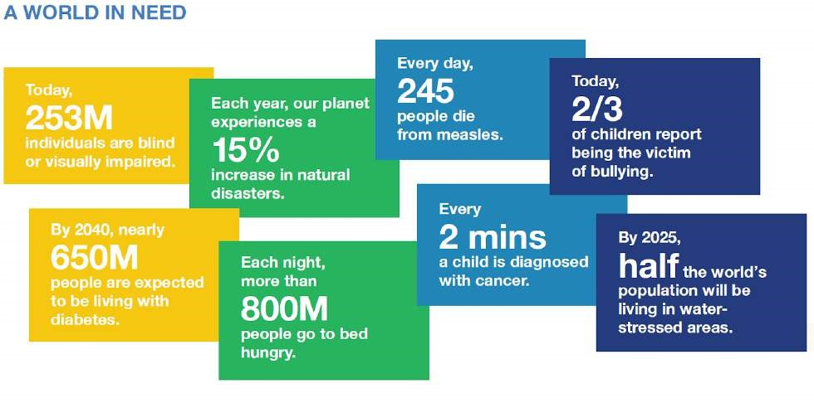

Do you wonder why should your club consider donating to LCIF?

Just look at the statistics above – you and your club can make a global impact! LCIF gives a way for your club to extend its reach and impact. Donations can be designated to specific areas of service:

Vision
Youth
Disaster
Relief
Humanitarian
Efforts
Diabetes
Childhood
Cancer
Hunger
The Environment

Donations should be sent directly to LCIF, not to the district treasurer.

Mail checks, payable to LCIF, to:
Lions Clubs International Foundation
Department 4547
Carol Stream, IL
60122-4547 USA

You can also donate online at: https://lionsclubs.org/en/give-how-to-give/more-ways-to-give. Expand your club reach! – serve locally and give globally!

If you want more information or want one of us to visit your club please contact us:

Lion Sam Hopper choppershopper@aim.com  812.951.2185 | Lion Laura J. Davis  purdue3822@gmail.com  502.550.5008

Member Spotlight: 2VDG Lee Cuba
When did you join Lions Club? What motivated you to join? Now that you've been a Lion for 14 years, what motivates you to serve now?
July 25, 2005. Several of the Bedford Lions and myself are members of First Methodist Church of Bedford. They invited me to join. I believe and live knowing that serving others is what we are supposed to do.
Do you currently hold positions in our district? What positions have you held within your local Club? If relevant, what Lions positions have you held at the District level or higher? Which was most memorable and why?
I am in my 3rd year as Zone Chair and just starting as 2nd Vice District Governor. I have served on the Board of Directors: 2007-2009, Club Secretary: 2009-2015, and Club President: 2015-2016. With each position, training has been made available, giving me a sense of comfort in that position.
Throughout your time as a Lion, which service project have you been a part of that made the most impact on you? Why?
Eye screening has made the biggest impact. The results have been life changing because of early detection.
What Lions-related fundraising effort that you've participated in has been most successful in your community? What makes that effort stand out to you?
Our pancake breakfasts. It is a community effort with Lions, Boy Scouts, sorority sisters, and school organizations all helping (up to 100 volunteers).
If you had $100 for a Lions-related activity, where would you direct the funds? What if you were working with $1000?
For both answers: eye screening.
What advice do you have for Lions Club members in our district?
Grow through collaboration. Two working together can get more done than two working individually.

I'm the Guy/Gal
Author Unknown
I'm the guy/gal who asked to join your organization. I’m the guy/gal who paid his dues to join. I’m the guy who stood up in front of you and promised to be faithful and loyal. I’m the guy/gal who came to your meetings and no one paid any attention to. I tried several times to be friendly to some of the fellows, but they all had their own buddies they talked to and set next to.
I sat down several times but no paid any attention to me. I hoped very much that somebody would have asked me to take part in a fundraising project or something, but no one saw my efforts when I volunteered. I missed a few meeting after joining because I was sick and couldn’t be there. No one asked me at the next meeting where I had been. I guess it didn’t matter very much to others whether I was there or not.
The next meeting I decided to stay at home and watch TV. The following meeting I attended, no one asked where I was when the last meeting was held. You might say that I’m a good family man who holds a responsible job, loves the community, and his country.
You know who I am?
I’m the guy/gal who never came back!
It amuses me when I think back on how the heads of the organization and the members were discussing why the organization was losing members. It amuses me now to think that they spend so much time looking for new members when I was there all the time.
All they needed to do was make me feel needed, wanted, and welcome!

Lions Check Vision at 4H Fair
Submitted by Lion Jim Fisher
Members of the four Lawrence County Lions Clubs (Bedford, Bedford Noon, Mitchell, and Fayetteville Community) conducted vision screening at the Lawrence County 4H Fair from July 14, 2019 to July 20, 2019 and screened 118 adults for far and near vision and field of vision with 25 being referred with problems to seek additional follow up professional exams . We also screened 182 children for far and near vision with 26 being referred to seek additional follow up professional exams. For the first time at the fair this year, Lions screened 42 children ages six to two, with a KidSight camera, referring 2 with problems to seek additional follow up professional exams. Also thirty five pairs of new reading glasses were given free of charge to individuals needing corrective glasses to help improve their near vision We had a total of 30 volunteers from the four Lions Clubs who helped with the vision screening this year. Shown in the photo performing the screening are (L-R): Lions Luckie Jennings, Gary Ochs, George Gabel, Owen Hobbs, and Carol Hobbs.
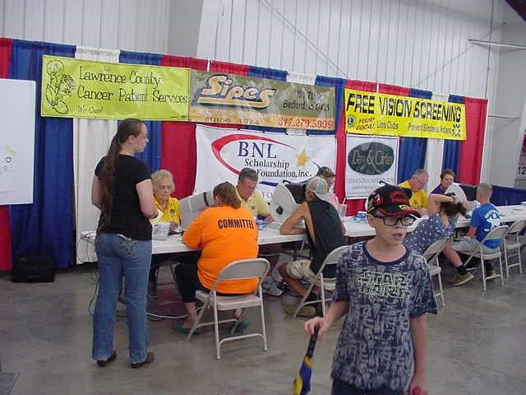

Save the Date
2019
September 19-21  October 12  October 19 | 43rd Annual USA/Canada Forum  2nd Cabinet Meeting  2nd Council Meeting | Spokane, Washington  Salem, Indiana  Bloomington, Indiana
2020  January 10-11  January 12  March 13-14  April 4-5  April 24-26  June 6  June 20  June 26-30 | Mid-Winter Conference (MWC 2020)  3rd Council Meeting  25-E Spring Convention / 3rd Cabinet Meeting Indiana Lions Leadership Workshop  Indiana Lions State Convention / District Caucus  Pre-Council Meeting  4th Cabinet Meeting / Picnic  103rd International Convention | Indianapolis, Indiana  Indianapolis, Indiana Mitchell, Indiana  Plainfield, Indiana  Bloomington, Indiana  Indianapolis, Indiana  Loogootee, Indiana  Singapore

Environmental Chairperson - Sharon Kamman
Our Lions motto is “We Serve”. I’m thinking of two more words that contain the word “serve.” Those words are conserve and preserve. I believe we were put here on earth to be good stewards of this beautiful planet on which we live. A good steward always has in his mind ways to conserve and preserve.

One of the ways is to teach children the best way to take care of our natural resources. Many years ago there was a little brown owl (Woodsy Owl) who was on posters and on TV. His motto was “Give a hoot – don’t pollute.” Also, all of us remember Smokey Bear who said, “only you can prevent forest fires.” If you work with children as a teacher, scout leader, or 4-H leader, talk with them about our job as good stewards of the earth.

Parents and grandparents of young children, you can give subscriptions to nature magazines such as
"Ranger Rick" or "National Geographic Kids." These are excellent resources that help kids learn about preserving and conserving.

Some interesting facts you may or may not know:

- Less than 1% of the earth’s water is drinkable.
- About 1/8 of the world’s population has no access to safe water.
- More than 25% of bottled water actually comes from municipal tap water.
- On average, an American residence uses about 100 gallons of water per day. Most of the water in households goes down the toilet.
- Leaving the faucet running while you brush your teeth loses 2 gallons of water per minute; so you could save 4 gallons (or more) by turning off the water until you’re finished brushing. - A dripping faucet could leak about 3,000 gallons of water per year.

Think about these things. Share them with your family and friends. How can we do a better job of conserving and preserving?

P.S. Last time I talked about butterflies. If you’re interested in Monarch butterflies, go to www.growingagreenerworld.com and look up Episode 804. Growing a Greener World is a TV show on Create TV, but you can catch many of their episodes on this website.

Correction
In the July newsletter, within the article "History of Lions and Leader Dogs," contact information was incorrect for Dustin Williams - 812-340-8757 (liondustin80@gmail.com) and Don Allen - 812-277-8914 (violinini1@gmail.com). If you're interested in the Lions Leader Dog program, please contact Lion Dustin or Lion Don for addition information.

Lions Cub Corner
New to Lions Club ? Welcome! Each month, Lions Cub Corner will feature information regarding Lions Club that will aid you on your service journey.
Indiana Lions Foundation (https://indianalionsfoundationmd25.org/?page_id=86) Grants are given to assist Lions organizations as they serve their communities.
Criteria for the grant:
- The project must be a Lions project. For instance, if your club takes on the project of funding equipment for the local fire department and raises funds from projects, grant applications and solicitations in the Lions Club's name, the application will be considered. It will not be considered if the request is for a grant to be given as a part of the fire department solicitation.
- Grants will not be given for the direct benefit of any one individual.
- To assist 400+ Clubs and 12,000 Lions, we encourage not more than 1 grant per Lions year per organization.
- The applying Lions Club must give direct financial support to the project.
- Grants are to match Lions organization funds up to $750.00.
- Club operation and routine maintenance expenses are not eligible for a grant; capital expenditures will be considered. The grant may be used for initial start-up costs and associated expenses for the purchase of equipment, real estate, or improvements to real estate.
- A Club must be in good standing with the District, States, and Lions Club International.
- For the complete Foundation Matching Grant overview, visit: https://indianalionsfoundationmd25.org/wp-content/uploads/2019/01/matching-grant-criterion-2019.pdf.
The Indiana Lions Foundation encourages organizations that receive a grant to assist by: purchasing a
W.P. Woods Fellowship and/or selling tickets at the Indiana State Fair and/or purchasing a Lions license plate and/or purchasing a brick paver.
District Special Projects
For information regarding a District Special Projects grant, please contact: Chairperson Lion Sue Leffler (Oakland City) - 812-677-0728, PCC Keith Thomas (Petersburg) – 812-354-4637, or Lion Laura Davis (Ramsey) – 502-550-5008.
Additional Resources
Tips for Grant Seeking and Proposal Writing (https://www.iidc.indiana.edu/pages/grant-funding-opportunities) Grants are available for parents/families and educators/professionals through many national, statewide, and local resources.
Assistance Listings (replaced Catalog of Federal Domestic Assistance) (https://beta.sam.gov) – Contains listings of federal programs for state and local governments, non-profits, various for-profit and non-profit organizations and institutions, groups, and individuals.
Foundation Directory Online (https://fconline.foundationcenter.org) – Search through grants and foundations by topic and subject interest.
Resources to find grant funding for your school district
(https://www.follettlearning.com/about-us/grants-and-funding)
Grant Watch (https://www.grantwatch.com/grant-search.php) – Search engine allows a search by state or country, funding source (federal, foundation, corporation, local, and state government), and specialty area (e.g. special education).
The Grantsmanship Center (https://www.tgci.com) – This website has resources for accessing grants, including several webcasts, articles, and a list of the top-giving foundations for each state.
Guides for Writing Proposals

http://www.npguides.org – non-profits guide to grant writing http://www.learnerassociates.net/proposal – guide for writing a funding proposal

Lions in Action
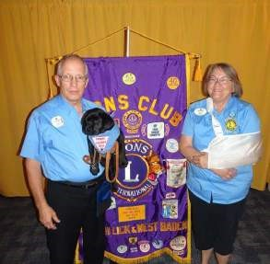
Puppy "Star" makes Official Visit to French Lick-West
Baden Lions Club. Future Leader Dog puppy "Star" was the star of the show during the Official Visit of District
Governor Sheryl Schafer, of Bloomfield, at the August 6th meeting of the French Lick-West Baden Lions Club.
"Star" is the ninth puppy raised by Past Council
Chairman Jeff Schafer (at left) and District Governor Sheryl who are among the volunteers who raise and train puppies for almost a year before they are sent to Rochester, Michigan for more intensive training and bonding with a blind person. During the visit, Governor Sheryl Schafer inducted the new 2019-2020 club
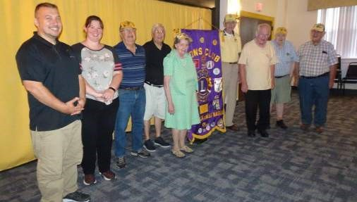
New French Lick-West Baden Lions Club officers installed. French Lick-West Baden Lions Club officers for the 2019-20 year took the oath of office administered by visiting District Governor Sheryl Schafer, of Bloomfield, during the August 6th meeting. From left, Chaplain Jason Lindsey, Membership Chair Samantha Prow, Tail
Twister Ron Woolsey, Director Willard Owen, Secretary
Frances Drabing, President Bill Willis, 2nd VP Bruce
Anderson, Director Rex Drabing and Treasurer Jim Springer. Not shown are 1st VP Cindy DeHart and Director Steve Owen. (Photo by Lion Bill Willis).
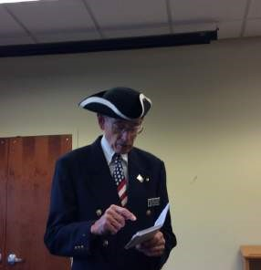

officers. (Photo by Lion Bill Willis).
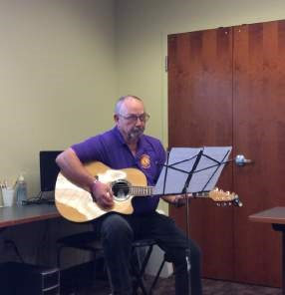

Lion Christy Nolan presents Bill
Day from the Jackson County History Center to help with the purchase of new heaters.
The Petersburg Lions held a Liberty Day program at the
Petersburg Library on August
29th. Pictured: Lion Lowell
Thomas, Petersburg President.
The Petersburg Lions held a Liberty Day program at the
Petersburg Library on August
29th. Pictured: PDG Bill Willis
(French Lick/West Baden
President – Liberty Day Chair).

Lions in Action
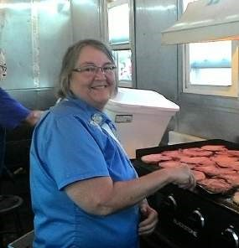
Sweet Corn Festival, Oakland
City. Pictured: District
Lion Billy Cook delivers dictionaries to two classes of 3rd graders at Dugger Elementary, | Lion Glynn Wills delivers dictionaries to third graders at RCA School in Graysville.
Governor Sheryl Schafer.
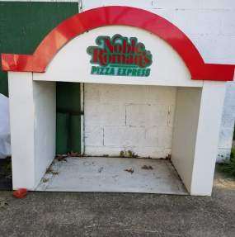
Oakland City Lions community project: Phase 1, unused pizza warmer.
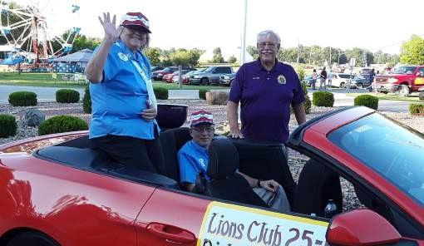
Sweet Corn Festival, Oakland City. Pictured: DG Sheryl
Schafer, PCC Jeff Schafer, Kenny Willis)
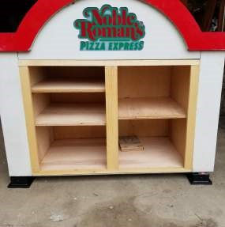
Oakland City Lions community
project: Phase 2, shelves installed. | Oakland City Lions community  project: Phase 3, Little Free
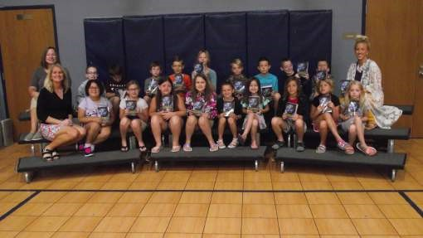
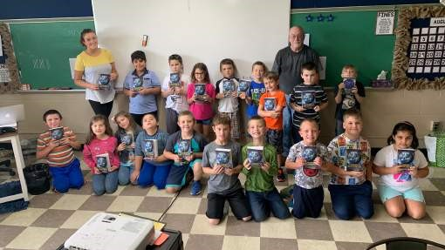
Library and Blessing Box.

