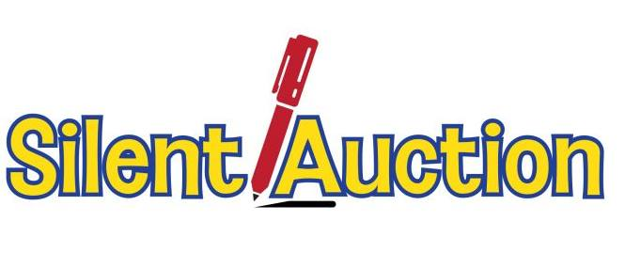

2024 Mid-Winter Conference – January 20, 2024

“Catch the Magic of Lionism!”

We are in need of items for the silent auction at the 2024 Mid-Winter Conference. If you would like to donate something, please contact either Co-Chair Lion Gretchen Xinopoulos at [liongretchen@att.net](mailto:liongretchen@att.net) or PDG Linda Scott at [lindamscott@comcast.net](mailto:lindamscott@comcast.net) . Funds raised from this silent auction will go toward support of the MidWinter Conference, to better help defray the costs. Thank you for your willingness to make this event a success.

