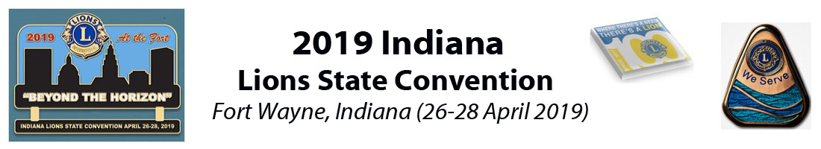

Vendor Application

Lions Exhibitor - $50 Non-Lions Exhibitor - $75 Additional Booth - $50

Each Booth includes
10x10 space
1 skirted table
2 chairs

Please return this form and payment by April 10 to:

PDG Don Cooper
1922 Kelley’s Landing
Fort Wayne, IN 46825
dkcoooper81@msn.com

Make checks payable to: 2019 Indiana Lions State Convention

Name ________________________________________________________________________

Organization/Club _____________________________________________________________

Email _________________________________________ Phone _________________________

______Lions Exhibitor $50 ______Non-Lions Exhibitor $75 ______Additional Booth $50

Total Enclosed ________________

