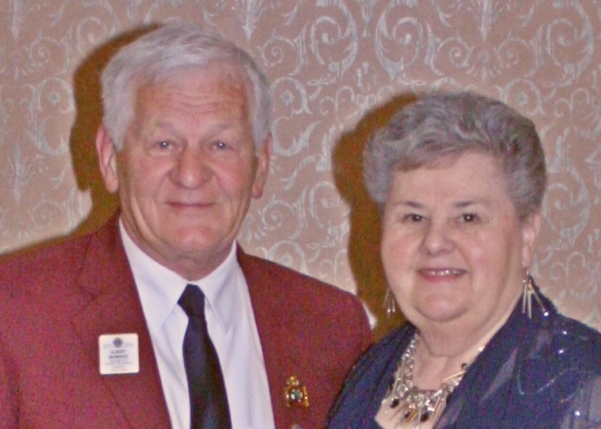

First Vice-District Governor
Albert Munneke
Millbrook and District Lions Club

Lion Albert grew up and attended school in the Orono area. He is self-employed as a licensed truck/auto mechanic.

Albert is married to Barbara for 45 years and they have two sons, both involved in the trucking industry. Albert and Barbara are proud grandparents of a two-year- old granddaughter

Albert joined the Millbrook Lions Club in 2003, held various offices, including two years as the clubs president, director, secretary and is currently treasurer.
He served on many committees and chaired several major fund raising projects, and was the host committee chair for the A-3 convention in 2011

The club was awarded the governor efficiency award when he was president and again when he was secretary. Albert has been voted Lion of the year three times, been awarded the 100% Secretary Award, the District Governor’s Appreciation and Region Chairperson Excellence Award and is a Melvin Jones Fellow recipient.

He is a graduate from the Senior Lion Leadership Institute, attended the International Lions Convention in Chicago and US/Canada Forum in Memphis Tennessee and is currently the 1st Vice-District Governor

Albert was involved with the Leadership Seminar at the MDA convention, the Club Excellence Program, and is the youth exchange chair person for A-3.

In his spare time he built a successful 16-room resort complex, a couple of houses and a campground.

Albert enjoys family time, r.v.ing, cooking, renovating, volunteering and spending a lot of time training their 6-month old puppy, Logan

