DISTRICT A-3
DIRECTORY


2011-12 INTERNATIONAL THEME
“I BELIEVE”

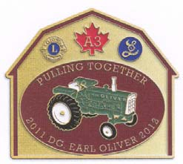
“Pulling Together”

District Governor
Earl Oliver

2011 – 2012

LIONS INTERNATIONAL PURPOSES

To Create and foster a spirit of understanding among the peoples of the world.

To Promote the principles of good government and good citizenship.

To Take an active interest in the civic, cultural, social and moral welfare of the community.

To Unite the clubs in the bonds of friendship, good fellowship and mutual understanding.

To Provide a forum for the open discussion of all matters of public interest; provided, however, that partisan politics and sectarian religion shall not be debated by club members.

To Encourage service. minded people to serve their community without personal financial reward, and to encourage efficiency and promote high ethical standards in commerce, industry, professions, public works and private endeavors.

Table of Contents

International President Wing-Kun Tam Bio page 4
DG Earl Oliver Biography page 5
1st VDG Mary Ann Smith Biography page 6
2nd VDG Albert Munneke Biography page 7
District A3 Cabinet pages 8-10
Region Chairs pages 11-13
District A3 Committee Chairs page 14-20
MDA Council of Governors page 21-22
Visitation Schedule page 23
Important Dates page 24
Past District Governors of District A3 page 25-26
Past District Governors transferred into A3 page 27
Past Council Chairs page 27
Past International Directors page 27
Honorary Committee page 28, 29
Lions Clubs in Alphabetic Order Page 30-52
Lioness District Executive page 53
Lioness Clubs page 53-56
Lions Pledge, Creed, Invocation Etc pages 58, 59
Useful Information pages 57-62
Contest Information pages 63-67
District Map page 68
Code of Ethics page 69

For more information see DISTRICT A3 website
www.e-district.org/a3
INTERNATIONAL PRESIDENT

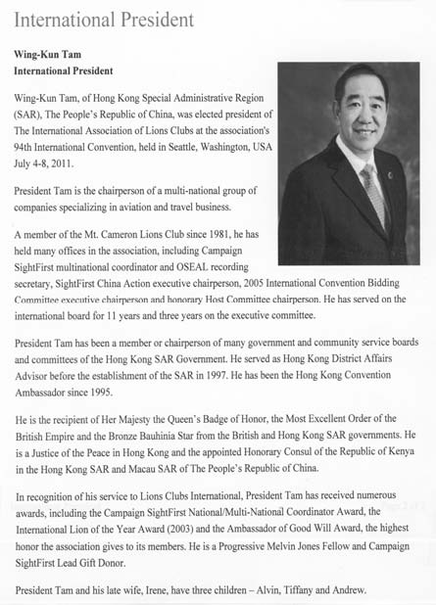

District Governor Earl Oliver
Norwood Lions Club

Lion Earl has been a member of the Norwood Lions Club since1990 where he has held many offices including being President in 1998/99.

Earl started serving District A3 as Zone Chair of 43 North in 2007/08 and is presently the District Governor. He has been a member of several committees including Long Range Planning, Sight First Two, MERL and is a Guiding Lion.

The highlight of Earl’s journey through Lions has been meeting people, fellow members of the Lions family through visiting clubs in the district and attending Forums and Conventions. He never ceases to be impressed and amazed by the many services provided by Lions to improve lives of those in need, locally and worldwide while at the same time improving many life skills of Lion members.

Over the years he taught school in several communities, settling in Norwood in 1967. As Technical Director, redesigning the courses and equipment of the Department was a challenging and rewarding experience. Earl and his family also operated a dairy farm for many years and now cash crop the land.

Lion Earl and Lioness Carol have been married 49 years and have six grandchildren. Around home Earl enjoys his farm, auction sales, antique tractors and trying to keep up to the activities of the grandchildren.

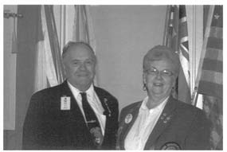

First Vice District Governor
Mary-Ann Smith
Newburgh-Camden Lions Club

Lion Mary Ann Smith was born and raised in the Kingston area. She was employed by Queen's University for over 30 years, retiring in 2004. However, she is still called in from time-to-time for vacation relief work in various offices.

She joined the Lions family in December 1999 and has served as Club Treasurer, Director and President. She was the District Chair of Vision Screening for two years. She was the District Chair for the Together We Can Campaign of the University Hospitals Kingston Foundation in 2009-2010.

Lion Mary Ann has received the International President's Certificate of Appreciation and is a Helen Keller and Melvin Jones Fellow. She received the Certificate of Enhanced Leadership Skills while at the USA/Canada Forum in Saskatoon. She is also a graduate of the Senior Lions Leadership Institute.

She is a Charter member of the Newburgh-Camden Lions Club, and was one of the guiding Lions in getting the Club started.

Lion Mary Ann and PDG Lion Victor have been married for 46 years and have 4 children and 5 grandchildren. She and PDG Victor enjoy NASCAR races and, when time permits, spending time with their children and grandchildren.

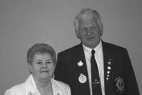

Second Vice District Governor
Albert Munneke
Millbrook and District Lions Club

Lion Albert immigrated from Holland, and was raised and attended school in the Orono area .He is self employed, operating a towing and truck repair shop,. He has tried his hands at many things, building a seventeen room resort complex, starting a camp ground and has built several houses including the one he lives in now for the last 22 years.

Lion Albert started with the Millbrook and District Lions club in 2003. He has served as director, secretary, two years as president and is currently treasurer.
He has chaired many major fund raisers and is very involved in many activities of the club.

Lion Albert started serving A-3 as outgoing youth exchange chair person in 2008, and now is youth exchange chair person for incoming and outgoing youths. In 2009 he started as zone chair in 10 south and as Region Chair in 2010 and was elected to serve as 2nd VD for the year 2011/2012’
He is involved with the club excellence program, and this year with the GMT/ GLT program

He has attended a USA/Canada forum in Memphis Tennessee, an International convention in Chicago, several MDA conventions.
He is a graduate of the Senior Lions Leadership Institute, a Melvin Jones Fellow recipient, 100% secretary award, and has received Lion of the year, three times from his club.

Lion Albert and Lion Barbara have been married for 44 years, have two Sons and one 1 ½ year old granddaughter. In his spare time he likes to spend time with family, camping, cooking and playing with his dog Kayla.

DISTRICT A3 CABINET

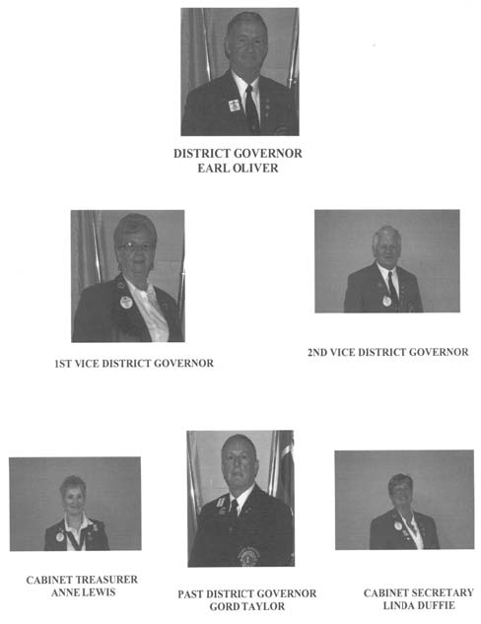

REGION 10 CHAIRS

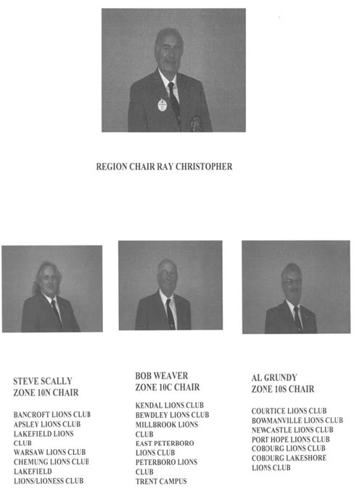

REGION 11 CHAIRS

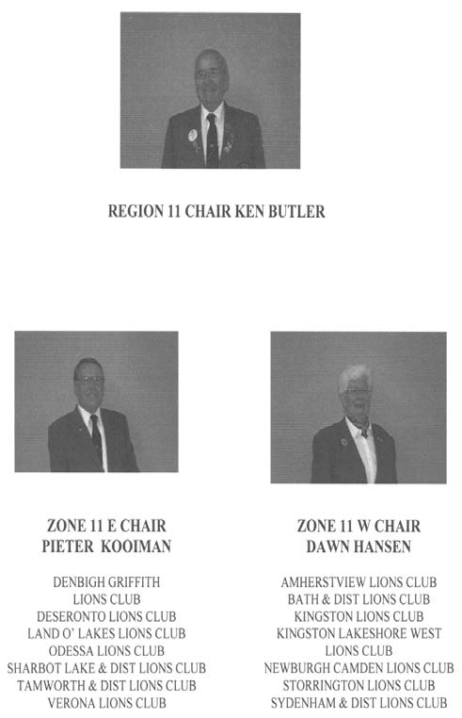

REGION 43 CHAIRS

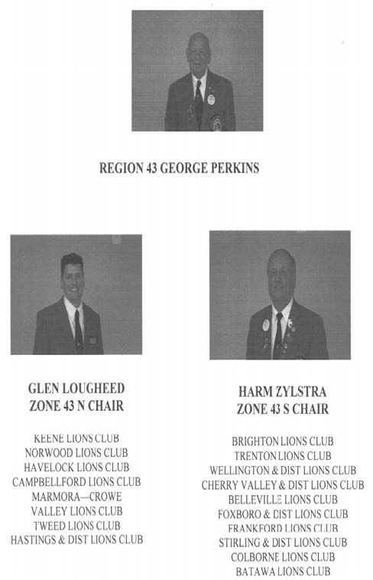

VOICE OF THE LIONS & LIONESS PINS

Don't overlook me Lions and Lioness.

I'm your pin.

Right up in front here put the spotlight on me because I'm proud to play a part in the lives of the men and women who wear me as their symbol of service to the community.

I've witnessed excitement, sadness and happiness. I've been with my wearer as eyes of deceased Lions and Lioness for deposit in the Eye Bank. I was there too, when I watched as the hungry were fed, and the destitute cared for.

I've seen the guide dogs instill in a blind person a new kind of confidence as they move about their sightless world.

I've heard the heart of the handicapped pounding with joy when Lions and Lioness visited them, I've seen and heard the laughter of children in playgrounds enjoying recreational facilities and leadership provided by Lions and Lioness.

Yes, I've travelled all over the world and can recall thousands of incidents diverted from sadness to gladness because those who wear me, made it so. I am a symbol of service to the world.

If I could really talk, I'd be too filled with emotional pride to say more than thank you and may God bless you and protect you. ~

LIONS PLEDGE

I pledge allegiance to my country and to the cause of peace throughout the world.

I believe in the principles of Lionism as contained in the Lions Code of Ethics.

I am proud to be a Lion dedicated to the service of others.

THE LIONS CREED

He/she achieves success who lives well, laughs often and loves much.

Who gains the respect of intelligent men/women and the love of little children.

Who fills his/her niche, who accomplishes his/her task, who leaves the world better than he/she found it, whether by an improved poppy, a perfect poem, or a rescued soul;

Who never lacks appreciation of earth's beauty or fails to express it;

Who always sees the best in others and gives the best that he/she has;

Whose life is an inspiration, whose memory is a benediction.

He/she is a Lion.

LIONS INVOCATIONS

Lord, hear our voice. Grant us strength and courage as
we seek to serve mankind; strengthen our
foundation of international goodwill

Continually remind us that we are here for the betterment
of others, and, in so doing, sustain us in sincerity and purpose

Help us all work to be successful in our obligations
and in our responsibility to Lionism
Amen

**************

0 Lord thy blessings now let fall
Upon thy Lions as they call
May all our ties of friendship be
Forever strengthened Lord by thee.
Amen

***************

Almighty and Eternal God, bless the Lions and guests
assembled here this day
Bless the food that we are about to receive and give
us wisdom and understanding that we may uphold the
principles of Lionism
Help us to pursue with energy the Objects and Ethics
of our Association
Let us maintain our simple purpose To Serve people
by giving our aide to those in need
Amen

***************

0 Lord, Thy blessings now let fall
Upon Thy Lions as we call.
May all our ties of friendship be
Forever strengthened, Lord, by Thee.
Amen.
USEFUL INFORMATION

District A-3 Web page: www.e-district.org/a3
MDA web page: www.mdalions.org
MDA Resource Centre: www.magma.ca/~johnston/lions/
Lions International web page:www.lionsclubs.org

Lions Quest
The Canadian Centre for Positive Youth Development.
Box 33049, Waterloo, ON N2T 2M9
I-800-265-2680
pat@lionsquest.ca

Lions Foundation of Canada (Dog Guides)
152 Wilson Street, Box 907, Oakville, ON L6J 5E8
905-842-2891 or 800-768-3030 or fax 905-842-3373
Executive Director: Sandy Turner,

Leader Dogs for the Blind
Box 50, 1039 South Rochester Road, Rochester, Michigan,
U,S,A., 48307-3115
248-651-9011

Lions Clubs International Office:
International Association of Lions Clubs,
300 - 22nd Street, Oak Brook, Illinois, U.S.A., 60523-8842
630-571-5466 or 800-710-7822

Lions MD "A" Secretary
Lion David Voisey (Viv)
Lions Clubs International, Multiple District 'A'
30 Ventnor Way Nepean, ON K2J 1 M3
H: 613-843-1687. Fax: 613-825-1930 secretary@mdalions.org

Lions MD "A" Treasurer
Lion Jack Fisher (Evelyn)
7606 Aked Rd. RR 4 Bowmanville, ON. L 1C 3K6
905-263-8043 treasurer@mdalions.org

'
USEFUL INFORMATION

Club Supplies Sales Department - Lions Club International
Email:
www..lions.clubs.org .
1-800-710-7822 300
Fax 630-571-0964

Snail Mail:
Club Supplies Sales department
300 West 22nd Street
Oak Brook, IL 60523-8842 USA

Lion’s Magazine Reporter
Lion Wilma Bush
Email:wilma.bush@sympatico.ca

District A-3 Web page: www.e-district.org/a3

0 Canada

O Canada, our home and native land,
True patriot love in all thy sons command.
With glowing hearts we see thee rise,
The true north strong and free.
From far and wide, O Canada,
We stand on guard for thee.
God keep our land glorious and free.
O Canada we stand on guard for thee.
O Canada we stand on guard for thee.

God Save the Queen

God save our gracious Queen;
Long live our noble Queen;
God save our Queen.
Send her victorious,
Happy and glorious,
Long to reign over us.
God save our Queen.

USEFUL INFORMATION

The Star Spangled Banner

0 say can you see, by the dawn's early light,
What so proudly we hailed at the twilight's last gleaming.
Whose broad stripes and bright stars, through the perilous fight
O're the ramparts we watched, were so gallantly streaming.
And the rockets red glare, the bombs bursting in air,
Gave proof through the night that our flag was still there.
0 say does that star spangled banner yet wave
O're the land of the free and the home of the brave?

Remember
District A-3 Web page: www.e-district.org/a3

CLUB EFFICIENCY CONTEST
REGULATIONS
Begins 1st July, Ends 31st March
All A3 Clubs Automatically entered

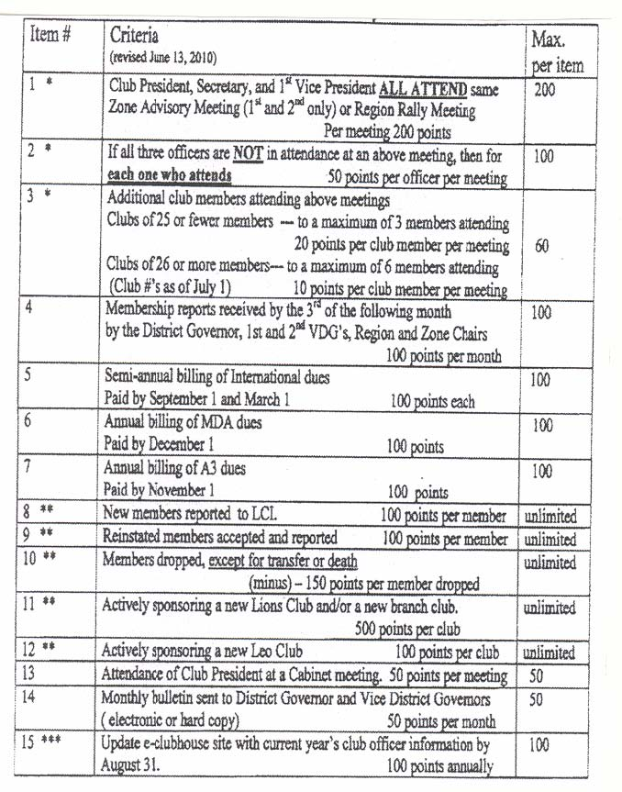

* Items 1, 2, 3 Zone and region chairs must send a copy of the sign in sheets for their meetings to the 1st VDG before 31st March for these clubs to be included
** Items 8, 9, 10, 11, 12-time period annually is from 1st April to 31st March of the year completing the contest
*** Item 15. District webmaster is to send a summary to 1st VDG
CLUB EXCELLENCE AWARD

(Replaces the 100% Club President Award or Club President Excellence Award)

Criteria

CLUB IN GOOD STANDING-
International per capita taxes and new member entrance fees are paid in full and there is no outstanding balance ofUS$50 or more that is ninety (90) days or more past due.
SERVICE - The club must conduct at least three service projects
CONTRIBUTION -The club has either contributed a minimum of$10 for each club member to LCIF or awarded a Melvin Jones Fellow or a progressive Melvin Jones Fellow.
MEMBERSHIP - The club achieved a net growth in membership (including branch club members when applicable) or sponsored a new club. The new members attended an orientation and were properly inducted into the Lions club.
COMMUNICATION - The club has publicized the club's service activities to the public through local media and effectively communicated activities to club members.
LEADERSHIP DEVELOPMENT -All officer positions were filled in accordance with the constitution and bylaws by qualified Lions, a majority of the club officers participated in a leadership training program at the zone, district, multiple district or international level and the club was represented at zone meetings.
CLUB DEVELOPMENT - The club has hosted regular and meaningful club meetings and submitted the Monthly Membership Report, the Service Activity Report, and the Club Officer Report (PU-I0l) in a timely manner. To qualify the club must further the objectives of the association, adhere to the association's constitution and by-laws and policies, and meet each requirement noted below during the fiscal year.

A completed form (available on LCI web site) must be mailed to the English Language Department at International Headquarters, or faxed to (630) 706-9130, to arrive by September 30, 2011.

The award will be mailed to the 2011-2012 district governor for presentation.
100% SECRETARY AWARD

Qualifications
Download the appropriate application form from www.a3Iions.org or ask the Zone Chair for a form. In order for the club Secretary to receive this award, the form must be completed, signed by the appropriate people and sent on to the District Governor by May 15 of the Lions Year. The Governor upon approval of this application will send the 100% Lions Secretary Award to the incoming Club President for presentation.

Criteria:
1 The Secretary must submit a Membership and Activities Report Every month to:
Lions International
The District Governor
The Region Chair of the club's Region
The Zone Chair of the club's Zone

2 All twelve monthly M&A reports must be accounted for during the year

3 M&A reports must be completed correctly and received by the District
Governor by the 5th of the following month.

4 Form PU-101 with the names, addresses, telephone numbers, etc., of the newly-elected President, Secretary, Treasurer and Membership Chair must be properly completed and received by the Intemational Office by May 26.

5 The Secretary must have attended, in person, at least 2 Zone Advisory
Meetings of the Club's Zone

6 The Secretary must have attended either the District A-3 or MD "A" Convention, or alternatively, the School for Incoming Club Officers, during the term of office.

7 Names of the incoming Club President, 1st. Vice President, Treasurer,
Secretary, Membership Chair and Bulletin Editor must be mailed to the
District Governor Elect as soon as possible after the club elections.

Secretaries
Remember the help line if you are having problems – see page 52
DISTRICT A-3
VISITATION CONTEST

Contest Rules:
The Purpose of the Contest is to promote a spirit of Inter-Club harmony and to see how other Clubs function.

. Contest period - September 1st. to March 31st. inclusive.
. Visitation Reports to be E-Mailed or sent to the Visitation Chairman by the 10th of the following month.
. If repeated visits to the same club are made... only the single best visit score will be allowed.
. A minimum of 2 Lions must be on each visitation.
. All visits must be made in District A-3 or adjoining Districts to A3.
. Visits to adjoining Districts will receive member points up to 200 total kms round trip from their home club.
. Trips within District A-3 will be allowed to their total round trip Kms, measured from their home club.
. Recognized Lions functions or activities are: Zone Meetings, Region Rallies, Charter Nights, Lions International Nights, District Conferences, Sports or Social events sponsored by Lions Clubs
. No member of Cabinet or Lion campaigning for Office is eligible to win the Visitation Contest.
. Contest will be in two (2) Categories:
- .Clubs with 25 or fewer members.
- Clubs with 26 or more members.

Points will be awarded as follows:
- One (1) point per member per km traveled from home club.
- Deduct 25% of member points if visit is made with any District Officer or International Officer a on his Official visit.
- .Bonus points 100 points total if a full 1 0% of active membership are on the same visit.
OR
- 0 200 bonus points when a full 25% of the active membership is on the same visit.
OR
- 500 bonus points when full 50% of the active membership is on the same visit.

The names of the winning Clubs and the Lion who traveled the most kms will be announced at the District A-3 Convention in April of each year.

For 2011-12 email to fstewart@nexicom.net.
DISTRICT A3
CLUB BULLETIN CONTEST

JUDGING GUIDELINES

The format of the cover of the Bulletin should include the identification of the Club, Zone, Region and District; the names, addresses and phone numbers of the Club President, Secretary and Bulletin Editor. Other appropriate information could include: names, addresses and numbers of District Officers; attendance make-up information including the place and time of meetings of nearby Clubs and finally the Club Roster or Membership Count.

SCORING

COVER
Name of Club 2) Zone, Region & District identification 3) Names, addresses & phone numbers of Club President, Secretary & Bulletin Editor 4) Publishing date & frequency of the Bulletin 5) Any other appropriate information:. 5 points

CONTENT
The date, time and location of upcoming meetings & programs: 7 points
Report on Club activities; include actions by Board of Directors: 7 points
Coming events at the Club, Zone, Region, District and International levels: 7 points
Information relative to Membership Development & Retention 7points
Report on previous meeting including any Board of Directors meetings 7 points
Constructive editorials 7 points
Personal news about members. 7points
General info as it concerns your District and Lions Clubs International. 7 points
Effective use of humour 7 points
Continuous receipt of Bulletins i.e Months of Oct.-Feb inclusive 7 points
General Effect: 25 points

SUB-TOTAL 100 point$

Deductions-10 points each of humour in bad taste & plagiarism
The Bulletin Contest is based on Bulletins published & judged for the months of October through February
There are two (2) categories MONTHLY and TWICE MONTHLY for
a) clubs with 29 members or less and
b) clubs with 30+ members

LIONS CODE OF ETHICS

To Show my faith in the worthiness of my vocation by industrious application to the end that I may merit a reputation for quality of service.

To Seek success and to demand all fair remuneration or profit as my just due, but to accept no profit or success at the price of my own self-respect lost because of unfair advantage taken or because of questionable acts
on my part.
To Remember that in building up my business it is not necessary to tear down another's; to be loyal to my clients or customers and true to myself. Whenever a doubt arises as to the right or ethics of my position or action towards others, to resolve such doubt against myself.

To Hold friendship as an end and not a means. To hold that true friendship exists not on account of the service performed by one another, but that true friendship demands nothing but accepts service in the spirit in which it is given.

Always to bear in mind my obligations as to citizen to my nation, my state, and my community, as to give them my unswerving loyalty in word, act, and deed. To give them freely of my time, labor and means.

To Aid others by giving my sympathy to those in distress, my aid to the weak, and my substance to the needy.

To Be Careful with my criticism and liberal with my praise; to build up and not destroy.

