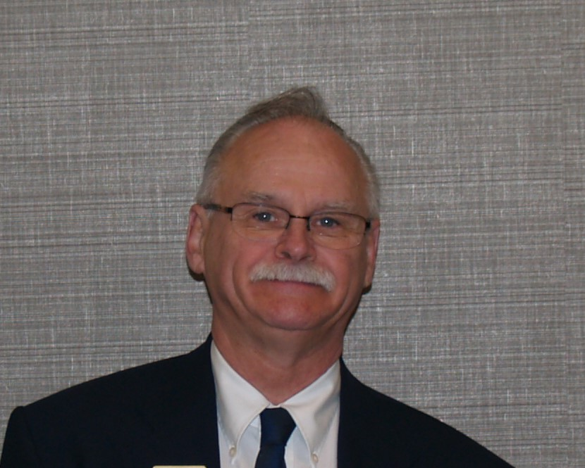

**Bill hails from the Niagara Peninsula and moved to Central Frontenac Township, with Linda, over 40 years ago. Bill and Linda live in the country, with 2 small dogs – A Shih Tzu and a Yorkshire Terror – as well as with an abundance of wild life that appear out of the woods at any time.**

**Lion Bill joined the Sharbot Lake & District Lions Club in 1992. He has been Club Treasurer and, twice, Club President. He has worked on every committee – hammered nails, flipped burgers, washed dishes, planted trees, etc. – like every other Lion out there. He has attended many forums and conventions. Lion Bill served as Zone 11W Chair in 2013/14 and Region 11 Chair in 2014/2015.and 2nd Vice District Governor in 2015/2016. He attended the Advanced Lions Leadership Institute in Calgary in 2015. Lion Bill is a Certified Guiding Lion, as well as a Club Quality Initiative Facilitator. He has received the Lion of the Year Award, the Distinguished Service Award, the Helen Keller Fellowship and is a Melvin Jones Fellow. Lion Bill has completed all of the courses offered on the LCI website and also received the bachelor’s degree from the Lions University .Lion Bill believes the key to successful and harmonious clubs is communication. Lion Bill believes in the code of ethics –“I shall be careful with my criticism and liberal with my praise, so that I will build up, and not destroy”.**

**Lion Bill**