District A3 Lions Cabinet Meeting Minutes
Saturday, February 15, 2020

Host: Stirling and District Lions
Stirling Arena, 435 West Front Street
Stirling, ON

10:15 Pre Cabinet meeting 10:30
12:00 Lunch
12:45 Cabinet Meeting

 |  |  | report | Action taken/notes
 | Call to Order & Opening Remarks | DG Susan Taylor |  | Meeting was called to order at 11:52 am.
 | Welcome | Stirling  Lions |  | Lion President Alana, of the Stirling and District Lions Club welcomed all to the meeting.
 | LUNCH |  |  | Coffee, juice and muffins was provided by the Stirling Club in the morning. A great lunch of soup, sandwiches and desserts was also provided by the Club
 | Invocation, | FVDG Don Radnor
 | Guest Speakers (15 minutes) | ID candidate, MDA, Environment |  | DG Lion Steve Burrows introduced PDG Lion Allan Snider, candidate for International Director addressed the meeting.  PDG Barb Ennis and PDG Dave Hewitt spoke to the Lions regarding MDA Convention.  Lion President Alana gave a presentation on the environment.
 | Administration Committees
 | Bereavement | PRC Dawn Hansen |  | Bereavement Report to Cabinet -- February 15,2020  Governor Susan, Cabinet and Lions Family, our deepest sympathies go out to the Clubs and family members who have lost the following Lions since the last Cabinet meeting.  Lion Ray Bauer—Frankford Lions  Lion Dorothy Stevens—Trenton Lions  Lion Ed Warren—Sharbot Lake and District Lions  Lion Joseph O'Brien-- Warsaw and District Lions  Lion Peter Klein—Bancroft Lions  Please stand for a moments silence.  May They Rest in Peace.  Respectfully Submitted,  PRC Dawn Hansen,  A3 Bereavement Chair
 | New Business & Approval of Agenda | DG Susan Taylor |  | Moved by Lion Frank, seconded by Lion Cheryl that the agenda be approved. CARRIED.
 | Approval of Minutes: November 23, 2019 | DG Susan Taylor |  | Moved by Lion Mark, seconded by Lion Glenn that the minutes of the previous Cabinet meeting be approved. CARRIED.
 | Secretary’s Report & Correspondence | CS Bill Pollick |  | Ancaster Lions will be celebrating their 75th Anniversary in October.
 | Treasurer, Budget, Finance Report | CT Albert Munneke |  | Moved by Lion Frank, seconded by Lion Dave that the Treasurer’s report be accepted. CARRIED.  District A-3 Treasurers report as of Jan 31120  DG Susan  This my 3rd report to cabinet.  Our current bank balance is at $40,749.15, this amount includes various committee funds.  One club still own the A-3 & M D A dues ( $385.00 ), contacts by email and personal contact from the governor, still no payment received at the time of this report, the district will forward the MD-A portion upon receipt of these funds  A copy of the bank statement and the balance attached as of Jan 31/20  Report respectfully submitted  Albert  District A-3 treasurer  Account Acti' ity page ok'2  Account Activity  .23  httpsr:•ea.s,) web.td.com/waw.'ez.•ü0210>2020  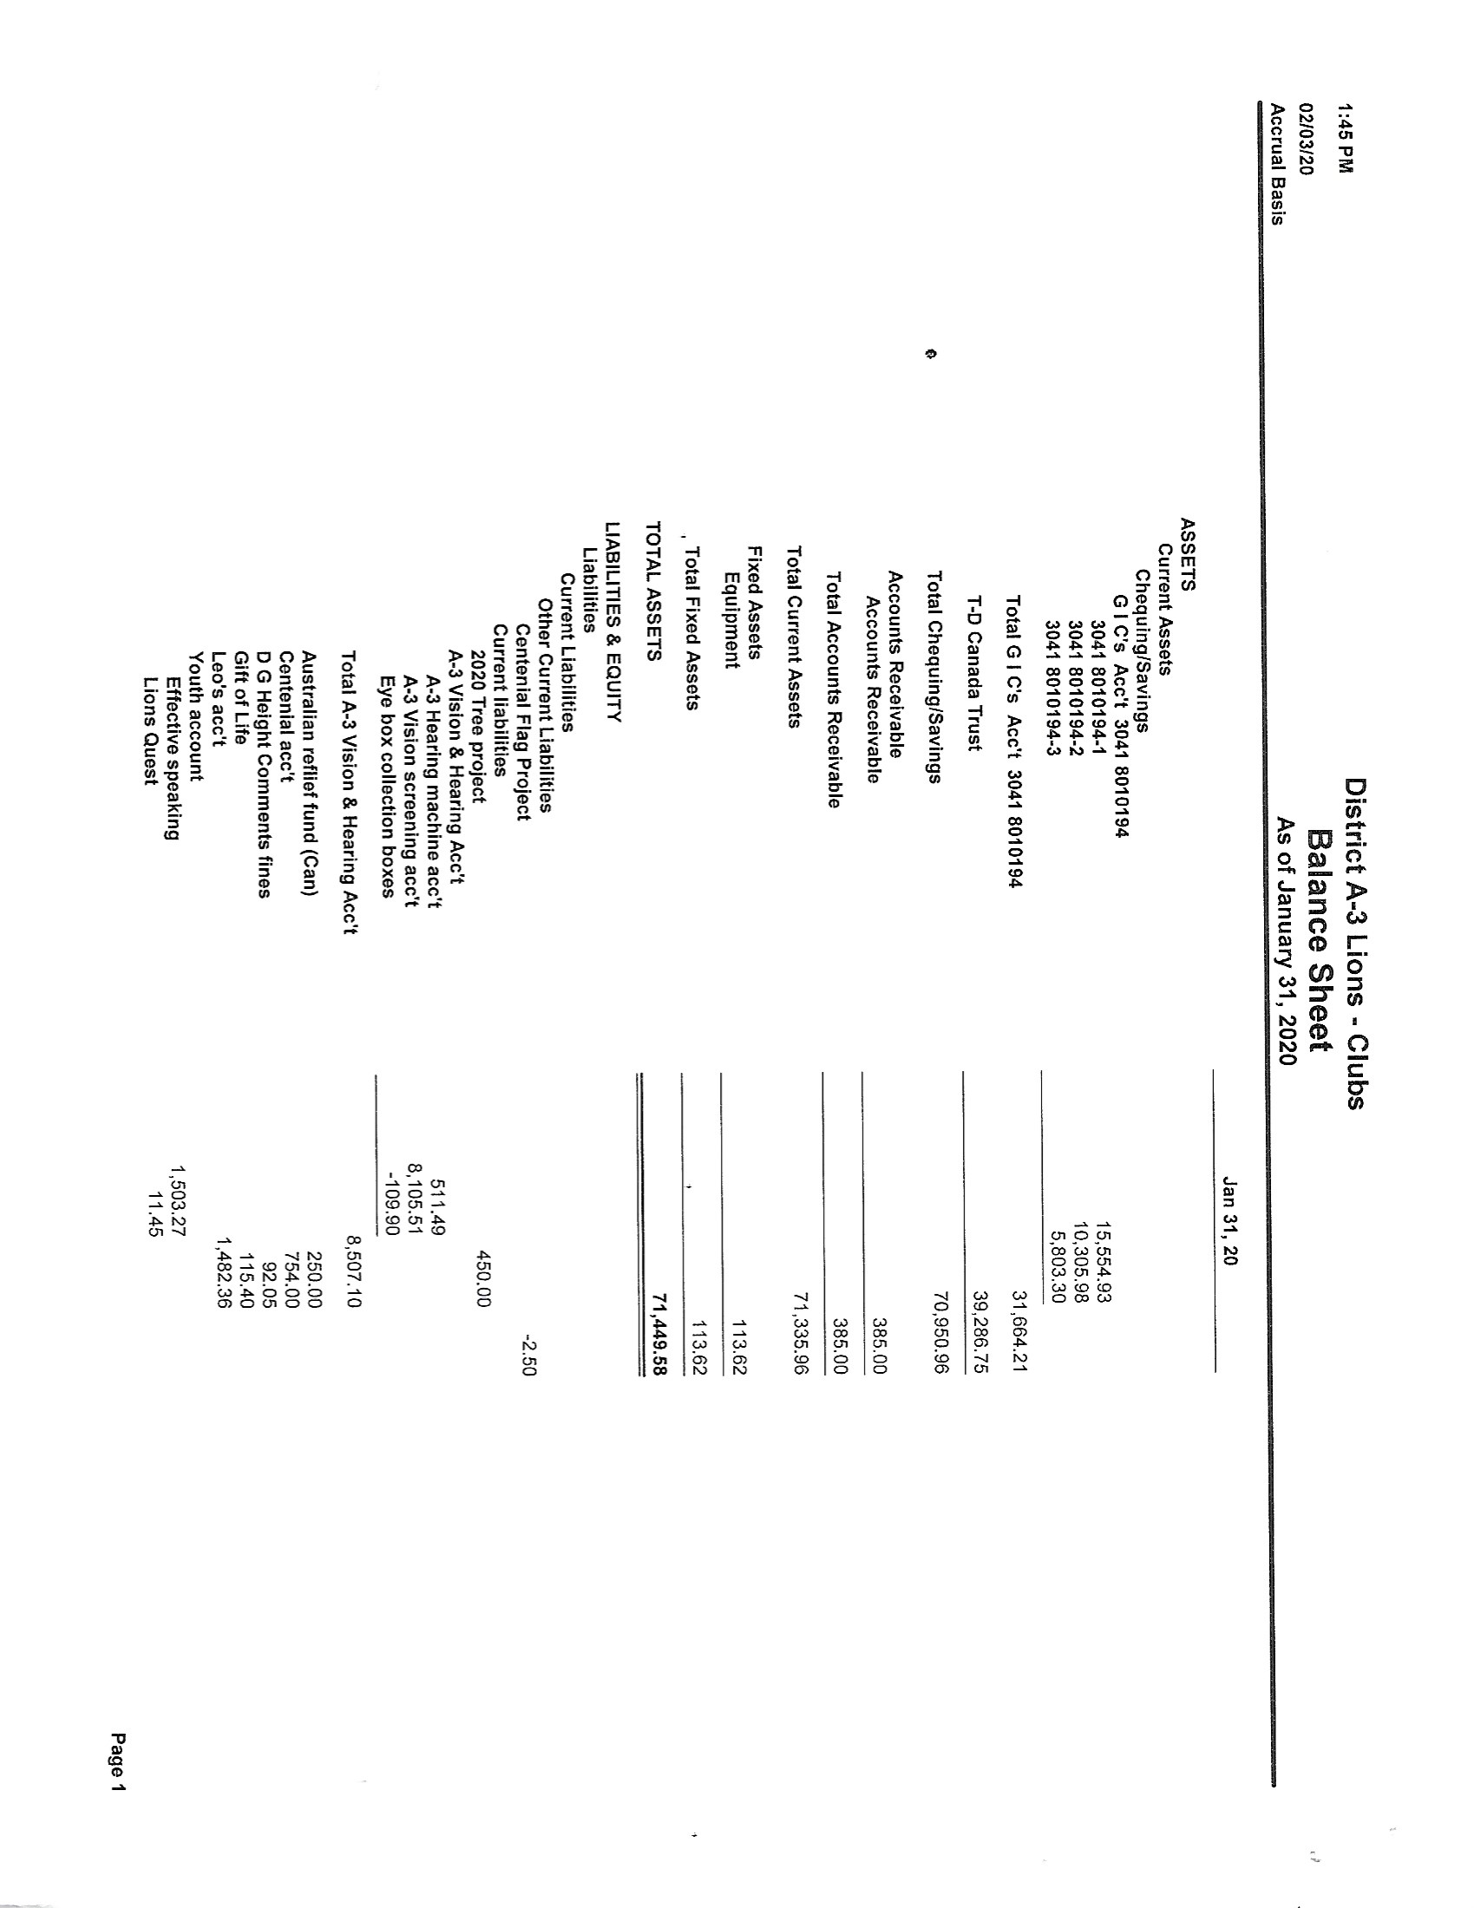  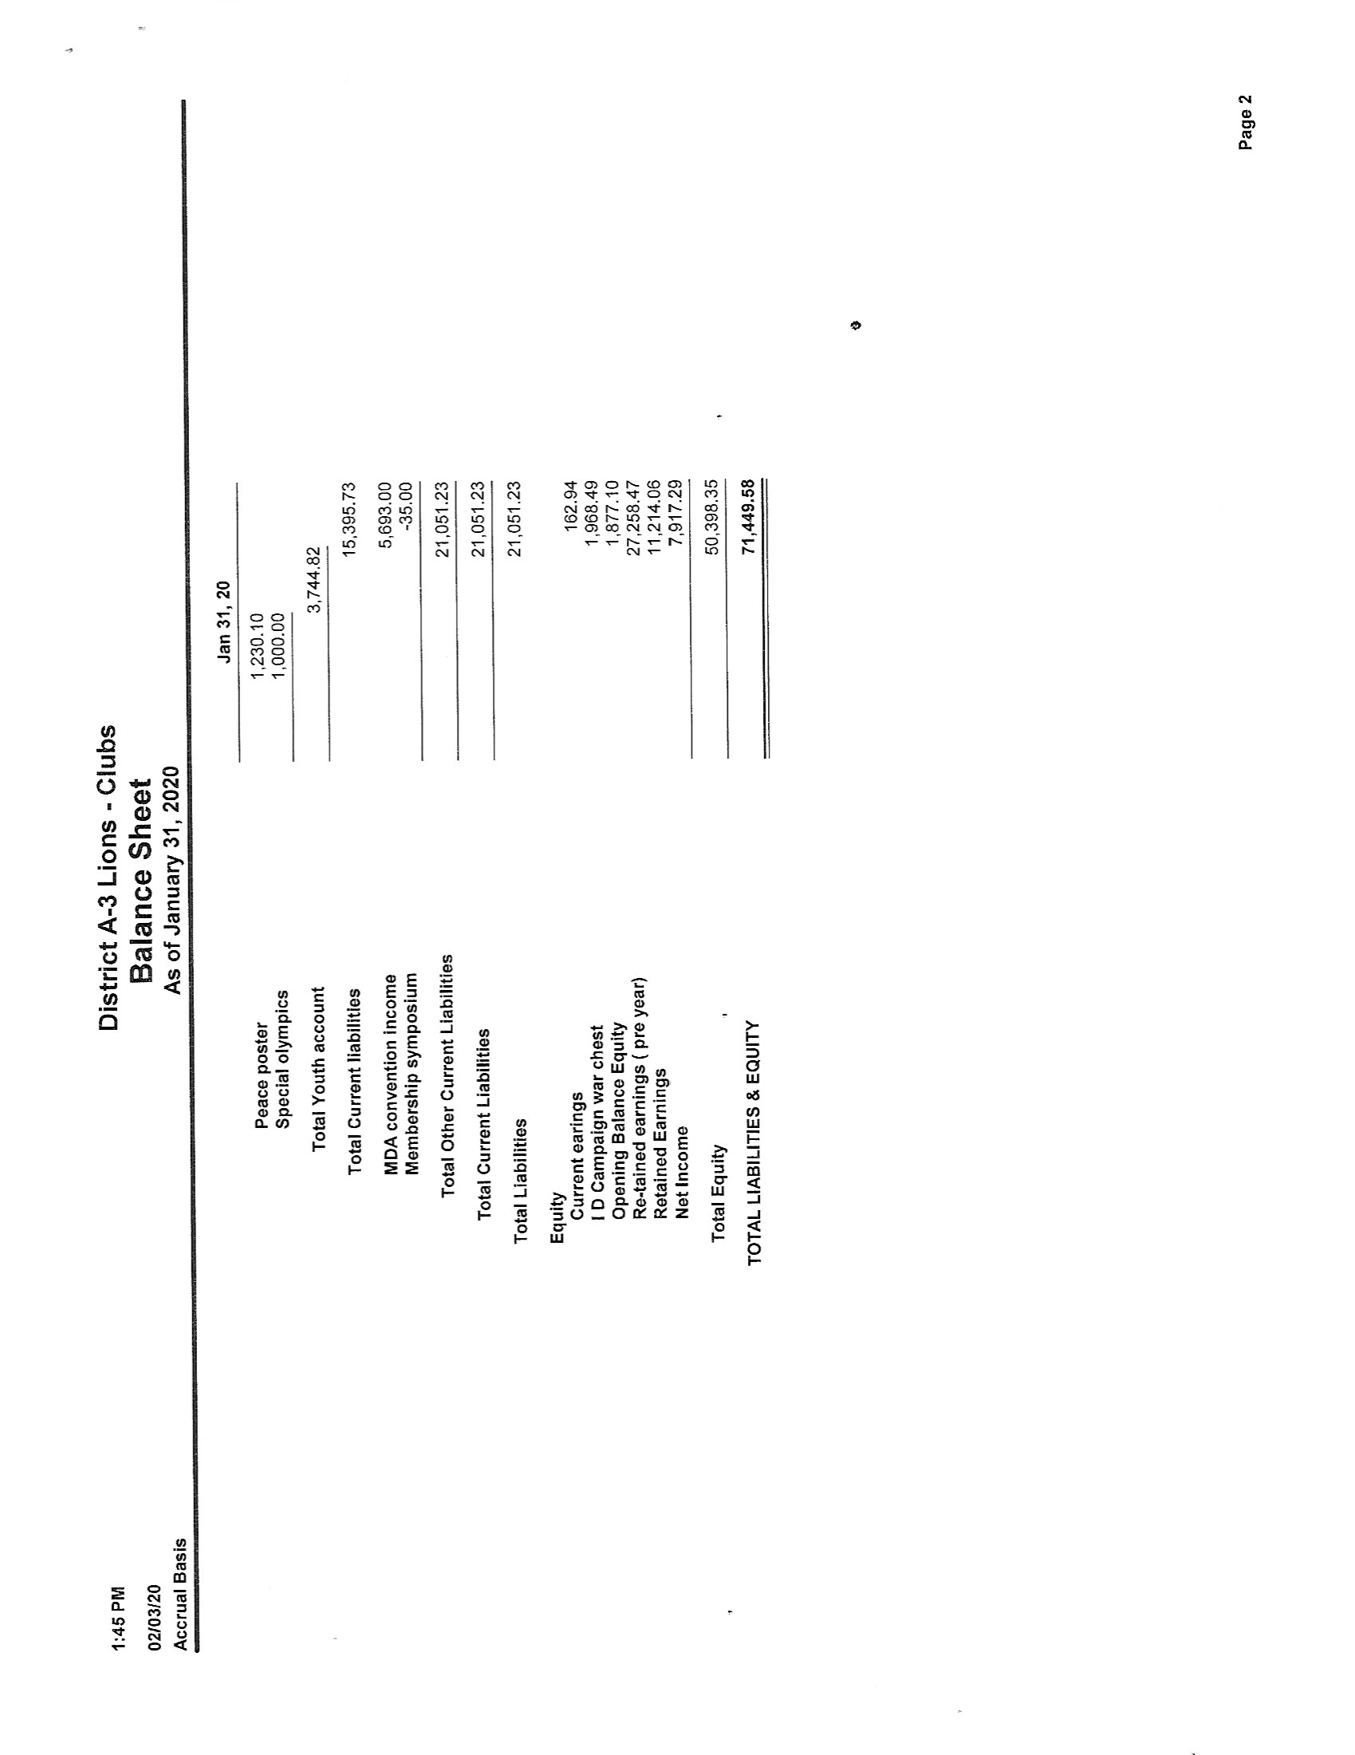  District A3 Lions Clubs  Account Name Budget 2018-2019 Actual Budget 2019-2020 Actual  A-3 dues assessment to Clubs 12,600.00 12,600.00 12,620.00 12,480.00  M D A dues assessment to Clubs 18,270.00 18,270.00 22,085.00 211840.00  Dues - Levy for New Clubs 1,260.00 1,262.00  Interest Revenue 65.00 125.53 13.00 157.53  Bank acct balance rebate 59.40 54.54 34.65  Miscellaneous Revenue 0.00 0.00  GAT 1,000.00 1 ,878.41 1,000.00 GST , GLT & GMT  A 3 Convention Income (refund) 0.00 0.00 2,600.00  Cabinet meals tip jar 182.90  Total Income 33,254.40 32,928.39 39,746.54 34,512.18  Badges & Crests 1,300.00 1,141.00 1,300.00 246.14  Bank Charges 59.40 81.96 75.00 34.65  M D A clubs dues forwardwd 18,270.00 18,270.00 22,085.00 21,840.00  District A3 Convention (seed money) 0.00 2,600.00 1,000.00 1000.00 for 2020  Eye glasses collection boxes 200.00 200.00  District Directory 1,000.00 1 ,345.27 1,500.00 1 ,425.50  District awards / Web site 350.00  District Equipment 1,200.00 113.62 200.00  Incoming cabinet training 500.00 476.71 600.00  New Club Regalia 500.00 0.00 750.00  Club Officer training 1,200.00 875.91 1,200.00  Cabinet officer training/Extra Training 1,000.00 526.50 1,000.00 542.08  2,250.00 162.76 2,250.00 GST  Global Membership Team - Extension 750.00 0.00 1,500.00  Queens Campus Dues 134.00 134.00 0.00  Meals - Cabinet 1,400.00 902.76 1,400.00 394.90  Room Rent-Cabinet 200.00 100.00 200.00  Honorarium-Secretary 400.00 400.00 400.00 800.00  Postage/Courier-Secretary 75.00 75.00  Supplies/Printing-Secretary 150.00 14.71 150.00  Honorarium - Treasurer inc milage 400.00 400.00 400.00 800.00  Postage/Courier - Treasurer 75.00 90.00 75.00  Supplies/"Printing - Treasurer 250.00 177.79 250.00  Awards - DG 1,000.00 958.01 1,000.00 242.00  Zone / Region / VDG,s Cabinet Expense 1000..oo 975.00 1,300.00 1 ,200 oo  L C I F Chair person expense 250.00 70.00 150.00  Donation for A-3 Convention Guest Speaker 400.00 400.00 400.00  Accounting Program  International Spouse Travel 1,000.00 1 ,ooo.oo 1,000.00 1,000.00  Misc Expense 250.00 215.45 250.00 44.07  District officers election 200.00 150.00  ALL' training ( cabinet members ) 1 ,ooo.oo 1,000.00 1,000.00 500.00  Total Expenses 35,763.40 29,831.45 43,460.00 30,069.34  Profit/Loss -2,509.00 3,096.94 -3,713.46 4,442.84  Budget - Current Year - 2019/2020 Revised
 | Audit (Nov. mtg only) | PDG Russ Mitchell
 | GAT - DG Susan Taylor |  |  | Moved by Lion Don, seconded by Lion Carmen that the reports be accepted. CARRIED.  February 15, 2020  Cabinet Members, Fellow Members of the Lions Family,  Welcome to the third cabinet meeting of this Lions year. Welcome to our guests.  Our cabinet this year should get survivors badges. We have had a number of changes and several Lions have stepped up to fill positions. Thank you again to all who stepped up.  ZC10S Debra McGaffin has stepped down for personal reasons and PRC Kevin Kimmerly has volunteered to finish the year as the zone chair for zone 10 south. Several of us have had medical challenges but we are recovering. This cabinet team has assisted each other as it was needed. Teamwork makes the dream work!  Since the Christmas break our Lions clubs have been hard at work serving their communities.  Your cabinet has also been busy visiting, holding Zone meetings and Region Rallies. PDG Gord and I, accompanied by several Chemung Lake District Lions, have visited 12 Lions Clubs and have several more visits planned. I even have a booking to be the Easter Bunny in April after the convention.  In January, the District hosted a very successful Membership Symposium, with clubs sharing success stories and attending clubs having an opportunity to work on a membership plan for their club. Many thanks to the GMT for presenting a great day and to the Havelock Lions for hosting the Symposium.  The convention committee has also been hard at work to prepare a great convention for you and you will hear more about that later in the meeting.  Respectfully Submitted,  Susan  DG Susan Taylor
 | Constitution and By-Laws | SVDG Mark Kelso |  | Constitution and By-Laws Committee report to cabinet 15 February 2020  DG Lion Susan, fellow Cabinet members, Lions and guests;  This is my third report to cabinet for the Lions Year 2019-20 as the District Constitution and By-Laws chair.  Our District Constitution and By-Laws are in good shape. I have received no requests for amendments thus far this Lions year.  I recently reviewed our Constitution against the latest Standard form available through the International Board Policy manual dated Oct 2019 and can report that we are in compliance with that version. I will note that there are currently 2 (two) proposed amendments that require approval at the International Convention in June. These amendments are to mandatory wording within the Constitution and as such I will be recommending their adoption once finalized in June, most likely at the first Cabinet meeting of the next Lions year.  Respectfully submitted  Lion Mark Kelso  Constitution and By-Laws Chair 2019-20
 | Convention Committee | PDG Bill Lewis |  | TO LIONS FAMILY  THIS IS YOUR THIRD REPORT TO CABINET  AS OF THIS WEEK THERE ARE 152 REGISTER  ALL OF THE ROOMS ARE BOOKED THAT’S WHERE BLOCKED  THE HOST COMMITTEE IS WORKING HARD TO MAKE THIS A GREAT COMVENTION  LOOKING FORWARD TO THE ROARING PARTY ON FRIDAY NIGHT  RESPEFULLY SUMMITTED  YOURS IN LIONISOM  BILL LEWIS  CONVENTION CHAIR
 | Elections and Credentials | ZC David McKellar |  | Elections and Credentials for 2020  Good Afternoon District Governor, Cabinet Members, Lions and guests  This is my first report as the appointed chairman of Elections and Credentials for 2020.  Lions we have started recruiting candidates for next year’s cabinet.  The election procedures shall be in accordance with A3 Constitution and bylaws (7 Sept 2019).  It will for the most part run almost the same as last year.  If you are looking for copies of the paperwork, it’s in the annexes of the updated Constitution.  Club secretaries are to fill out the paperwork and email it to District Governor Susan for her signature. She will send it on to the cabinet secretary for filing, and myself, so that I can add the names to the Candidate List.  Entitlement of the number of ballots shall be sent directly to the club secretaries from me through the Cabinet Secretary.  The secretaries shall print off and issue them to the Lion members, who are voting for each club. Remember, you must have a signed ballot by your club secretary and an up to date Lions ID card in order to vote. If you don’t, you will be turned away.  Voting shall start at 0845 on Sunday 4th April 2020 the location to be announced later during the convention.  Good Luck fellow candidates.  Respectively submitted by  ZC Dave McKellar  Elections and Credentials  Chairperson
 | Lions Clubs International Foundation (LCIF) | PID Terry Graham |  | District A3 LCIF Report  Cabinet Meeting Feb. 15, 2020  Stirling & District Lions Club  District Governor Susan, Cabinet members, Lions all,  Campaign 100 – Empowering Service  Our 300 million Capital Campaign to expand our service.  LCIF has made $343,000 US to the Australian wildfires.  At the start of this Lions year, I set some goals.  As a reminder they were:  - To increase our overall giving as a district.  - To increase club participation/donating. (LCIF contribution is needed for your club excellence award).  - Be a Model Club – a per-member contribution of $500. US over the next 5 years.  - Be a Maple Leaf Club: a per-member contribution of $10.00 US for the next 36 months. $US 120/year per member  - For the above - the funds can come from club treasury  - Personal contributions - contribute yourself, enough over the next 3 years to be recognized with a Melvin Jones Fellowship and a contributor in supporting Campaign 100: Empowering Service.  - My goal was for every club to award a MJF each year to a deserving Lion. I have encouraged clubs to use previous LCIF contributions in conjunction with new contributions to purchase MJF.  - Special fundraising event for LCIF  I have made phone calls, club visits, and Zone meetings. I still have many clubs to visit.  I will try to attend as many Zone meetings, as possible..  To date our contributions this year are 14,876.16 and the total for the last 2 ½ years is 67,443.57.  This year to date, in MDA, we are the district with the most contributions.  To stay # 1, we need to keep our donations coming in.  Thank you to the clubs and the Lions that have stepped up with personal contributions to support our Foundation.  Report respectfully submitted,  PID Terry Graham  A3 LCIF Chair.  Matching Grant Proposal: re Trenton Hospital Smart IV Pumps  The Batawa, Brighton, Frankford and Trenton Lions have been working together to raise funds for 67 new IV Smart Pumps at Trenton Memorial Hospital. The total cost of these new IV Smart Pumps is $335,000. The project kicked off this past June with Lion Doug Crews of the Trenton club offering to match any amount the clubs raise for this project up to $50,000. Since that initial launch in June, the four clubs have raised $54,000 to bring the grant total raised including Lion Doug’s matching funds to $104,000.  We are requesting $75,000 US to match the monies raised so far. With this money, we will be able to donate $208,000 to Trenton Memorial Hospital Foundation (TMHF). The remaining, $127,000 has already been raised by the TMHF so this would finish the purchase of these 67 IV Smart Pumps.  Background:  Currently the IV pumps that are in use at Trenton Memorial Hospital (TMH) are beyond their designed life span, lack modern technology that help prevents incorrect dosages and are becoming unreliable. The IV pump is one of the most iconic pieces of equipment in a hospital. 90% of all patients hospitalized will require an IV pump. A person is hard pressed to not know someone has had needed this life saving devise. It supplies life saving drugs, hydration, nutrients and is one of the most widely used devices in a hospital. With the old IV pumps at, the ability for the medical staff to provide the highest quality care for our patients is becoming compromised. The need for these life saving pumps to be replaced has resulted in the Trenton Memorial Hospital Foundation (TMHF) teaming up with local Lions Clubs to raise the needed funds to purchase 67 of the new, state-of-the-art pumps.  The Trenton Lions Club have been an integral part to TMH since the hospital was first built in 1951. The Trenton Lions were one of the pioneering service clubs to start fundraising to build a new hospital in Trenton in the late 1940’s. The Trenton Lions saw a need for better healthcare in their community over 80 years ago and to this day have been a steadfast supporter of TMH. When the Trenton Lions Club member Doug Crews learned about this project to replace the new IV pumps, he wanted to carry the tradition of the Trenton Lions financially supporting TMH. It was Lion Doug’s father who was the President of the Trenton Lions when they embarked on fundraising for the new hospital in the late 1940’s. Lion Doug has committed to donating $50,000 towards this project and the Trenton Lions, in partnership with the Brighton, Frankford and Batawa Lions have committed to raise at least another $50,000. With these funds, and a matching grant from LCIF, TMHF will be able to purchase 67 new IV Smart Pumps. Each pump costs $5,000 CAD resulting in a total project cost of $335,000 CAD.  These pumps will have the latest in technology that will help prevent incorrect dosages to patients. Incorrect dosages is the most common medial mistake in hospitals. These new pumps will prevent those very mistakes. The new pumps will also enable multiple medications to be administered, be capable of treating both infants, children and adults, and most importantly, be reliable for when they are needed most.  Last year over 79,000 people used TMH. Of those, almost 70,000 patients required the use of an IV Pump this year alone. TMH patient usage is increasing at approximately 5% per year which will mean well over 70,000 people will directly benefit annually from these new pumps. The life expectancy of the IV Smart Pumps is 10 years. Over the life of these pumps, over 700,000 people will directly benefit from these machines.  TMH services the Quinte region. People from Brighton, Belleville, Prince Edward County, Stirling and as far north as Bancroft make use this hospital. TMH is the regional hospital for day surgeries including cataract, Comprehensive Breast Assessment Centre, Dental, ophthalmology and orthopedic surgery. The region is a mix of urban and rural with over 65% of the residence of this region over the age of 50 and 26% are over the age of 65. Complex health care issues; chronic obstructive pulmonary disease (COPD), diabetes, high blood pressure, chronic pain, obesity and cancer are the leading health issues. The average family income of $46,855. (2016 Census)  Project to date:  The $104,000 has been raised to date. The pumps will be purchased this summer so this grant request must be submitted by the Feb 2020 deadline to meet the grant requirements. If we should be successful, the 67 IV Smart Pumps will be purchased this summer and the entire project will be finished by fall 2020. This project has the chance to impact many lives and has allowed four Lions clubs to work together to achieve a common goal in our community. The Lions have a long standing history of supporting TMH and this support will create an impact for many years in the Quine region.  Jeff Moorhouse, Batawa Lions Club  Trenton Memorial Hospital Foundation  Lions Club of Trenton  77 Campbell Street,  PO BOX 21051  Trenton, Ontario  District Governor Lion Susan  My name is Lion Mike Seymour from the Lions Club of Trenton, Ontario. I am writing you today to inquire if the  District Cabinet would consider support to our community project for an Inclusive Playground in City of Quinte West.  The Trenton Lions Club has proposed to establish the Inclusive Playground on land supplied and maintained by the City of Quinte West on Bay Street, Trenton, on the east side of Club 105. This equipment willfeature avenues for our local youth and mature adults to use their minds to build self-confidence with physical activity.  The primary objective of the Inclusive Playground Equipment is to allow our youth and seniors to feel independent and foster better health. This equipment would build agility, strength, thru exercise in the outdoors allowing the individua!s to fee! part of our community.  Areas of opportunity to increase accessibility for all to be able to participate in play and recreation with in our own community. Individuals with special requirements to have the ability to enjoy and take advantage of the playground equipment. The goat as portrayed in the above picture is to have playground equipment for a!! individuals including ones with special abilities. This type of playground equipment is not evident in our  The goal if achieved, would reduce social isolation, foster an active fife style for everyone of all ages, circumstance, needs thus creating opportunities for everyone to participate. The development of strong social, emotional skills of children, youth and to enhance our senior’s opportunity to interact with today’s youth.  Moved by Lion Mark Kelso, seconded by Lion Bill Shaw:  to accept the presentation by Lion Jeff Moorhouse re the grant application for the Trenton Hospital Smart IV Pumps and to accept the presentation by Lion Mike Seymour requesting cabinet support for a future matching grant proposal for an Inclusive Playground in the City of Quinte West."  Unanimous
 | Research & Long Range Planning | FVDG Don Radnor, SVDG Mark Kelso
 | IPDG Frank Hewitt |  |  | Attn: Immediate Past District Governor’s Report  Re: 3rd Cabinet Meeting  Cabinet Members, District Officers, Lions, Lioness and Guests,  Please accept this 3rd report to Cabinet as the Immediate Past District Governor. I haven’t too much new to report since my last report to District. I really haven’t been called on to anything this past year, but I at least let them all know that I am here and ready to help when asked.  Since taking on this position I have installed the officers in one club, inducted 5 new Lions into the wonderful organization and I have performed the Lions Service at 5 Lions funerals this year. And I was proud to do each and every job.  I am still doing what I can with helping others within the District. I am working hard with the Port Hope Lions Club and the Courtice Lions Club. I am proud to say that both clubs have been very receptive to working along with me and we are making small steps towards rebuilding them back to where they should be. Both Clubs are working with other clubs in the communities and both clubs are being supported by their Zone and Region Chairs, which is really showing them the support from our District. Port Hope has added 3 new members since we began this process and Courtice has had 2 past members return, as well as several guest to their meetings.  I have also taken to mentoring an incoming President for our club and she is coming along very nicely. Lion Kirby will make an excellent President for the East Peterborough Lions Club and hopefully she will complete her life in Lions by moving up as well.  I am also actively searching out Zone Chairs for my own Zone to help strengthen this Zone as well as our District.  I am not quite sure what the Immediate Past District Governor’s duties are following their year of being Governor, but so far it seems like a true waste of Lions education and time holding this position. But I will never allow myself to slip away that easy with something I truly love doing. I will be returning to what I love and working with each of you as much as you like.  Respectfully submitted,  Your Proud Immediate Past District Governor (IPDG)  Lion Frank Hewitt
 | Historian | Lion Terry Haskin |  | There will be a display of the Lions history at convention.
 | Hearing Services/ Home for the Deaf | Lion Susan Flanigan |  | REPORT TO CABINET FEBRUARY 15, 2020  HEARING SERVICES/LIONS HOMES FOR DEAF PEOPLE  Governor Sue, Members of Cabinet, Lions, Lioness, Guests:  The Lions VEST DRAW tickets are currently being circulated. Each club will receive one book of ten tickets to sell to the Lions' family. Additional tickets will be available at Convention or from myself, if you give me a call.  Lions Homes for Deaf People Board will be meeting on February 19, 2020. This will be a bittersweet gathering as we will be attending LION JACK GRAYDON's visitation in Oakville. Sadly, Lion Jack passed away just a month after losing his wife IRIS after almost 62 years of marriage.  Lion Jack was a founder of LIONS HOMES FOR DEAF PEOPLE and with Lion Gary Martins, instituted the HELEN KELLER AWARD as a funding initiative for Lions Homes for Deaf People projects. Lion Jack was an amazing Lion who worked, always, for the good of his community and kept things moving through his faith in Lions. We will miss his presence.  The LHDP Board's most recent activity has been in Peterborough. I reported the anticipated Official Opening of the Peterborough location in my last report. We are awaiting schedules of various dignitaries who will attend. I will announce the date as soon as it is settled.  Respectfully submitted  Lion Sue Flanigan  Hearing Services/Homes for the Deaf
 | Leader Dog | Lion John Morris |  | Leader Dogs for The Blind chair report for the February 15th cabinet meeting.  Good afternoon district Governor Susan members of cabinet and guests.  It has been a great year so far for your Leader Dogs for The Blind chair. So far we have 3 sponsored puppies and 3 bricks.  Havelock Lions club sponsored a puppy as well as Napanee lions club also sponsored a puppy and Lyn and I also sponsored a puppy thanks to a generous donation we received for Leader Dogs.  The Chemung Lake Lions club bought a brick as well as the Cobourg Lake Shore Lions club bought a brick and the Peterborough Lions club also bought a brick.  With the puppies and bricks plus other fantastic donations from Lions clubs we sent in $3.650.00 just before Christmas. Thank all of you that have donated so far to Leader Dogs For The Blind. Your generous donations give someone like me a new leash on life.  For our fund raising basket which I mentioned in a past report we have collected $321.00 and we still have lots of time left to get donations on this item.  Earlier in this report I mentioned giving someone a new leash on life. I want to let you all know that my Wife Lyn has to retire Lois due to cataracts in both eyes. She is switching to Leader Dogs For The Blind and she has been excepted for training. She is now waiting for a dog. So no matter how big or small the donation is we appreciate all of you very much and thank you from the bottom of our hearts for supporting Leader Dogs For The Blind.  Sincerely,  John Morris your district A3 Leader Dogs for The Blind chair.
 | Lions Foundation of Canada (L.F.C.) | PDG Earl Oliver |  | Lions Foundation of Canada, DogGuides  Report to Cabinet #3, February 15,2020  Hosts – Stirling Lions Club  This report is to show appreciation from the Lions Foundation of Canada to the clubs of District A3 that took part in the “Walks for DogGuides” in the spring of 2019.  Lions Clubs of Chemung Lake, Newcastle, Peterborough, East Peterborough, Peterborough Lioness, and Cobourg were presented at a recent Region Rally with certificates of appreciation and banner patches for their participation. Today Lions Clubs of Bancroft, Belleville (area) /Wellington, Brighton, Colborne, Campbellford, Keene, Norwood, Havelock, and Trent Campus are still to be presented.  If you are counting, there were about 16 Clubs walking. However as indicated in my report number 2, A3 clubs, about 40 of them, donated very generously directly from their clubs. See me to look at these totals if you wish. A3 in many ways has supported DogGuides very well in 2018/2019 .  Would a representative from each of the above highlighted clubs (names read out) please come forward.  (Present certificates and patches.)  Respectfully submitted, Lion Earl.  Moved by Lion Don, seconded by Lion Dave that the reports be received. CARRIED  Moved by Lion Cheryl, seconded by Lion Frank that the reports be received. CARRIED.
 | Global Service Team - Lion Glenn Feltis |  |  | GST 3rd Cabinet report. All Clubs have been very busy doing generous service work in their communities, and that is what we do. I am very happy when I go on to Facebook District A3 site and see the amount of service activities that we all do and continue to do.  A note to all Club Presidents and secretaries; it is important to report your club activity to LCI through Mylion. Currently 22 clubs in our district have not reported any service activity, despite the fact that clubs have been very busy doing a lot of good service in their areas. If your having issues with Mylion you can contact LCI and ask for help and they will guide you through the process.  I have been invited and plan to attend the Zone 10C Advisory meeting 18 Feb to assist Zone 10C Chair Kate Hewitt as her focus will be on Service.  Respectfully submitted  GST Lion Glenn Feltis
 | Vision Screening | PRC Dawn Hansen / PZC Nancy Lane |  | Several schools have been canvassed to get involved with the Lions Vision Screening.
 | Vision Recycled Eye Glasses | PZC Rodney Lloyd
 | Childhood Cancer | Lion Lydia Elliott |  | Fellow Lions,  Well, here we again in a new year and Childhood Cancer is still very prevalent and remains the most common disease-related cause of death – more than asthma, diabetes, cystic fibrosis and AIDS combined.  Scary? No, Horrifying! To think that children born into today’s society have to suffer this horrible and deadly disease.  Research shows the actual cause is still unknown because cancer is not just one disease but a combination of more than 100 diseases. There are lists of risk factors ranging from getting older, smoking, no protection from the sun’s rays, weight, unhealthy diet, drinking alcohol, coming in contact with harmful household chemicals and the list goes on and on. But how can a young child, a few months old, become subjected to some of these risks? It may be possible that genetics play a part in this disease with the outside risk factors being the contributing portion.  Between 2009-2015 there were 4715 new cases of cancer in children 0-14 years of age in Canada, an average of 943 cases per year.  But this is a worldwide problem. In developed countries like Canada, Japan and the United States, more than 80% of children with cancer survive whereas in low or middle income countries the survival rate is only 10%. I’m sure you have all heard that LCIF in May 2019 entered into a formal partnership with Global HOPE (Hematology-Oncology Pediatric Excellence), and their initiative is to improve the standard of care with cancer in sub-Saharan Africa.  So we must continue the fight to find a cure for Cancer, especially for the children, as they are our future.  We all donate our time and energy to have fundraisers in support of Childhood Cancers and we need to continue on this path. Our Chemung Lake District Lions are doing just that – at our next POGO luncheon on Saturday, April 18th at the Wesley United Church on Buckhorn Road at Curve Lake Road. Every club is doing fundraisers and we can only hope that the funds raised will help find this cure sooner than later.  I would love to hear of some of the ideas for fundraisers that you have used or are thinking of using as they may help inspire others to participate.  Lion Lydia Elliott  Chemung Lake District Lions
 | Diabetes Awareness | ZC Dave, Lion Heather McKellar |  | Diabetes Awareness  Good afternoon, District Governor, Cabinet members, Lions, Lioness, Leos, and guests. This is our second report to Cabinet for this year.  Lion David and I attended the Diabetes Canada and MDA Diabetes Chair Workshop, in Markham last September. It was very informative. It showed us what the other districts are doing to conquer Diabetes.  We have an upcoming event at chairperson Kate Hewitt’s Zone Meeting in Kendall on the 18th February it please try to attend the meeting.  Respectfully submitted,  Lion/Lioness Heather McKellar  A3 District Co-Chairperson  Diabetes Awareness
 | Environment & Environmental Photo Contest | Lion Alana Bancroft |  | No photos have been submitted as of yet.  Moved by Lion Frank, seconded by Lion Fred that the reports be received. CARRIED.
 | FVDG Don Radnor |  |  | FVDG Lion Don Radnor ; report to cabinet Saturday February 15/2020  District Governor Lion Susan, members of cabinet, members of the Lions family,  This is my third report to cabinet as your 1st VDG  This continues to be a very busy winter, between club visits, Zone meetings, Region Rallies, and the continued learning opportunities, in preparation for my role as your District Governor.  Along with Lion Ruth Anne we have just completed the Lions Quest Canada national gathering weekend. Lots of valuable information, great fun, fellowship, and a lot of new friends.  At the time of filing this report, I am preparing for my training, scheduled for the week of February 10th thru 14th in St Charles, anxious, excited and, nervous all at the same time.  With the help of PDG Bill Zwier, Lions learning day is nicely taking shape, and I hope to have a good turnout of new officers, interested in their new roles as Lions leaders.  We are still learning to navigate the new MyLion reporting system and we are slowly getting a handle on our Service reports, and I thank our club secretaries for persevering.  To the clubs that have afforded me the privilege of inducting new members into our association, thank you, there is no greater pleasure for a district officer than to perform this ceremony.  I look forward to continuing my learning journey and I thank the PDG’s for their guidance, wisdom and encouragement.  I will continue to try visit the clubs of A3, as I draw great energy and inspiration from the stories of service, our clubs write every day.  The membership symposium held in January was truly inspirational, with a good turnout of Lions from across the district, exhibiting a real interest in improving our membership, numbers and experience  If there is anything I may be able to assist you with, please, do not hesitate to call.  Respectfully submitted  Lion Don
 | Global Leadership Team (GLT) | PRC Jim Peters |  | Global Leadership Team Coordinator Report  February 15, 2020 Stirling Lions Hall, Stirling  To District A3 Governor Lion Susan and Cabinet; Lions, Lioness, Leos and guests.  This is my third report to cabinet for the 2019-20 Lions Year.  Since the last Cabinet meeting I have attended the Zone 43 W Zone meeting in Madoc on November 25, 2019.It was once again great to experience the energy at the Madoc Lions and in Zone 43 W. As well as having the opportunity to present information, the visiting Lions were able to see firsthand the impact of family friendly meetings.  I attended the Lions District A3 Membership Forum in Havelock on January 18, 2020. It was a terrific program. On February 1, 2020 at the Zone 10 N, Zone meeting in Lakefield I heard how some of the ideas from the Forum were already being applied within the clubs of that Zone.  The Lions year is moving along quickly and we are now at the point in the year when Lions should be looking at the next step in their journey and the leadership opportunity it presents. It is especially important to have the support of your club and to fill out the nomination form for submission when seeking the opportunity to be a zone chair or other office within the District. The qualifications and forms are easily available within the District A3 Policy Manual at the District A3 e-Club house.  Respectfully submitted  District A3 Global Leadership Team Coordinator  Lion Jim Peters
 | Honorary Committee | PDG Bill Zwier
 | Incoming Officer School | PDG Bill Zwier |  | DG Susan, Cabinet, Lions, Lioness, Guests  This is my report to Cabinet.  Learning Day has been confirmed for April 25, 2020, in Batawa. Lunch will be catered by Lion Diana Lloyd. Our committee got together on January 31, of this year, to discuss the final details for learning day. All courses for the day have been selected and we will be contacting Lions withing the District to help teach and prepare for courses that will be given. Notices of Learning Day will be out shortly, as soon as we finalize the instructors for that day. Respectfully submitted PDG Bill Zwier.
 | International Advisory Committee (IAC) | PID Terry Graham |  | International Relations Report  Feb. 15, 2020  Stirling & District Lions Club  DG Susan, Cabinet members, Lions all,  Past International Bruce Beck and Lion Erin will be our guest for the A3 convention. DG Susan filled out the online forms and LCI did approve her request for PID Bruce. I have PID Bruce’s travel itinerary and we will pick them up on the Friday of the convention. As he is flying home late Sunday afternoon, he will be at all our convention activities.  With the passing of 1st VP Haynes Townsend, Lions Club International has appointed PID Doug Alexander as 1st VP. At the International convention in Singapore, he will be on the ballot for President. As he was appointed as 1st VP, he never was elected to that position. Therefore, any Past International Director could run for the position of President. To date I have not heard of another candidate.  3rd Vice-President Dr. Patti Hill will move up to 2nd VP in Singapore.  This report respectfully submitted,  Lion Terry Graham PID  International Relations
 | Lioness Liaison | ZC Ruth Newell
 | Camp Dorset | PZC Steve Scally
 | Gift of Life | PZC Steve Scally |  | Moved by Lion Don, seconded by Lion Cheryl that the reports be received. CARRIED.
 | BREAK
 | SVDG Mark Kelso |  |  | 2VDG Report to Cabinet 15 Feb 2020  District Governor Susan, Cabinet members, Lions Lioness, Leos and guests  This is my third report to cabinet as your 2nd VDG.  I continue to be busy visiting clubs and Zone meetings passing on our International President’s message of diversity and servant leadership. I continue to support DG Lion Susan with her goals specifically aimed at leadership, service and membership each of which are essential factors in the success of Lions and District A3.  I have visited 25 Clubs so far and have attended Zone meetings in every Zone except 43E and 10S, I have also attended both Region Rallies in Region 11 and Region 10. The membership symposium put on by GMT PDG Lion Gord was outstanding with everyone coming away talking about how they can spice things up in their own clubs.  Through my club visits I continue to be amazed at the variety and scope of the service being done in this district. I have also noted that some clubs are still a bit shy to get the message out and I am encouraging them to do so sooner than later, we can no longer afford to be the “best kept secret in town”.  LCIF and Campaign 100 remain dear to my heart and I have been encouraging club and individual Lion’s to provide their support so that we can surpass the LCIF donations made in the last Lions year.  Leadership is one of the pillars to Lions success and now is the time to step out and join the leadership team. I congratulate those who have already been endorsed and are in the running and I encourage anyone who wants to take the challenge to step up and get started, it is fun and you will gain tremendous personal growth.  I am thrilled with what we have accomplished so far this Lion’s year and excited for what is yet in store because we still have a third of the year left to do even greater things.  Remember that just like the rest of the Cabinet team I am here to help and I am just a phone call, text or e-mail away.  “Its Great to be a Lion!!!”  Respectfully submitted,  Lion Mark Kelso  2VDG District A3  markaltcrz@yahoo.com  613-968-1738 (C)
 | Global Membership Team (GMT) | PDG Gord Taylor |  | District A3 Global Membership Coordinator  Report to Cabinet  February 15th, 2020  District Governor and Members of Cabinet,  This report is based upon Lions Clubs International Membership Statistics as of February 14th  My last report spoke of following the 5 year trend of losing members in the first half of the year and ultimately losing more members overall than gaining members. The November report stated that as of the end of October our membership was 1237.  In January we held a Lions Symposium with a Focus on Membership. This Symposium was well attended with 79 Lions from 24 clubs in attendance, even though the weather was not great that day. I want to congratulate the clubs that participated and those that presented. The highlight of the day, I believe was the sharing of best practices from Tamworth, Madoc and Lakefield Village Lions Clubs. I believe that the material they presented gave the other clubs present some new and fresh ideas to work on to kick start their membership initiatives. I want to thank the Havelock Lions Club and 1st Vice District Governor Don for hosting the day.  Since then I have presented at the Region 10 Rally and have suggested that clubs need to view Membership Initiatives in the same way they view Service Activities. If one new Lion means that we can serve 70 more people in need then we need to do as much planning and involvement in membership drives as we do in planning and carrying out fund raising and service activities. I have stressed the use of the Lions Club International materials that are online and available in hard copy from the Membership Department.  I plan to visit three Zone meetings in the coming month with the Governor and have been asked to speak at one of them and will make myself available at the other two if there are issues that need to be addressed.  Our Extension Initiatives in the Orono Area have been less than successful with little or no support from neighbouring clubs. Past District Governor Paul Baker, the District Governor and I did sit down and plan. An initial survey of the village, speaking and meeting with individuals produced a list of 17 residents that showed some interest in a Lions Club. A glitch with the local newspaper in not publishing an article that was prepared by PDG Paul resulted in no one attending the planned information meeting. PDG Paul is in the process of a move from the community and has a busy work and Lion schedule. I have turned over the list of interested individuals to the Kendal Lions Club and asked them to follow up to see if we are able to recruit some of the individuals.  We have three clubs in the District that are rebuilding and have been assigned a Guiding Lion to assist them and I am hearing from other clubs that they are actively recruiting as well as examining ways to change their meetings and initiatives to be more attractive to community members. Many small clubs are assisted by a network of volunteers who express that they are not interested in joining our organization, but with effort and changes to programming we may attract some of these people if we just keep asking.  I am pleased to report that some of these efforts seem to be paying off. As of February 14th, 2020, District A3 membership according to Lions Clubs International stands at 1252, up 15 members from my last report and I understand that there are clubs inducting more members this month.  Respectfully Submitted,  Past District Governor Gord Taylor  Global Membership Coordinator
 | Campus Club Liason (as needed) | Lion Tom Houston, Queens  FDG Don Radnor, Trent
 | Family and Women Membership | Lion Connie Kelso |  | Suggested that Clubs hold more “family” meetings.
 | Leo & Lions Service for Children | PDG Dave Hansen
 | Lions Quest | Lion Larry Beeler, Lion Joan Beeler |  | Lions Quest Report to Cabinet  February 15,2020.  Greta Thunberg, Autumn Peltier and Emma Gonzalez,-these are names you may recall from some news reports or magazine articles- young people who care deeply about what is happening to our climate, our water, and our children and young people. Each of these young people (and many more) has decided that they can make a difference in the present and future of their peers by standing up and speaking up for our children and youth.  We need to do the same! Lions Clubs International has challenged us to work for diabetes, hunger, childhood cancer, vision and the environment. Did you know that overriding each of these initiatives that they want us to work on is YOUTH? Thankfully, not all our children and youth will have to deal with the effects of one of our initiatives.  They will, however, have to learn to work with others and share resources and deal with bullying. Lions have a fully developed program to help communities and schools and youth leaders and parents support the development of healthy, capable, young people of strong character.  Lions Quest is a program owned by LCIF and delivered by Lions Quest Canada, one of our two Canadian Lions Registered Charities. We need your help to ensure that this opportunity continues to be available in our District. Right now we are in urgent need of your financial support. Over the last few years we have offered the Lions Quest school based program to over 50 District A3 educators and we have provided a community workshop for 25 adults working with children and youth in our District. We were able to do this because over the years some of our clubs have continued to put Lions Quest into their budgets and have sent their donations to our District Treasurer. These funds combined with a grant from L.C.I.F have enabled us to organize and deliver these opportunities. We have now used up all of our Lions Quest designated funds and we cannot apply for any more support from LCIF until we can demonstrate that there is a willingness in our District to organize and support this most important program.  You have heard the expression, “It takes a village to raise a child.” Well, we are the villagers. We need tools to help us. Lions Quest provides the tools for the villagers to use. Whether you hardly every interact with youth or you are volunteering in school breakfast programs or you are a parent or grandparent, you know that our children are facing a very different present and future than we faced when we were their ages. Lions Quest is the tool kit to help schools and community members help our children. Please find $$$ in your club to keep Lions Quest available in our District. Without your help, we will not be able to provide this important resource to our children and youth.  Please make sure that your club donates whatever you can afford to our District A3 Treasurer. We need your support. Please visit our Lions Quest table at our Convention in April to look at the resources we have available, ask questions and donate funds. We cannot do without your support.  Respectfully submitted,  Larry Beeler.
 | Literacy Chair | PCS Karen Christopher |  | No report.
 | Peace Poster | Lion Carol Oliver
 | Effective Speaking | PCC Graham Lewis |  | The “Speak-off” will be held in Peterborough on February 22. This competition ends at the District level.
 | Special Olympics | Lion Theresa Hewitt |  | Moved by Lion Frank, seconded by Lion Don that the reports be received. CARRIED.
 | R10C Beth Lazar |  |  | Region 10 report Greetings fellow Lions, Lioness, Leos and guests This is my third report to cabinet. January 14th, I attended the Courtice Lions Club meeting. Where business was covered as well as a service project. We wrapped and packed over 500 pairs of glasses and accessories. It's nice to see the great energy the Courtice Lions have. We had a great turnout February 8th with 55 Lions attending our Region 10 Rally at the East Peterborough Lions Club. Valentine's was the theme. So we celebrated by exchanging Valentine's, enjoying candy, and putting hearts on the Valentines tree saying why we love Lions. PDG Lion Gord Taylor gave a presentation on membership. Cathy Tollefson from Our Daughters Project was our guest speaker. Thank you so much to the East Peterborough Lions Club for hosting
 | Z10N Ruth Newell
 | Z10C Kate Hewitt |  |  | Lion Leaders of District A-3, It is with great pleasure that I submit my third cabinet report. We are about half-way through another Lions year and Zone 10 Center is not ready to slow down. With the winding down from Christmas parties and New Yeas celebrations, Lions are getting back into it and it is such a pleasure to see. We are winding up and fighting the winter blues with a zone meeting on February 18th, 6:30pm. The Meeting will focus on Service, as we covered Membership in September and Leadership in November. I am excited to be bringing in some of our district Service chairs to help me. I eager to make all of my official club visits before the Christmas break, which helped these clubs become a little more familiar with me, and I had the honour of going and speaking as Zone Chair at the Cobourg Lakeshore Lions Club this passed January 15th, as their Zone Chair has stepped down, and they too, are doing a lot of good work. I don’t believe there are any clubs in A-3 that can’t be said for. Unfortunately, I have not heard anything further from Trent Campus, despite my efforts to get in contact with them.  I am working on planning one more meeting for 10C in May, to celebrate the year that we have had and explore the future and get to know each other. While this is not yet planned, keep an eye out, as it will be an open house for all Lions to attend and get to know the Clubs of 10C and the work that they do!  On another note, I feel it is important for me to mention that the Canadian Young Lions Retreat is coming together, and the date is fast approaching! This district would greatly benefit form having some of their Leos experience this retreat, as it is what inspired me to become a Leader in Lions. We are also looking for some assistance to help make this retreat happen and keep the costs low for attendees. If your club as donated, I thank you from the bottom of my heart, and if not, I encourage you to please consider it.  Respectfully submitted,  Zone Chair Lion Kate Hewitt
 | Z10S Beth Lazar |  |  | Zone 10 South Report Greetings fellow Lion, Lioness, Leos and guests This is my first report to Cabinet as Zone 10 South Chair In January District Governor Lion Susan asked me to take over the duties as Zone 10 South Chair. Many of the Lions Clubs in 10 South prepared Christmas baskets donated funds or collected food for Christmas. In December the Cobourg Lakeshore Lions donated $500 in books to Notre Dame school in Cobourg. The Cobourg Lakeshore Lions continue with their weekly service and preparation of lunch to over 400 children at a local school. January 15th Zone 10 Centre Chair Lion Kate Hewitt visited and gave a very inspirational speech to the Cobourg Lakeshore Lions. I visited the Courtice Lions Club in January where we packed and sorted over 500 pairs of eyeglasses and accessories. It's great to see the new energy the Courtice Lions have. Presently the Courtice Lions are working on their bank statements before they can continue to donate funds. We had the second Zone advisory meeting for 10 South January 20th with the Cobourg Lions Club hosting. PDG Lion Gordon Taylor spoke on Branch and Specialty clubs. Due to the length of recovery with my eye and limitations I have asked PZC Lion Kevin Kimmerly to continue the duties of Zone Chair of 10 South. I'm sure Lion Kevin will do a great job. Thanks Kevin
 | Facebook & Club Communications | Lion Kim Carr
 | Lions Magazine | Lion Kim Carr |  | Lion Kim will be taking over the Lions Magazine role.
 | Lions Fellowship | PRC Diana / PZC Rodney Lloyd |  | Moved by Lion Frank, seconded by Lion Glenn that the reports be received. CARRIED.
 | R11C Fred Brown |  |  | This is my third report to Cabinet.  Region Rally was held in Napanee on Dec 19, with guest Britt Benn, Canada’s Ruby Star, for world and Olympic Bronze medalist. In October, of last year, I was asked to help raise money for dialysis chairs in Napanee under the Kingston Hospital Foundation. We got all the money together, as of February 1, 2020. Helped Eldon, Tom and Carman at Queens, for new membership drive. I have attended all Zone meetings.  Respectfully submitted, Lion Fred.
 | Z11E Carman Fisher |  |  | 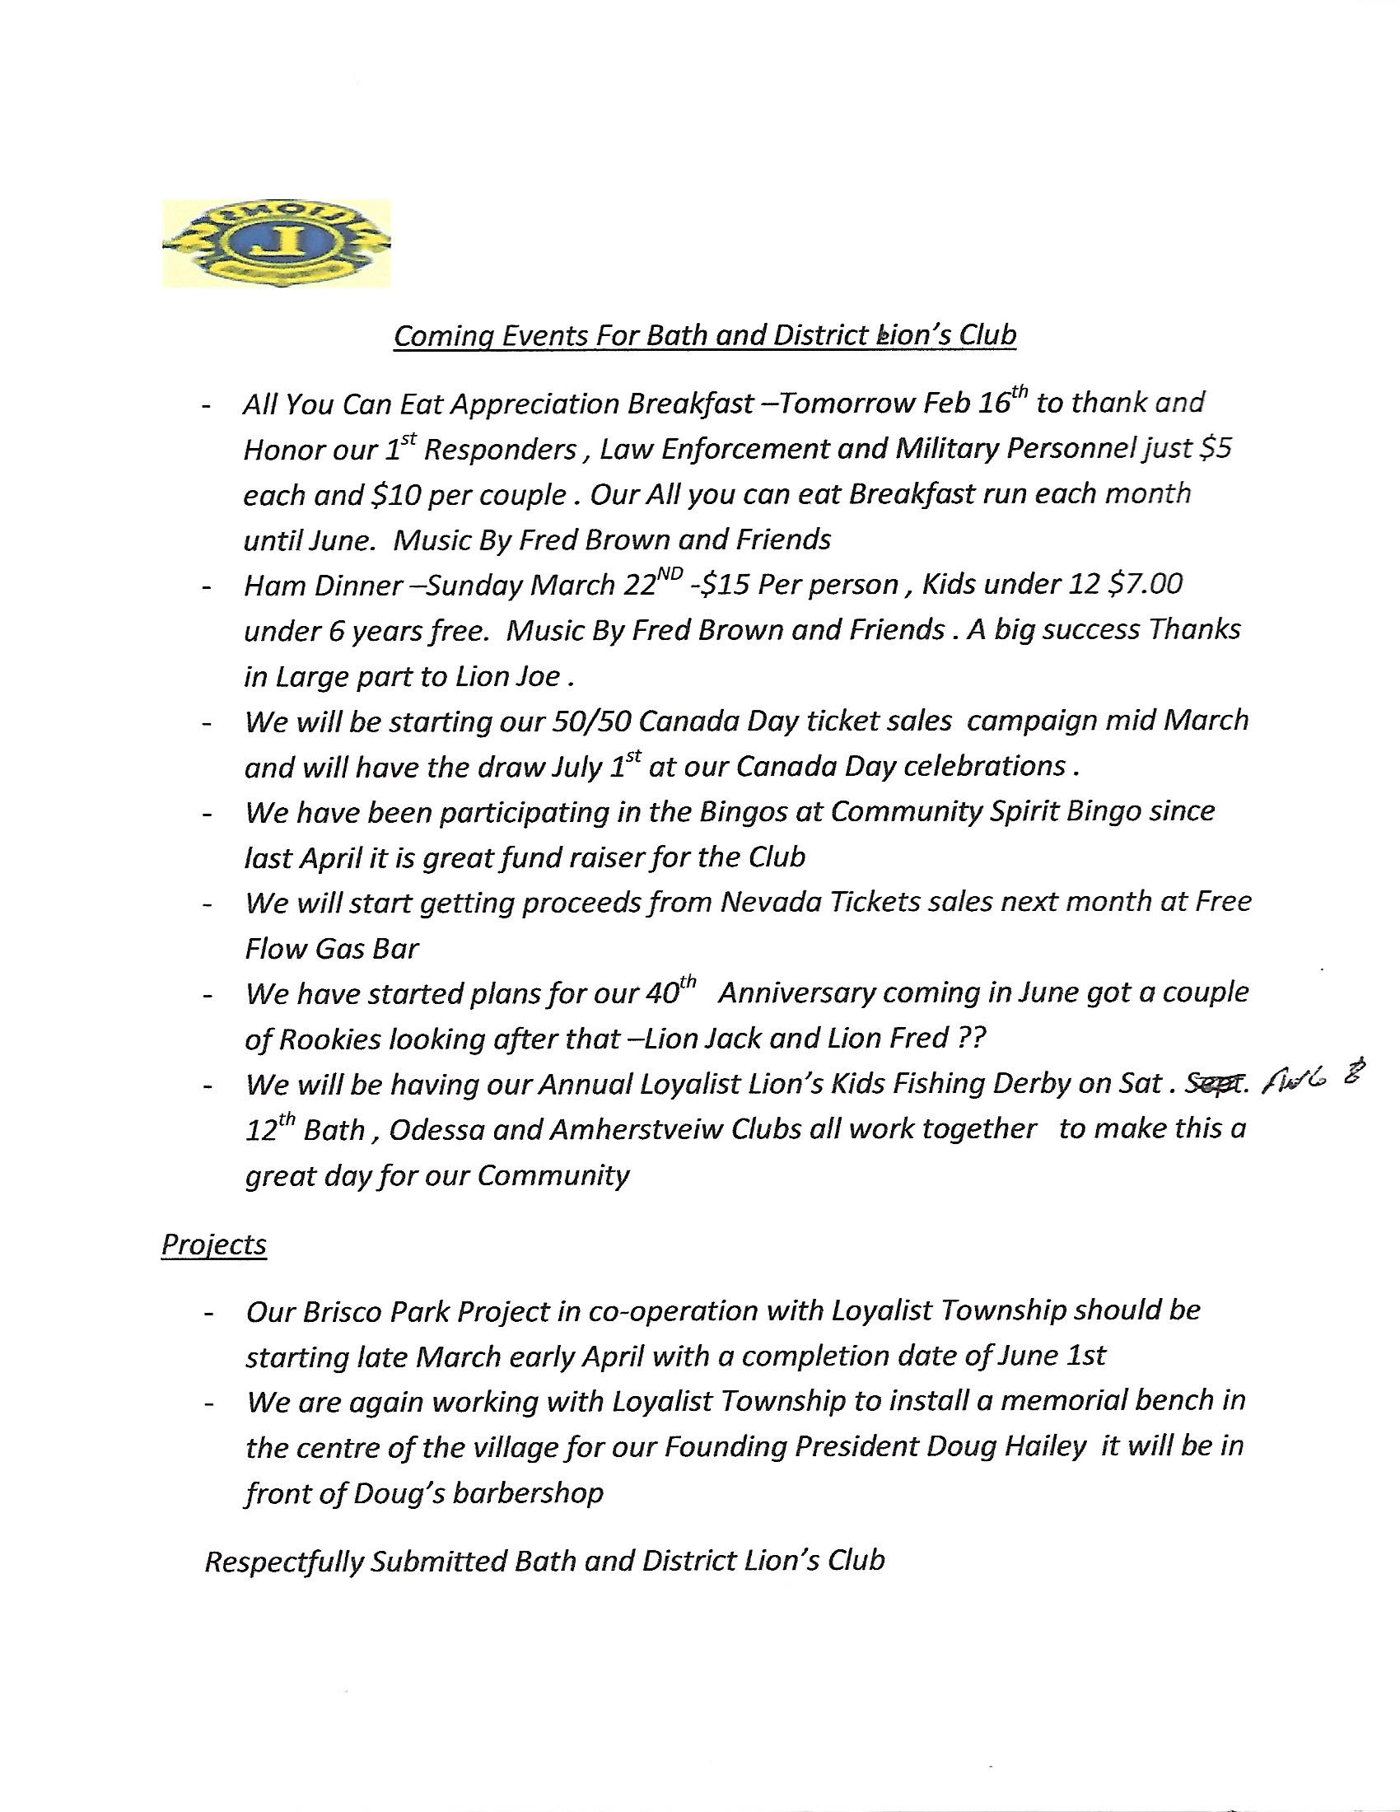
 | Z11W J.J. (Red) Emond |  |  | LIONS ZC 11W REPORT TO CABINET - 15 FEBRUARY 2020 - STIRLING Since the last Cabinet meeting in November, I have visited two clubs; officiated at two inductions and one funeral; attended the Membership Symposium and participated in different fundraising activities. My fellow lions who accompanied me at the recent Membership Symposium were pleasantly surprised to see so many lions willing to share their efforts and success stories in the betterment of the Lions. They found the sessions interesting, valuable and enlightening. The Tamworth presentation proved to be most interesting and should have motivated many to follow their lead in communicating effectively and in timely fashion using the internet. Sadly, only three of seven clubs from my zone had representation at these valuable sessions. In fairness, weather forecast and travel advisories for that day discouraged many living east and north of Havelock to head down the road. My most recent visit with the lions of Odessa convinced me that all Lions strive to make the lives of all, including fellow lions, most enjoyable at reasonable cost. For example, drinks are only $3.00 and the nice beef dinner served $12.00. Good on them for financially doing their best for their members and guests attending Lions functions. All of my visits have proven to be successful and revealing of the efforts clubs have made to promote the true spirit of our Organization. Respectfully submitted Lion J-J (Red) Emond ZC 11W.
 | Z43E Cheryl Lewis |  |  | This is my third and final report to Cabinet. On January 28, 2020, a Zone meeting was held in Tweed. In attendance was Lion Terry Graham, who spoke about the Canadian for Lion, LFC. Lion Don Radnor was also in attendance and advised us he was running for DG. There were 2 Lions from Foxboro-Melrose, 6 from Stirling and District and 7 from Tweed. Thanks to their great caterer we had a lovely meal. Seven Lions were inducted in Madoc on February 24. Two visits left to do and on Zone meeting. Respectfully submitted. Lion Cheryl Lewis.
 | Z43W Bill Shaw |  |  | District Governor Sue, District A3 Cabinet.  Visitation for Zone 43W is being resumed.  Havelock Club was visited on Tuesday Feb 4th.  Norwood club was visited on Thursday Feb. 6thfor their 68th anniversary, where 11 milestone recognition pins were awarded, including a 45 year recognition.  Scheduled visits include  Madoc: Feb 24th  Campbellford: Feb 26th  ^{Marmora-Crowe Valley: Feb 27th}  Zone meeting to be arranged for first (or second) week of March.  Respectfully submitted  Bill Shaw  District A3, Zone Chair, 43West
 | Z43S David McKellar |  |  | Good Afternoon, District Governor, Cabinet members, Lions, Lioness, Leos, and guests.  This is my second report to Cabinet for this year.  I have completed all my formal visits to the 43 South Lions Clubs.  I have also conducted two Zone Advisory meetings; the first on 25th Sept 2019 in Wellington. The second was on the 18th Nov. 2019 in Colborne. I am planning my last advisory meeting on the 11 of March the main thyme is Membership.  All of the clubs are doing well, The Trenton Lions last Friday had their most successful Spaghetti dinner to date raising over 2000 dollars for the fire relief in Australia.  The same weekend the Batawa Club worked their hearts out and held another very successful pond hockey tournament.  As well, they have partnered up Trenton and Frankford clubs to raise funds to buy medical equipment for TMH.  The Wellington club is hard at work serving their community, getting ready for the next Guide Dog Walk, which is fast approaching.  Lastly, The hard working Colborne crowd are back in the saddle. Their upcoming meeting is going to be held in the public Library to celibate all the books the have donated to the community.  All in all, 43 South is busy, happy and doing great.  Respectfully submitted,  Lion David McKellar  A3 43 South  Zone Chairman
 | Webmaster & Technology | PRC Tom Houston |  | Moved by Lion Glenn, seconded by Lion Cheryl that the reports be received. CARRIED.
- c | New Business | DG Susan Taylor |  | A3 will be asking all its Lions Clubs to donate money for the Tree Project. $6500 US is needed.
 | Questions/For the Good of Lionism | DG Susan Taylor |  | 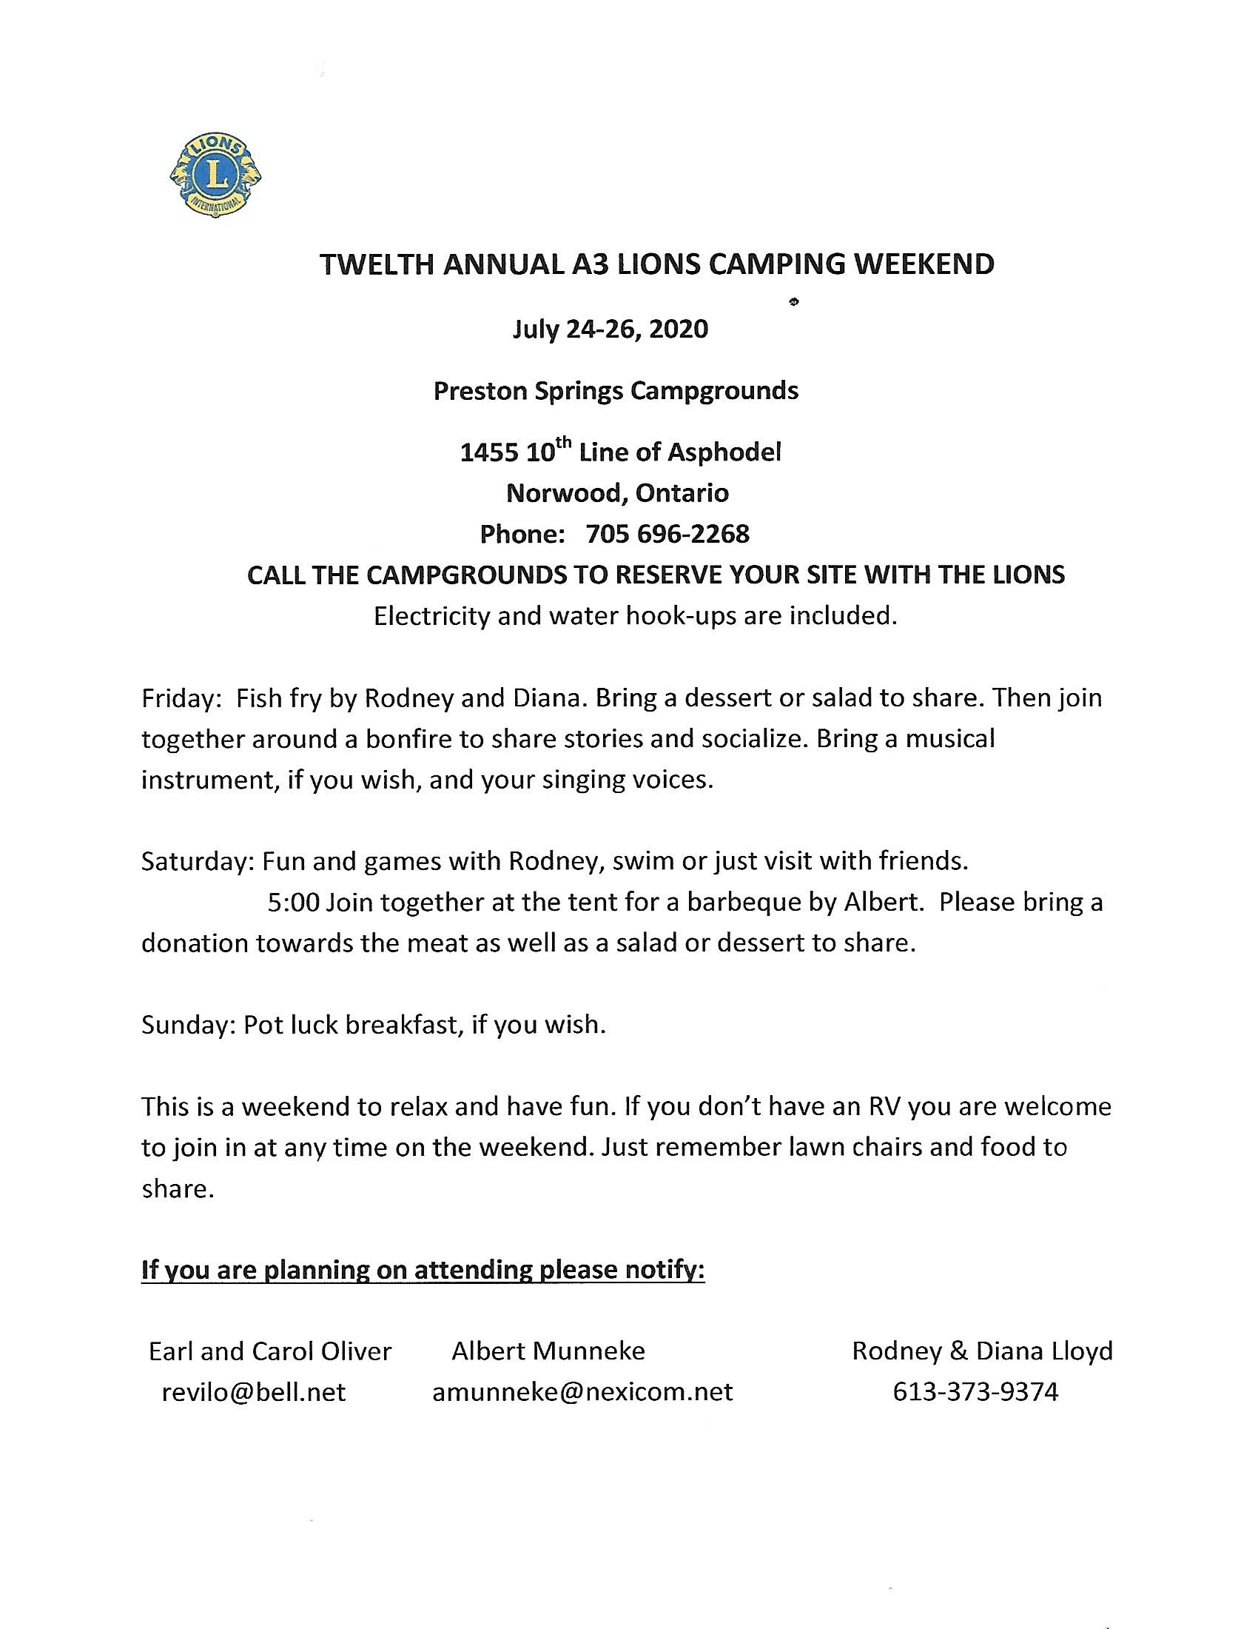
Lion Jeff reported that money had been donated for dialysis chairs at the Trenton Hospital
Lion Mark reported that applications for grants for Trenton playground had be submitted.

Suggested by Lion Sue that clubs consider awarding a Helen Keller Fellowship to deserving people.

Certificates were presented to several Lions on behalf of LFC.

Lions Dawn, Dave, Mark and Bill Zwier were presented with certificates for completion of Guiding Lions program.

Thanks to the Havelock Lions Club for hosting the Membership Seminar.

Lion Harm reported that the Spaghetti dinner held at the Trenton Club, on January 28, took in $2000. Money will be used for the Australian Relief Fund and the Batawa Pond Hockey Tournament.

 | Closing Remarks & Adjournment | DG Susan Taylor |  | Lion Susan thanked everyone for attending this meeting.  Meet adjourned at 3:05 pm

