In 2019-2020 we are continuing to emphasise teamwork. Your club is a team and needs to function harmoniously. I believe that there are 3 components to effective teamwork

- Effective Communication, electronically, and face to face. Emails can be misinterpreted.
- Cooperation is also key because as we often quote “Alone we can do so little, together we can do so much”. To be successful we need to cooperate. Lions are at their best when they have a goal.
- Respect is essential. Respect for each other as people. Respect for other’s points of view. We can agree to disagree without belittling each other.

Teamwork = Communication, Cooperation + RESPECT

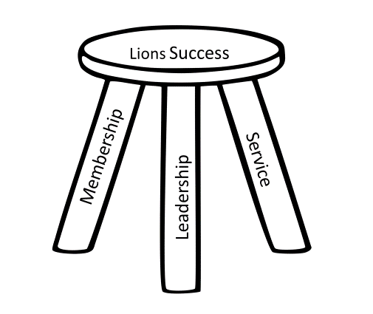
My favourite visual when talking to Lions is the
Three Legged Stool.

It represents the Membership, Leadership and Service elements of our approach to Lions.

Service is the ultimate goal in everything we do, but without Membership we have no one to do the service, and without Leadership we can waste time and effort wandering aimlessly.

Service = Membership + Leadership. They are interdependent

At the International convention, our International President for 2019-2020, Dr Jung-Yul Choi has introduced his theme,
”We Serve Through Diversity, in Harmony”.
He emphasized that Lions not only serve the world, we represent the world. Together we are more than we are alone. He wants us to practise Servant Leadership, which is characterized by the phrase “What can I do for you? Dr Choi wants us to lead by example.
Have a great year Lions. The A3 Team of Lions is ready to go.
DG Susan

