Lemons to Lemonade in 2020
This Photo by Unknown Author is licensed under CC BY-NC
This Photo by Unknown Author is licensed under CC BY

Covid-19 gave us Lemons this year but our A3 Lions did a great job of making Lemonade. Our
“Adopt a Long-Term Care Facility” programme has been a great success. We have served our neighbours, friends and some family members very well. Not only did we provide food but we also provided support and encouragement. Looking after someone’s mental health is as important as providing food. Well done Lions! Can we use this as a stepping stone to a new service project for your club?

This has been an unusual finish to the year. Yes, we had to cancel our convention but everyone lost something: brides and grooms have postponed weddings, graduates lost a chance to celebrate their achievements, parents and grandparents lost precious visiting time, and some lost loved ones and are not able to celebrate their lives properly. So, in the large scheme of things, a convention is a little thing. We also learned to use online tools to vote and hold meetings.

This year we focused on team building and working together in harmony and with respect. Be in communication with your club members especially those who are alone. Take care of each other and in return you will be able to do a better job as a club. Invite others to join you.

I had a great team of Cabinet members. A huge thank you goes out to each of them for the time and care they dedicate to you and your clubs. They do it because they care. Several of us worked through personal health crisis which gave us challenges, but the cabinet members stepped up to assist each other. A special thank you goes to those who stepped up to fill vacancies on cabinet. My Vice District Governors are two of the best in Canada. I was a lucky District Governor and we are in good hands in the coming years.

Thank you notes are one way we show our appreciation to someone. I certainly appreciate all of the lovely cards and messages that you sent to me.

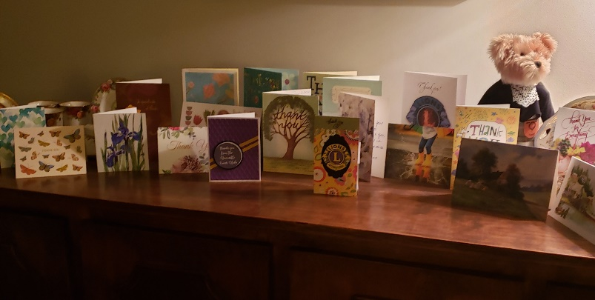
This is my “Thank you” to all of you.

Yours in Lionism
District Governor Susan

“Kindness Matters”

