District A-3 Officers 2018 – 2019

District Governor Lion Frank Hewitt

[thelionwhisperer2017@gmail.com](mailto:thelionwhisperer2017@gmail.com)

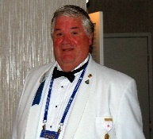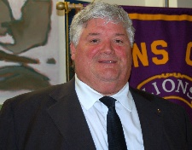

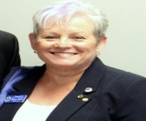

1st Vice - District Governor Lion Susan Taylor

[librariansue@gmail.com](mailto:librariansue@gmail.com)

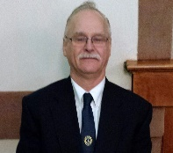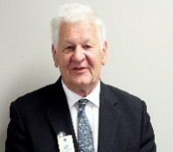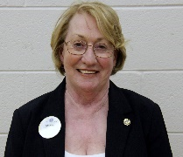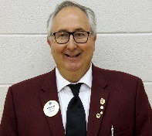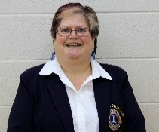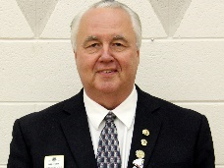

I.M.P.D.G. Lion William Zwier

[zwierw@gmail.com](mailto:zwierw@gmail.com)

Zone 10 North Chair – Lion Ruth Newell

[lionruthnewell@gmail.com](mailto:lionruthnewell@gmail.com)

Region 10 Chair – Lion Kevin Kimmerly

[kckimmerly@gmail.com](mailto:kckimmerly@gmail.com)

Cabinet Treasurer Lion Albert Munneke

[amunneke@nexicom.net](mailto:amunneke@nexicom.net)

Cabinet Secretary Lion Lori Loucks

[cabinetsecretary2018@gmail.com](mailto:cabinetsecretary2018@gmail.com)

2nd Vice – District Governor Lion Barry Chisholm

[barry@goldfields.ca](mailto:barry@goldfields.ca)

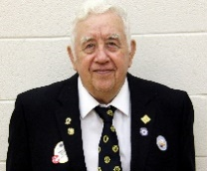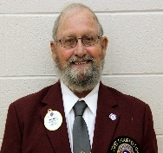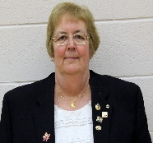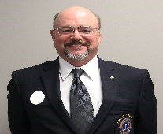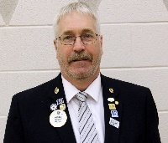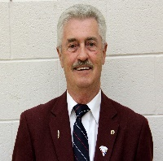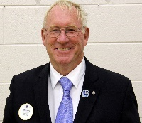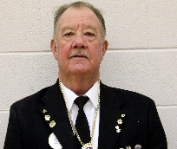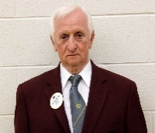

Zone 11 West Chair – Lion Larry Martin

[lnjmartin@yahoo.ca](mailto:lnjmartin@yahoo.ca)

Zone 11 East Chair – Lion Ralph Boomhower

[gjtssmith@gmail.com](mailto:gjtssmith@gmail.com)

Region 11 Chair – Lion Linda Zwier

[zw3026@xplornet.ca](mailto:zw3026@xplornet.ca)

Zone 43 East Chair – Lion Fred Brown

[fredbrownbrown9@gmail.com](mailto:fredbrownbrown9@gmail.com)

Zone 43 West Chair – Lion Don Radnor

[4girlz4don@gmail.com](mailto:4girlz4don@gmail.com)

Zone 43 South Chair – Lion Dave McKellar

[davidmckellar02@live.com](mailto:davidmckellar02@live.com)

Region 43 Chair – Lion Mark Kelso

[markaltcrz@yahoo.com](mailto:markaltcrz@yahoo.com)

Zone 10 South Chair – Lion Al Grundy

[papa.grundy@gmail.com](mailto:papa.grundy@gmail.com)

Zone 10 Center Chair – Lion Syd Hopkins

[shopkins@nexicom.net](mailto:shopkins@nexicom.net)