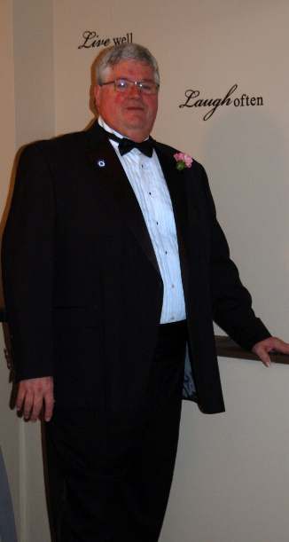Lion Frank Hewitt was born in Sault Ste. Marie, Ontario and comes from a large family of 6 brothers and 2 sisters. His parents moved all over Ontario, from Northern towns like Geraldton to the big city of Toronto before settling in Sutton, Ontario.

Lion Frank attended High School at Sutton District High School before taking a position at the Coca Cola plant in Uxbridge. While working there, he served 4 years as President of the UFCW Union. After working there for 10 years, he decided he needed a change in his life.  He left Coca Cola and went to work for the City of Toronto for 2 years, then moved on to working with his brothers who formed their own cable installation company in Gravenhurst.  Lion Frank formed, co-owned and operated Hewitt Brothers, a disc jockey and security business, with his brother Randy.  He primarily worked in the security and performing arts industry for over 23 years before switching directions and joining Century Transport where he drives Airport Shuttles and Charter Bus.

His first introduction to Lionism was with the Gravenhurst Lions in 1997, where he served many positions including President, and brought the first female member into the club.  He later moved to the Peterborough area for work and joined the Peterborough Lions Club in 2010, then transferred to the East Peterborough Lions Club in 2015. Since joining Lions, Frank has sponsored 9 people into this wonderful organization. He has won a Lion of the Year Award twice, the Bulletin Award three times, and is the proud recipient of a Melvin Jones Fellowship and an International Appreciation Award.

Lion Frank served as Zone Chair for 2 years, covering two zones during his second term, and served as Region Chair for Zone 10 before deciding to continue moving up to District Governor.

Lion Frank and his wife Lion Theresa currently live in Peterborough, where they are always happy to share their home with 7 children, and 4 grand-children. Lion Frank has always been a believer in the Lions Code of Ethics that states, “To be careful with my criticism and liberal with my praise; to build up and not destroy” and he tries to always remember and live by that.