**Social Media Tip: How to Use Hashtags**



You might hear us telling Lions to use hashtags when posting pictures and stories of service activities on Facebook and Twitter, but what exactly is a hashtag and how do they work? Here's a basic rundown:

**What is a Hashtag?**

**hash·tag -** ˈhaSHtag/ - noun  
*(on social media sites such as Twitter) a word or phrase preceded by a hash or pound sign (#) and used to identify messages on a specific topic.*

When you add #LionsClub to a message on Twitter or Facebook, you're essentially joining a conversation. People on Twitter and Facebook can search for a specific hashtag, and your message will show up in those search results. Your hashtag is letting everyone know the great things that your Lions club is doing for the community.

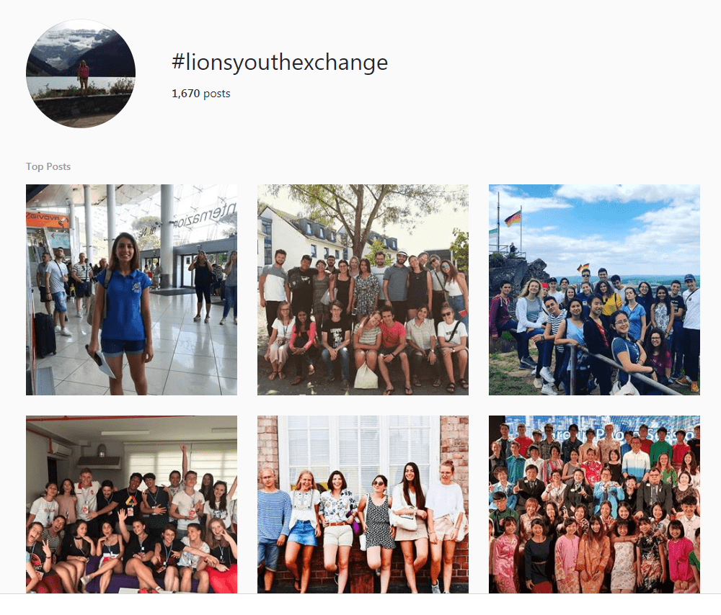

**Using Lions Hashtags**

There is a handful of hashtags that we use in our social media communications, and we encourage Lions to use them, as well. Pick one or two hashtags under which your message falls; for example, if you're posting a photo of a recent Centennial Service Challenge activity, add #LIONS100 to the end of your message. Or if you're sharing photos from your convention experience, use #LCICon. For more general posts -- perhaps a simple photo of members at a local food pantry or library event -- use #LionsClub.

**Suggested Lions Hashtags (this list is English only and not comprehensive)**

**For general club- and service-related posts**

#LionsClub  
#LeoClub  
#ProudLEO  
#LionsEverywhere  
#WeServe  
#KindnessMatters

**For international Lions events:**

#LCICon   
#LDUN

**For program-related posts:**

#LionsYouthExchange or #LionsCamp  
#LionsFightDiabetes  
#PeacePoster  
#SightForKids

**Share Your Stories**

Hashtags also help us share your stories with Lions everywhere. We'll often search for Lion’s hashtags on Facebook, Twitter and Instagram and post the stories on our official social media channels. Take pride in your service and help us share your story! **#WeServe!**