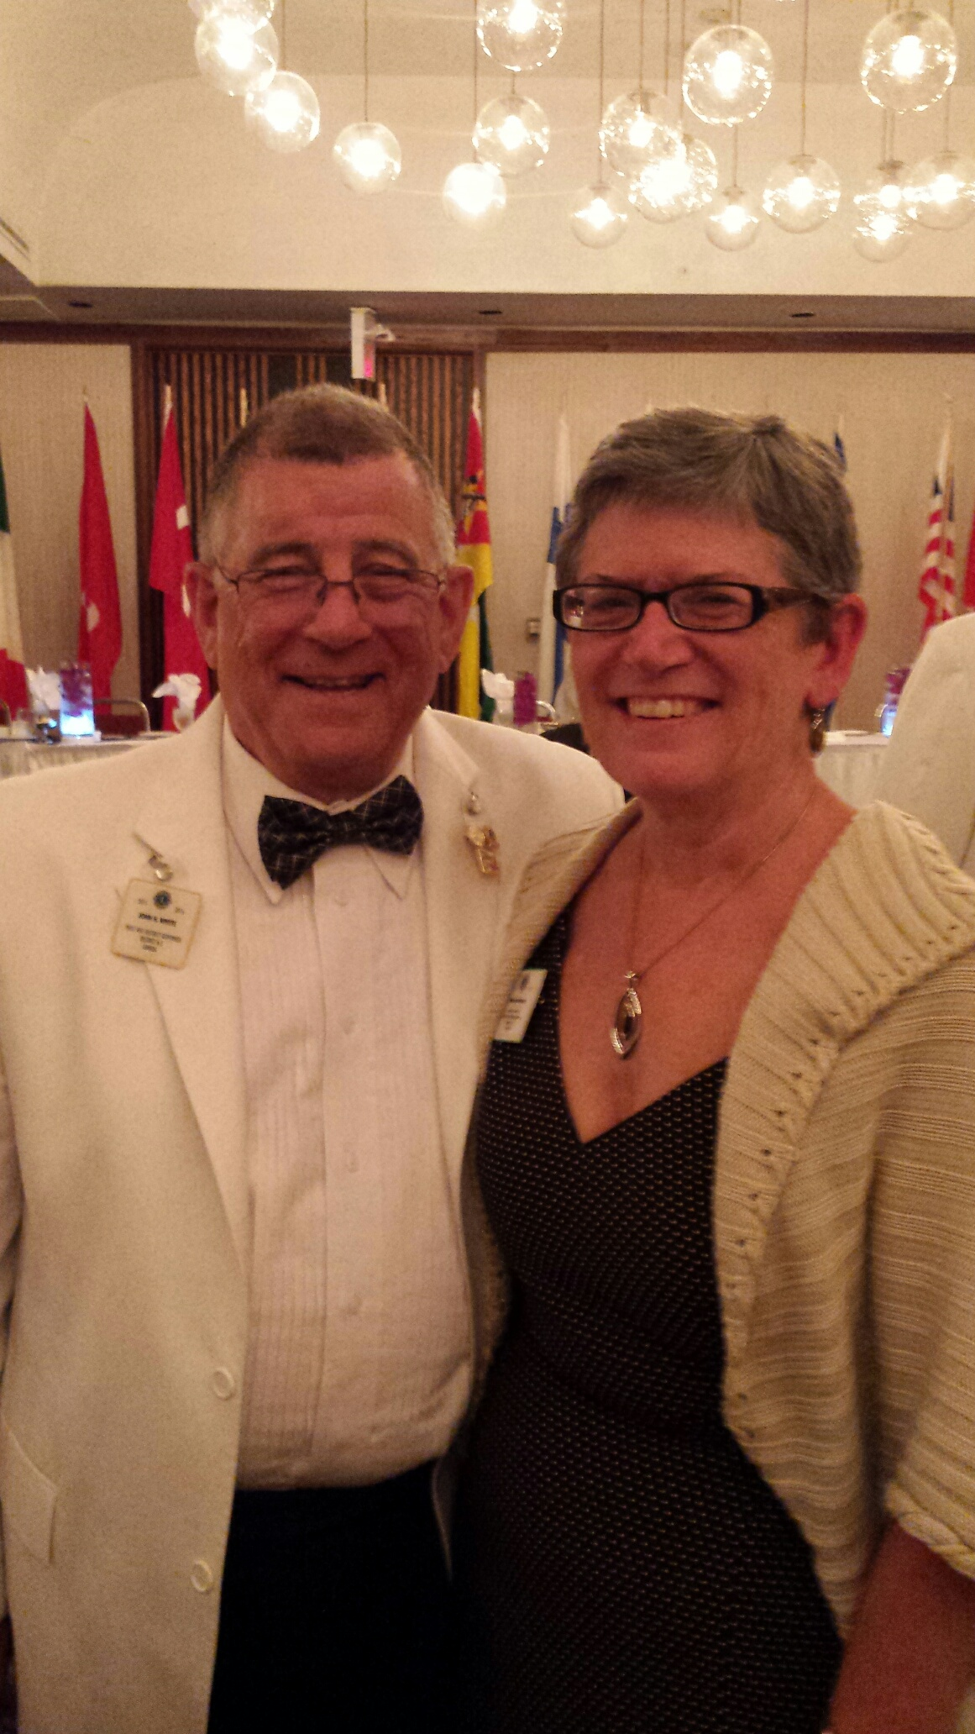

Lion John is of Austrian origin. His family left Austria in 1938 and relocated to Bombay, India where he was born. The family moved to England when he was 2 years old. He was educated in England but admits that academia was not his strong point. He made up for it by excelling at sports, particularly team sports.

Lion John moved to Canada in 1985 and became a Canadian citizen in 1987.

Prior to taking semi-retirement he spent 46 years in sales, marketing & business management in Canada, the USA, Europe and North Africa. He now works part-time in the tasting room/boutique at Sandbanks Estate Winery in Prince Edward County.

His involvement in community service began in 1973 when he joined the Round Table of Britain & Ireland where he was a member for many years. He joined Scarborough Cedarbrae Golden Mile Lions Club in 2006, where he served as Leo Advisor, Peace Poster Chair, Youth Chair, Vice President and 3 terms as Club President. He also served as District A-711 Peace Poster Chair. Lion John transferred to the Wellington District Lions Club in 2013. He has served District A-3 as Peace Poster Chair, Zone Chair and 1st Vice District Governor.

Lion John is the recipent of 2 Club President’s Appreciation Certificates, a Lion of the Year Award, an International President’s Extension Certificate and an International President’s Letter of Commendation. He is a Certified Guiding Lion. He is also a graduate of the Advanced Lions Leadership Institute and a graduate of the Lions University Bachelors Program and will be graduating from the Masters Program this year at the USA/Canada Lions Leadership Forum in Omaha, Nebraska.

Lion John and his partner Lion Kathy Marchen live in the beautiful village of Wellington in Prince Edward County and have a blended family of 7 children, 8 grandchildren, 3 cats and 2 dogs.

