STURM HUMANITARIAN FOUNDATION
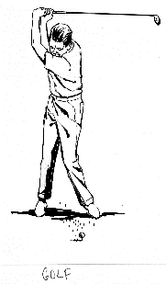
OF LIONS DISTRICT 27-B2
29th Annual Golf Outing
Saturday, July 13, 2024
Parkway Golf Course
Pound, Wisconsin
Hole Prizes - 50/50—Fun Games
$90 per golfer or $360 per team
Includes 18 holes of golf, a cart and a dinner.
Scramble Rules Apply
Parkway members $75 per golfer

Starting Time 12:30 pm Shotgun Start
Hole Sponsor (cost $100) __________________
Club: ________________________________________
Contact Person: _______________________________
Phone: (Cell)_________________(Email)___________
Golfers:
_____________________ _____________________
_____________________ _____________________

Early Registration by June 30 gets you 1 Mulligan Ticket per Golfer
Reservations required by July 6, 2024

CHECKS PAYABLE TO: Sturm Humanitarian Foundation
Mail to: Lion John Dunlap Phone: 920-621-1118
2216 Rasmussen Pl. email: jdunlap1251@gmail.com
Ashwaubenon, WI 54304

