STURM HUMANITARIAN FOUNDATION

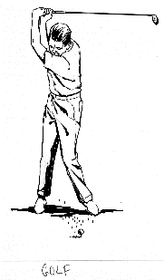OF LIONS DISTRICT 27-B2



***31st Annual Golf Outing***

*Saturday, July 11, 2026*

*Parkway Golf Course*

*9004 Mulligan Way*

*Pound, Wisconsin Public Welcome!*

Hole Prizes - 50/50—Fun Games---Putting Contest

$90 per golfer or $360 per team

Includes 18 holes of golf, a cart and a dinner.

**Scramble Rules Apply**

Parkway members $80 per golfer

Starting Time 12:30 pm Shotgun Start

Hole Sponsor (cost $120) __________________

Club: ________________________________________

Contact Person: _______________________________

Phone: (Cell)_________________(Email)___________

Golfers:

_____________________ _____________________

_____________________ _____________________

Early Registration by June 30 gets you 1 Mulligan Ticket per Golfer

**Reservations required by July 5, 2026**

CHECKS PAYABLE TO: Sturm Humanitarian Foundation

Mail to: Lion John Dunlap Phone: 920-621-1118

4116 Woodland Rd #1 email: jdunlap1251@gmail.com

Green Bay, WI 54313