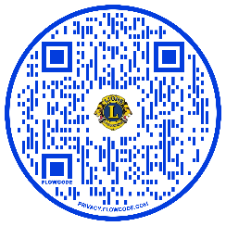
The Childhood Cancer (ChC) committees of Colorado and Wyoming are working to develop various programs and projects that local clubs can be involved with.
More information about each of these can be found on our website, www.CWLionChC.org

Pop a Top for Ronald McDonald House Charities of Denver
Collecting pop-top pulls from aluminum cans for Ronald McDonald House to support their operations continues to be a project that we believe every club in Colorado and Wyoming can adopt as it requires little effort to support Childhood Cancer. Get details on the website.
Kards for Kids / Caring Cards
This program encourages Lions Clubs to send handmade greeting cards to kids suffering from childhood cancer and to other individuals going through life saving treatments and staying at Brent's Place. Brent's Place will be the primary contact for distribution of the cards,
- Kards for Kids will go to pediatric cancer patients.
- Caring Cards will go to adult patients staying at Brent's Place suffering from cancer and other life treating illnesses.
Details of this program can in a later article in this newsletter and on at www.cwlionschc.org/kards-for-kids

Quilts for Childhood Cancer patients
We are still working to finalize plans for a quilting program to provide quilts to Childhood Cancer patients and should have details next month. Continue to check our website for last minute updates.
Christmas Gifts for Kids at Ronald McDonald House
As a last-minute project, Centennial Airport Lions and the Childhood Cancer committee are collecting Christmas gifts for Ronald McDonald House’s Toy Store at their annual Christmas Party, December 7.
Future Projects Being Worked
We are going to work with the District Governors to sponsor a community service project at one of their cabinet meetings where Lions can bring household items and we will distribute them to Ronald McDonald House and to Brent’s Place.

