Lion Jim Aucoin

Second Vice District Governor

District N-1 2016-2017
Lion Jim joined the Red Lake District Lions Club in Multiple District 5M10 in 1984. When he finished his 36 year teaching career in 2003, he and his wife Linda moved to Fredericton in 2004. He transferred to the Nashwaaksis Lions Club when he arrived. Lion Jim has held every office in Lions and he was honored to serve 5 terms as President.
He has held various positions at the District N-1 and Multiple District N levels including Constitution & By-Laws Committee, Peace Poster Contest and NB Lions Cavalcade for Diabetes chair.
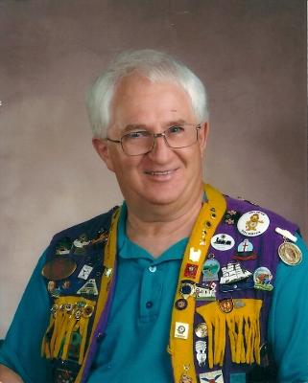
Lion Jim has received recognition for his 32 years of service in Lions including:
- Melvin Jones Fellow in 2004
- District N-1 Outstanding Club President in 2011
- Multiple District N Best President in 2011
- District N-1 Lion of the Year in 2012
- Judge Brian Stevenson Fellowship in 2013 and
- District Governor N-1 Appreciation Award in 2014.
He has attended one International Convention in Toronto and
one Multiple District N Convention in Fredericton. He attends
District N-1 Cabinet / Fall Rally meetings and Annual Conventions.
Lion Jim has received Certificates of Appreciation from the
Lions Foundation of Canada Dog Guides, Canadian Diabetes Association, Canadian Blood Services and the Nashwaaksis Lions Club.
He has been a facilitator for the Ontario Teachers Federation, a volleyball official in his 49th year, a Knight of Columbus and a community activist.
Lion Jim has been married to Linda for 36 years and they have three children.

