** **

**2019-2020**

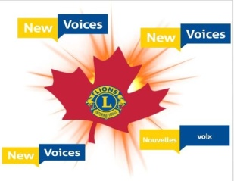

**LIONS DISTRICT N 1**

**Agenda**

**Cabinet Meeting – Nashwaaksis Lions Club**

**September 8, 2019**

**9:30 am**

1. Zone Chair Meeting
2. PDGA – Long Range Planning & Goal Setting Meeting

**11:00 am**

1. Call to Order
2. Singing of National Anthems
3. Moment of Silence for World Peace and Deceased Members
4. Lions Invocation
5. Approval of the Agenda/Additions
6. Roll Call
7. Opening Remarks: District Governor Lloyd Soucie
8. Introduction of the Head Table
9. Recognition of PID Rod Wright and Past District Governors
10. Recognition of Leos and Lionesses
11. Remarks by host President Lion William Scott
12. Report by District Governor Lloyd Soucie
13. Club Visits
14. Congratulate Award winners from last evening
15. Stress importance of nominations for above
16. Report from1st Vice District Governor Paul Gauthier
17. Report from 2nd Vice District Governor John Bettle
18. Report from IPDG Brennan Beaumont
19. Cabinet Secretary’s Report
20. Roll Call Summary
21. Approval of Minutes
22. Annual Meeting April 7, 2019 (Fredericton)
23. DGO August 10, 2019 (Hampton)
24. Correspondence
25. Cabinet Treasurer’s Report
26. Financial Statement Update 2019-20
27. Report on New Voices



**District Governor**

Lloyd Soucie

8 Pleasant Street

Fort Kent, Me USA 04743

[lsoucie@roadrunner.com](mailto:lsoucie@roadrunner.com)

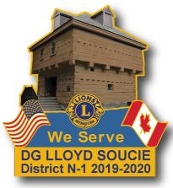

**1st Vice District Governor**

Paul Gauthier

92 Heron Drive

Stratford, PE C1B 2B9

[gauthierple@hotmail.com](mailto:gauthierple@hotmail.com)

**2nd Vice District Governor**

John Bettle

491 Robertson Road

Titusville, NB E5N 3W6

[John14bettle@gmail.com](mailto:John14bettle@gmail.com)

**Cabinet Secretary**

Susan Sangster

1180 Rte 105,

Douglas, NB E3G 7K1

sesangster@gmail.com

**Cabinet Treasurer**

Carlos Vicente

5 Legion Court

Saint John, NB E2K 4V9

carlos.vicente@bellaliant.net



