Lion Jim Aucoin

Candidate for District Governor

District N-1 2018-2019
Lion Jim joined the Red Lake District Lions Club in Multiple District 5M10 in 1984. When he finished his 36 year teaching career in 2003, he and his wife Linda moved to Fredericton in 2004. He transferred to the Nashwaaksis Lions Club when he arrived. Lion Jim has held every office in Lions and he was honored to serve 5 terms as President.
He has held various positions at the District N-1 and Multiple District N levels including Constitution & By-Laws Committee, Peace Poster Contest, Zone chair and NB Lions Cavalcade for Diabetes chair.
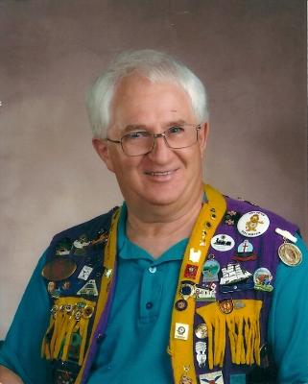
Lion Jim has received recognition for his 34 years of service in Lions including:
- Melvin Jones Fellow in 2004
- District N-1 Outstanding Club President 2011
- Multiple District N Best President 2011
- District N-1 Lion of the Year 2012
- Judge Brian Stevenson Fellowship 2013
- District Governor N-1 Appreciation Award 2014
- District N-1 Best District Chair 2015- 2016
- District N-1Second Vice District Governor 2016-2017
- 2016 USA/ Canada Lions Leadership Forum in Omaha, NE
- District N-1 Zone Chair Liaison2016-2017
- Certified Teacher for Lions Quest 2018
- District N-1 First Vice District Governor 2017-2018
He has attended one International Convention in Toronto and
two Multiple District N Conventions in Fredericton, NB and St. John’s, NL.
He attends District N-1 Cabinet / Fall Rally meetings and Annual Conventions.
Lion Jim has received Certificates of Appreciation from the Lions Foundation of Canada Dog Guides, DiabetesCanada, Canadian Blood Services and the Nashwaaksis Lions Club.He has been a facilitator for the Ontario Teachers Federation, a volleyball official in his 51st year, a Knight of Columbus and a community activist.
Lion Jim has been married to Linda for 38 years and they have three children.

