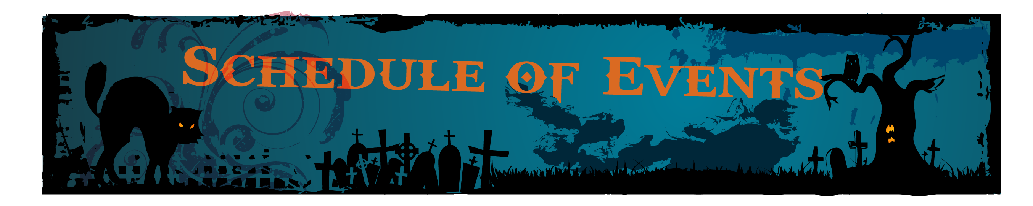

Friday October 10, 2014
8:00am Registration/ Trick-or-Treat
9:00am Call to Order- Convention Begins
12:00pm Model Lunch
6:00pm Monster Bash!
- Ghoulish Italian Dinner
- Halloween Costume Contest
- Spooky Raffle & Prizes
- Creepy Entertainment
- Live Band and Monster Mash Dancing!
Come dressed to scare at our Monster Bash! Prizes will be given for best costumes!

Saturday October 11, 2014
9:00am Call to Order
12:00pm Lunch
6:00pm Governor’s Banquet
- Prime Rib Dinner
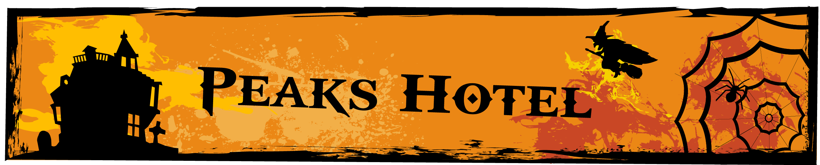

Park City Peaks Hotel 2346 Park Ave, Park City, UT 84060
$59/ night at the Peaks Hotel in Park City. Includes breakfast! (Reserve by September 30th, 2014) www.parkcitypeaks.com
*Guests may call the Park City Peaks directly at 435-649-5000 or 800-649-5012 to make their reservation
*They MUST mention “Lions Club” or “Lions Club District Meeting” for the group discount
*The rate is $59 plus room tax, currently at 10.95% *The rate is good for any standard room, either with one KING bed or a room with two QUEEN beds
*There are suites available for an additional $50 per night (plus applicable tax). Suite are double the size of standard rooms. All suites have one KING bed, plus a sofa sleeper
*Rate is based on single/double occupancy. Additional people 13years & older are $10. Children 12years & younger stay for free
*Rate includes hot/cold Continental Breakfast, served 7am – 10am daily
*FREE parking and FREE Wi-Fi
*NO RESORT FEES

Convention Pricing:
**** Early Registration Only $10! Per Person (Until October 1, 2014, $15/Person After Oct. 1) ****
$10 Early Registration
$12 Friday Lunch
$15 Friday Monster Bash Italian Dinner
$12 Saturday Lunch
$20 Saturday Governor’s Banquet Prime Rib Dinner
*Drinks are included with all meals
*Wine will be available at both dinners for a $5 donation per glass
Send checks to:
Park City Lions Club
Attn: Carolyn Suchala
3018 West Daybreaker Drive
Park City, Utah 84098
To Process Credit Cards, Call Brianna Seymour: # 208-761-1996
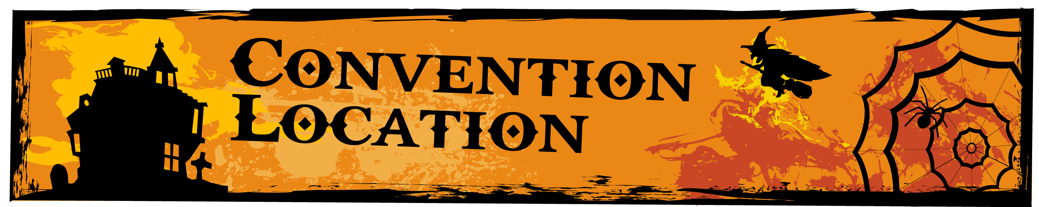

550 Main Street Park City, Utah 84060 (In the Elks Lodge)
We are pleased to invite you to the 28U District Convention in beautiful Park City. The location of the convention is not located in the Peaks Hotel, but instead on beautiful Main Street in a recognized historic building that overlooks bustling Main, as well as the ski resorts.
Getting to the Convention:
There is FREE bus direct service from the Peaks Hotel to the site of the convention.
There is a FREE parking garage located behind the building on Swede Alley.
A Notice about Accessibility:
Due to the fact that this is a recognized historic building, it is not ADA accessible. The convention will be held at the top of two flights of stairs. There are bathrooms located in the convention room. If you need assistance accessing the convention hall, please let us know in advance so that we may make preparations for you.

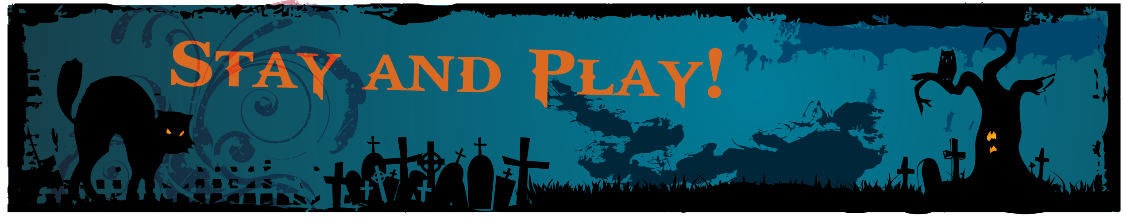

Spend Some Time in Park City!
Fun Things to Do!
www.visitparkcity.com
www.parkcity.org
Park City History Museum:
www.parkcityhistory.com
Kimball Art Center:
www.kimballartcenter.org

