Purpose

This narrative provides specific information about the Lions Club’s KidSight equipment lending program, the screening equipment we use, and how to prepare for and screen students. Some text is italicized, bolded and noted in red for additional emphasis.

We assume that your screening date(s) has already been scheduled. If not, please contact your Lions Club KidSight Coordinator:
Name: ______________________
email: ______________________
Phone: _____________________

Welch Allyn Spot Screener

Welch Allyn, a well-established, global medical equipment manufacturer, makes the Spot vision screener used for the KidSight program. The device is portable, easy to use, fast, and requires minimal training. No eye-drops are needed and the device captures information from about three feet away from the student. A summary of screening results is immediately available (on-the Spot screener). Report printing will be done by exporting results to a USB (thumb) drive.

While not all medical conditions can be identified, the Spot device screens for six common amblyopic vision risk factors, specifically: myopia (nearsightedness), hyperopia (farsightedness), astigmatism (blurred vision), anisometropia (unequal refractive power), strabismus (eye misalignment) and anisocoria (unequal pupil size).

Forms and Documents

Forms and documents used for a KidSight screening include:

- (Optional) If you ask for parental consent, a template is available from the Lions Club.
- (Optional) – SpotSubjects.csv file (template list of students to be screened). A template file will be on the USB thumb drive we provide to you.
- Results Letter – Generic form letters, supplied by Lions, used to convey the Spot screener report to parents.
- Spot Results – This report is printed on the reverse side of the Results Letter.

How Many Students Do You Intend to Screen?

If you intend to screen only one or just a few students, required information can be easily entered directly on the Spot device for each student. (See Appendix A.) However, if you wish to screen more than a few, we recommend creating a SpotSubjects.csv file from school records for upload to the Spot device. (See Appendix B.)

Where Will Screening Take Place?

The Spot screener works most efficiently in a slightly dim-lit space so that student’s eyes naturally dilate. If you are screening one student at a time, your office or work-space should be sufficient. If you intend to screen many, you may wish to find a larger space.

What Information Will You Need?

You will need the following information for each student to be screened: first name, last name, date of birth, gender, and whether they currently wear eyeglasses or contact lenses.

Student name spelling and birth date* accuracy is critically important since this will be shown on reports sent home to parents. *Birth date is used to set criteria used during the screening.

What Sort of Training and Support Is Available?

There are four ways we can help you get comfortable with using the loaned Spot screener and complete your screening efforts:
- Administrators Guide - This is a step-by-step guide.
- A Zoom “conference” session with your assigned Lead from the Lions Club – To walk you through data entry, help you get ready to screen, and answer your questions.
- Welch Allyn’s YouTube video – Click on the link for a nifty video introduction.
- Real-time phone support during screening, if necessary – We will provide you with primary and back-up contact names and phone numbers.

How and When Will I Get the Equipment?

You will arrange this with the assigned Lead Lions Club volunteer. On the agreed day/time, the Lead will bring the necessary equipment and supplies (kit) to your location.
- On arrival, we will call you, mask up, and bring equipment to the school door. We will not enter the school.
- Prior to, or on arrival, we will wipe down and sanitize the equipment and supplies.

How Can I Wipe Down/Clean the Spot Screener?
First, please do not touch or clean the recessed glass panel in the front of the screener.
The equipment will have been sanitized prior to its transfer to you. However, you may also wish to clean the equipment. Please note: Our Spot screener costs about $7,000 and is only compatible with two type of cleaners. As part of the kit, we will provide you with one of those choices, 70% alcohol wipes (Angel Tree alcohol hand wipes). Please do not use any other type of cleaner.

How Do You Screen One/Several or Many More Students?

We have provided detailed, step-by-step instructions for screening students.
- If you plan to screen one at a time or just a few, follow the outline in Appendix A.
- If you plan to screen more than a few (or many), for more efficient screening, please refer to Appendix B.

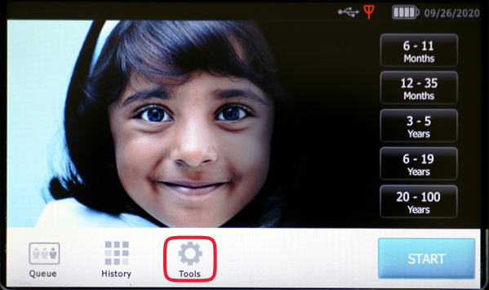
Keep in mind, that if you run into difficulty, we are only a phone call away.

How Do I Export Results to the USB Drive?

The Lions Club provided you with 2 USB thumb drives to export reports generated by the Spot device. Reports will be included in the exported information.
- Insert the USB drive into the Spot device.
- From the start-up (or Home), select “Tools,” then “Import/Export.”
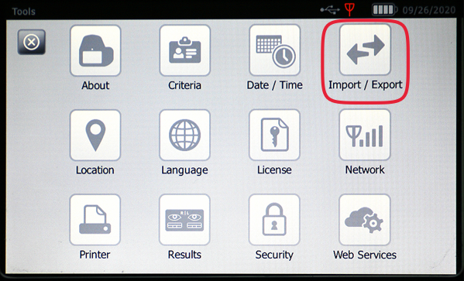
- Select “Export.” DO NOT check the box “Exclude Personal Data.”
- Wait for the export to finish. When the screen says “Export Finished successfully” select “OK.” The USB drive now contains Spot reports for printing.
- Gently pull the USB drive from its Spot screener port.
- Insert a second USB drive into the Spot device.
- From the start-up (or Home), select “Tools,” then “Import/Export.”
- Select “Export.” This time check the box “Exclude Personal Data.”
- Wait for the export to finish. When the screen says “Export Finished successfully” select “OK.” The USB drive now contains the data the Lions Club needs to track Spot usage.
- Gently pull the USB drive from its Spot screener port.

How Do I Print Welch Allyn Spot Screener Reports?

The Lions Club provides pre-printed letters used to convey reports to parents. We request and appreciate your willingness to use these pre-printed letters. The Spot report for each student will be printed on the back. We recommend that you print reports as you go by pressing the print button after each screening. Using our color printer makes it easier to find referrals because they are printed in red. If you choose to print all reports on the USB thumb drive, we recommend using a color printer.
- Mount the USB drive on your computer.
- Insert Lions Club pre-printed letters into your print paper tray. (Ensure you add this paper oriented so Spot reports will print on the blank side.)
- On your computer, navigate to the USB thumb drive. You will see two directories.
- Select (double click) the longer of the two directories that shows the Spot serial number and a date field. Note: if you screen on two separate days and export on both days, the date shown here may be useful in printing reports.
- Open the “pdf” sub-directory. Open one pdf report and test whether the paper supply is inserted properly in the printer. Re-orient the paper if necessary. Then, you may open and print each report individually or select all reports for printing.

What Do I Do with the 2 USB Drives?

Once you are satisfied that all Spot reports are printed, all pdf files may be deleted (or moved to trash) from the first USB drive.
- Insert the first USB drive into your computer.
- Open the “db” sub-directory and navigate to the “pdf” sub-directory.
- Save all pdf files to your computer.
- Important to protect personal information….navigate to the USB drive and delete or move to trash both primary directories, AND, if you created one, the SpotSubjects.csv file.
- “Eject” or Dismount the USB drive and pull it gently from the computer.

The second USB drive contains data the Lions need to track Spot screener usage.
- Open the “db” sub-directory and then save the file titled “SpotResultsExtended.csv” to your computer.
- Send the “SpotResultsExtended.csv” file to your Lions Club contact. FYI, this information is used to track results but also as information to obtain grants for future equipment purchases.
- Important to protect personal information….navigate to the USB drive and delete or move to trash both primary directories, AND, if you created one, the SpotSubjects.csv file.
- “Eject” or Dismount the USB drive and pull it gently from the computer.

How Do I Return the Kit to the Lions Club?

Please call or email your Lead Screener to arrange a date and time. The return kit should include everything that was delivered (except used forms and sanitizing wipes). The transfer sheet will be used to verify all equipment.

Types of Screening Results and Distribution to Parents

When screening and report printing is complete, you will have a two-sided report for each student. One side is a generic Vision Results Letter. The other side will be the specific Spot Results that displays the student’s name, date of birth, gender, and Spot screener results.

Types of Resulting Reports

- “Screening Complete” – All readings were within screening parameters for the age of the student related to the six risk factors noted on page one.
- “Complete Eye Exam Recommended” – One or more measurements were outside the normal range. We strongly recommend a complete examination by an eye care professional.
- “Screening Flagged” – You were not able to screen this student. We strongly recommend a complete examination by an eye care professional.

Sharing the Reports with Parents

Generally, reports should be sent home to parents within a day of the screening. If the individual student’s screening result is:
- “Screening Complete” – Make a copy of the report for your file and send the original home to the parents.
- “Complete Eye Exam Recommended” or “Flagged”
- Make two copies of the report. The original for the parent and one copy for the eye doctor should be sent home. Keep a copy for your file.
- Call the parent(s) to avoid surprising them with news of a potential concern.
- For very young students, you might consider sending it home in their day pack. For third grade and older students, we suggest mailing to the parent to ensure its receipt.

Follow-up, Insurance and Financial Assistance

Follow-Up

Eyesight is critically important to learning. If you identify a potential eyesight issue during screening, we look to you (school Principal, Nurse or Day-care Administrator) to follow-up with parents and encourage them to take the student to an eye care professional.

Within one week you should confirm with parents that they received the report and then four to six weeks later to confirm that the student has been taken to an eye care professional. Please ask about the appointment outcome.

Insurance and Financial Assistance

If families need help in getting an examination or glasses, there are several options available.

- Student’s Health Insurance - Purchased by the parents, these programs may provide partial or full coverage for vision examinations and glasses.
- Medicaid – In New Hampshire, eligible families can opt into either Medicaid's “Wellsense” or “Healthy Families” programs both of which actually pay most, if not all, expenses for exams and glasses.
- Lions Club Assistance - The Lions Club has provided assistance for eye examinations and glasses for those that need it. Please contact your Lions contact for details.

Finally
We welcome your insight and feedback on our process and work so that we can further improve the KidSight program.
Appendix A – Screening One or just a Few Students

For one student or just a few, the process is quite simple:
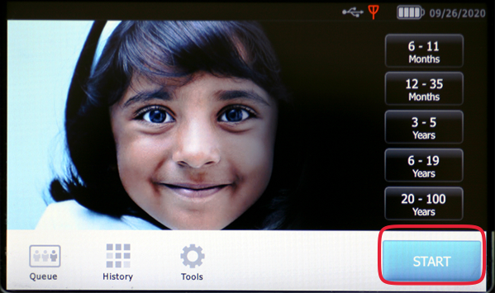
- Place the Spot’s safety strap around your neck and power up the device by pressing the black button on the back side of the screener. (Keep in mind, the Spot screener costs about $7,000. Please do not drop it.)
- When the Spot completes its start-up routine, check the battery symbol located in the right, upper margin. If the charge is low, plug in the unit.
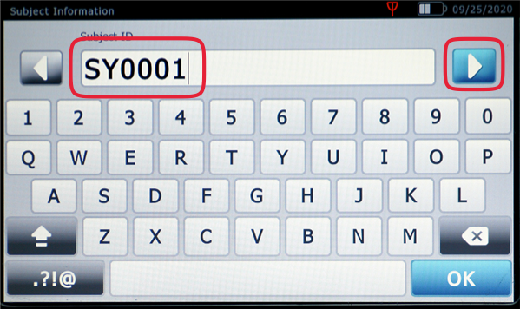
- Select the START button and then enter the student’s “Subject ID” (you might use school’s initials) and a unique number (example 1, 2, 3, 4, etc.) Select the arrow in the right, upper corner.
- Using the touch screen, also enter first and last name, and date of birth (DOB).
- After entering the DOB, on the Subject Information screen, select gender and note either “None,” “Glasses” or “Contacts.”
- Dim or turn off the lights, if possible. Close window shades and doors where bright lights.
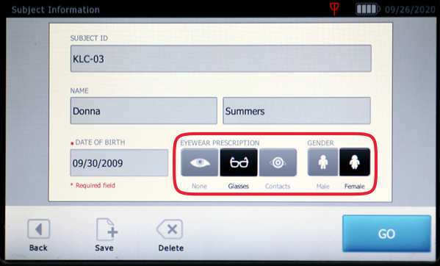
- Pause here to position yourself and the student (seated or standing). The student should be about three feet away from the screener and facing away from windows and open doors. The screener should be level with the student’s eyes, not pointing up or down, and not tilted to the left or right. Holding the screener, stabilize your arms by tucking them next to your torso. You should be free to easily lean or move slowly toward or away from the student.
- Select the “Go” touch-screen button.
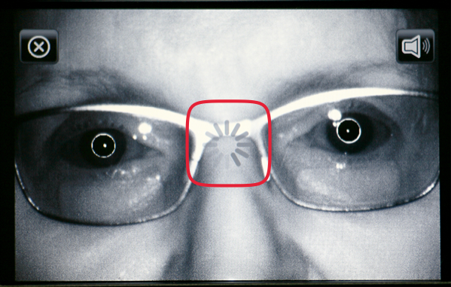
- You will want to center the screen image on the bridge of the student’s nose.
- Ask the student to keep their head straight up, stay quiet and still.
- Held about three feet from the student, the Spot screener will indicate if you are “Too Close” or “Too Far” away. If the screen does not immediately capture an image, slowly move the Spot screener closer or further away while keeping the bridge of the nose centered.
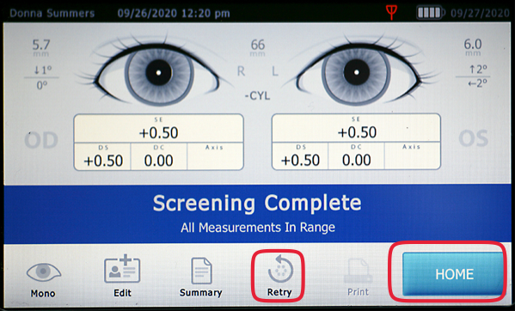
- Watch for a grey circling pattern right on the bridge of the student’s nose. Once in position, data capture is automatic and will generate a brief summary on-screen.
- You may “Retry” if you wish or select the “Home” button and proceed to enter another student’s personal information.
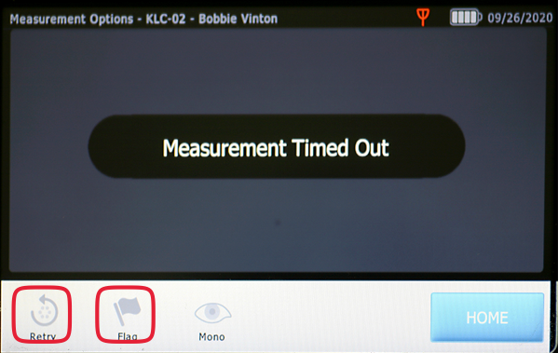
- If you are not able to capture an image, the screener may “time out.” If so, press the “Retry” button. If, after several tries, you are still unable to capture and image, press the “Flag” button.
- If a student normally wears glasses or contacts, screening should occur with eyewear in place. Screening students with glasses can be a challenge. If the screener “times out” try further reducing room lighting and just try again.
- If there is glare on glasses, sometimes it may be helpful to have the student tilt their head up or down just slightly to reduce the glare.
- We recommend that you print reports as you go by pressing the print button after each screening. Using our color printer makes it easier to find referrals because they are printed in red.
- If you choose to print reports after all students have been screened, go back to page three of this guide for how to export and print student’s screening reports using your own printer. We recommend using a color printer because referrals are printed in red. That makes them easier to find among all reports.

Good luck!!

Appendix B – Screening More than a Few Students

If you are screening many students, a larger space might work better. We have found that having four or five students seated in a semi-circle works well, while additional students wait nearby. The key to a speedy and efficient screening is having additional students in the same room waiting to be seated for screening. The queue also allows time for student’s eyes to naturally dilate and helps them become familiar and comfortable with the procedure.
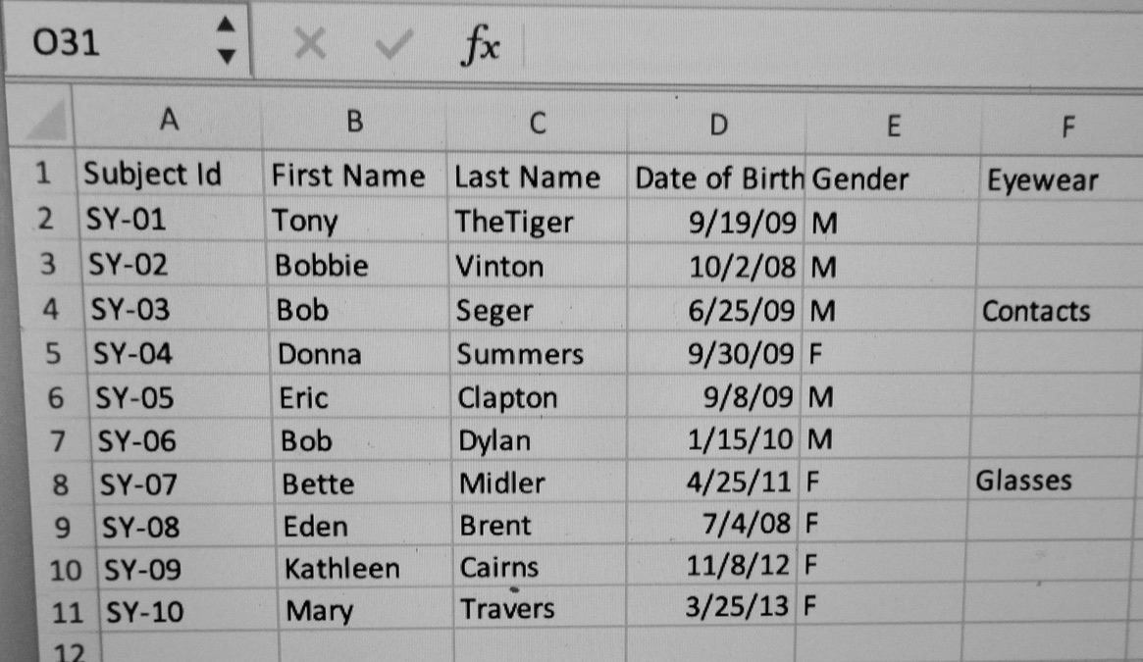
You can more efficiently screen a group of students with the Spot screener by creating a file called “SpotSubjects.csv”. A template of this file is included on the USB drive and looks like the graphic shown to the right.

Information for each student can be manually entered, exported or copied from your school’s database into a spreadsheet (e.g. Excel). The following process should be completed a day or two before the screening.

The information that needs to be entered into the spreadsheet is listed below:
- Subject ID – Unique ID in each cell of column (e.g. 01, 02, 03…). Keep it short, perhaps using your school’s initials and a sequence of numbers, one unique number for each student.
- First Name – Any combination of alpha characters. No punctuation e.g. hyphens, apostrophes.
- Last Name – Any combination of alpha characters. No punctuation e.g. hyphens, apostrophes. If you have a compound last name, include both in the last name field (excluding hyphens).
- Date of Birth – The date of birth needs to be in the format MM/DD/YYYY.
- Gender – Enter only “M” for Male, or “F” for Female. Alpha characters only. Do not leave this field blank.
- Eyewear – Enter “None”, “Glasses”, or “Contacts”. If none, you may leave this field blank.

NO TITLE, OTHER COLUMNS OR DATA CAN BE INCLUDED IN THE FILE.

Please save the file on your computer and our USB drive. Properly EJECT the USB drive from your computer. You may wish to print a copy for your own use in tracking who you have screened or still need to screen.

The file must be named and formatted as a csv file named Spotsubjects.csv to load successfully to the Spot screener.

To screen students:
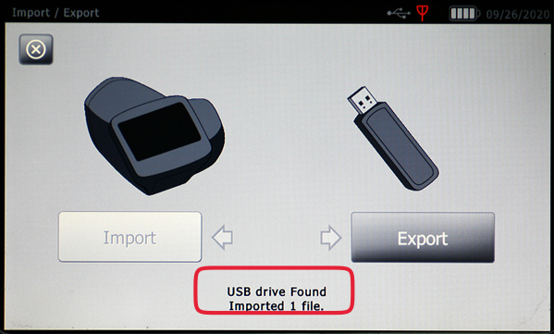
- Place the Spot’s safety strap around your neck and power up the device by pressing the black button on the back side of the screener. (Keep in mind, the Spot screener costs about $7,000. Please do not drop it.)
- When the Spot completes its start-up routine, check the battery symbol located in the right, upper margin. If the charge is low, plug in the unit.
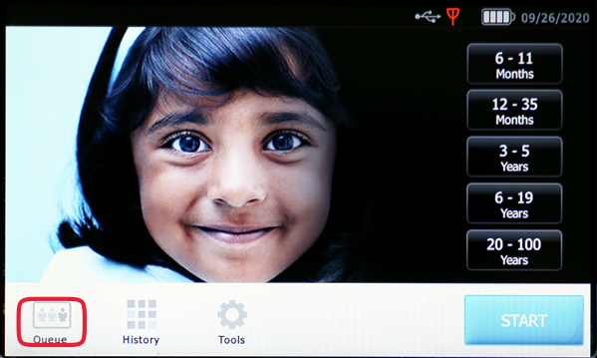
- Insert the USB drive into the Spot screener, and from the start-up (or Home) screen, select “Tools,” then “Import/Export” and “Import.” Wait for the import to complete. (Imported 1 File.) If the file fails to upload, first look for and delete extra spaces and all punctuation. Save the file. If that doesn’t correct the problem consult with your Lions Club member contact.
- Remove the USB drive and set it aside. Select the black “X” in the upper left of the screen to navigate back to the start-up screen. Select “Queue.”
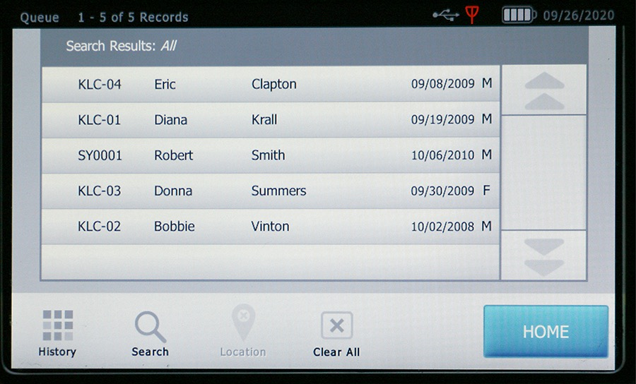
- Pause here to position yourself and the student (seated or standing). The student should be about three feet away from the screener and facing away from windows and open doors. The screener should be level with the student’s eyes, not pointing up or down, and not tilted to the left or right. Holding the screener, stabilize your arms by tucking them next to your torso. You should be free to easily lean or move slowly toward or away from the student.
- From the Queue, select the student to be screened and from the Subject Information screen shown to the right, verify/match this information to the student.
- A search through the queue can be done by either first or last name and can be abbreviated. The student can then be selected from the list provided.
- Select the “GO” touch-screen button.
- You will want to center the screen image on the bridge of the student’s nose.
- Ask the student to keep their head straight up, stay quiet and still.
- Held about three feet from the student, the Spot screener will indicate if you are “Too Close” or “Too Far” away. If the screen does not immediately capture an image, slowly move the Spot screener closer or further away while keeping the bridge of the nose centered.
- Watch for a grey circling pattern right on the bridge of the student’s nose. Once in position, data capture is automatic and will generate a brief summary on-screen.
- We recommend that you print the report as you go. That makes it easier to identify referrals.
- Select the “Home” button and proceed to the next student.
- If you are not able to capture an image, the screener may “time out.” If so, press the “Retry” button. If, after several tries, you are still unable to capture and image, press the “Flag” button.
- If a student normally wears glasses or contacts, screening should occur with eyewear in place. Screening students with glasses can be a challenge. If the screener “times out” try further reducing room lighting and just try again.
- If there is glare on glasses, sometimes it may be helpful to have the student tilt their head up or down just slightly to reduce the glare.
- Once all students have been screened, go back to page three of this guide for how to export and print student’s screening reports.

Good luck!!

