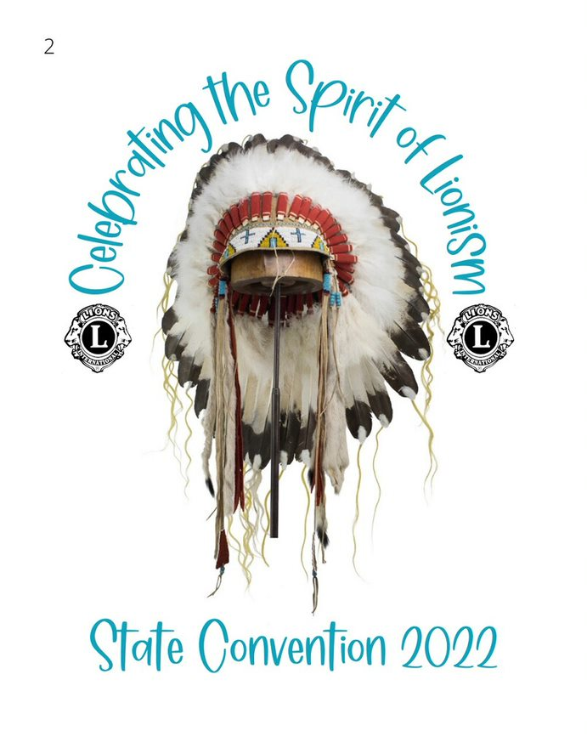

2022 ND Lions State Convention
October 21st and 22nd
Devils Lake, North Dakota

Convention Site: Spirit Lake Casino and Resort, 7889 ND-57 St. Michael, ND 58370

Convention Registration Fees | Banquet entree (Check option) | Questions Contact
October 24, 2021  to  June 30, 2022 - $85 | ☐Chicken Cordon Blu | Lion Kristi Swenson  701-302-0155  kristi.swenson0155@gmail.com
 | or
July 1, 2022  to  October 21, 2022 - $115 | ☐ Swiss Steak | Lion Jennifer Suko  701-320-1852  sukojennifer@gmail.com
Mail Registration to: Kristi Swenson, 414 1st Ave N, New Rockford, ND 58356

(Please use a separate form for each registrant)

☐ I need special vision accommodations
(Explain on the back of this registration form)

☐ I need special meal accommodations
(Explain on the back of this registration form)

Name: Click or tap here to enter text. ☐LION or ☐GUEST (Check One)

Preferred Badge Name: Click or tap here to enter text. Lions Club: Click or tap here to enter text.

Address: Click or tap here to enter text.

Phone:Click or tap here to enter text. E-Mail: Click or tap here to enter text.

No refunds for the $65 registration. Refunds after June 30th, 2022 is 50% of the registration fee. E-mail your refund request to Lion Kristi Swenson (kristi.swenson0155@gmail.com) no later than September 20, 2022.

Lodging Information

https://spiritlakecasino.com/
Hotel rooms at Spirit Lake Casino and Resort are blocked off for the convention at $75 a night. Reservations may be made after January 15th, 2022. Please call 701-766-4888 and tell them you are a Lion. Let’s fill the hotel with the Lions!
Make checks payable to ND State Lions Convention
